**Week 6 - Summative Assessment**

**Part 1 - Portfolio Assignment**

Spatial Data Analysis

**Mohammed Suleiman Ahmed Suleiman**

**R2302D16114905**

Quantitative Data Analysis

46303

**12-Sep-2023**

Introduction 3

How is this document structured 4

1.Week Formative Assessment 6

1.1 Introduction 6

1.2 Assessment Summaries 6

1.3 Key Findings and Insights 7

1.4 Challenges and Solutions 8

1.6 Future Applications 10

1.7 Conclusion 11

Week 1 Formative Assessment Submission 12

2.Week 2 Formative Assessment 30

2.1 Introduction 30

2.2 Assessment Summaries 30

2.3 Key Findings or Insights 30

2.4 Challenges and Solutions 31

2.5 Skills and Knowledge Gained 32

2.6 Future Applications 32

2.7 Conclusion 33

Week 2 Formative Assessment Submission 35

3.Week 3 Formative Assessment 50

3.1 Introduction 50

3.2 Assessment Summaries 50

3.4 Challenges and Solutions 51

3.5 Skills and Knowledge Gained 51

3.6 Future Applications 52

3.7 Conclusion 53

Week 3 Formative Assessment Submission 54

4.Week 4 Formative Assessment 83

4.1 Introduction 83

4.2 Assessment Summaries 83

4.3 Key Findings or Insights 84

4.4 Challenges and Solutions 85

4.5 Skills and Knowledge Gained 85

4.6 Future Applications 87

4.7 Conclusion 88

Week 7 Formative Assessment Submission 89

# **Introduction**

Welcome to my portfolio. This collection of work is a testament to my academic journey through the course, encapsulating the knowledge I have gained, the skills have honed, and the insights I have developed. The portfolio is centered around four formative assessments I completed throughout the course, each serving as a stepping stone in my understanding of complex themes of theoretical tenets of geography into practical cartographic tasks, thereby enriching both my skillset and understanding. They were not just weekly tasks but also laboratories of exploration – spaces where I critically engaged with diverse cartographic challenges, experimented with varied representation techniques, and curated map designs that resonate with the intended message.

Each assessment was a unique learning experience, allowing me to apply theoretical concepts to practical scenarios, thereby deepening my understanding and appreciation of the subject matter. They served as a platform for me to critically analyze various research situations, select and apply appropriate statistical techniques, and interpret the results in a meaningful way.

However, the purpose of this portfolio extends beyond merely showcasing my academic achievements. It also serves as a reflective document, a space where I introspect and critically evaluate my learning process. Reflection is a crucial part of learning, especially in a field as dynamic and evolving as research methodology. It allows me to step back and review my work, identify areas of strength, acknowledge areas that need improvement, and chart a path for future learning.

Starting with Week 1, we embarked on an exploration of the fundamental principles that underpin cartography. This foundational week served as a springboard for the subsequent weeks, ensuring a solid grounding in core concepts.

Week 2 shifted the focus towards the practical dimensions of cartographic representation. Here, the theoretical knowledge gained in the initial week was juxtaposed against real-world applications, underscoring the significance and relevance of cartographic studies.

By Week 3, the emphasis was firmly on thematic mapping. A detailed examination of various map types, from choropleth to isoline, provided both a theoretical and practical grasp of the topic. This week, in particular, highlighted the diverse lenses through which geographic data can be visualized and interpreted.

Concluding the month, Week 4 synthesized and consolidated the learnings from the preceding weeks. It fostered a period of introspection, allowing for the contextualization of the acquired knowledge and its potential applications in various professional and academic fields.

In this portfolio, the rigorous academic engagements of each week are delineated, punctuated with reflections on the learning process. The portfolio thus stands not only as a testament to acquired knowledge but also as an indicator of the intellectual journey through the intricacies of geography and cartography.

# **How is this document structured**

This portfolio provides a comprehensive overview of the varied topics and modules covered over Weeks 1 through 4. Its design is built for clarity and coherence, guiding readers through each week's content and insights in a structured manner. Below is a snapshot of the document's organization:

**1. Introduction:**

Each week's segment commences with an introduction that sheds light on the tasks and objectives tailored for that specific week. This preliminary section is instrumental in setting expectations for readers, guiding them through what lies ahead. Additionally, it accentuates the week's relevance, thereby interlinking the tasks with the broader objectives of the geography and cartography module.

**2. Assessment Summaries:**

Integral to every weekly segment, this section offers a meticulous recap of the tasks pursued during the week. It elucidates the week's aims, the techniques employed, and the outcomes realized. Serving as a chronological guide, it walks readers through each step, setting the stage for the subsequent deeper dives into findings, challenges, and skill acquisition.

**3. Key Findings or Insights:**

This component delves into the crux of each week's tasks, unraveling the most salient revelations or insights harvested. It not only underscores these findings but also elaborates on their implications in relation to the overarching module and the grander sphere of geography and cartography.

**4. Challenges and Solutions:**

A candid reflection on the impediments faced during each week's journey and the strategies leveraged to surmount them finds its place here. This introspection offers readers a glimpse into the problem-solving mechanics and the learnings distilled from challenges encountered.

**5. Skills and Knowledge Gained:**

This segment is dedicated to cataloging the specific skills and knowledge that were either newly acquired or further refined during the week's tasks. It encompasses both the technical proficiencies intrinsic to the module and the overarching skills like analytical acumen or critical reasoning.

**6. Future Applications:**

Peering into the horizon, this section extrapolates the applicability of the garnered skills and knowledge into prospective academic or professional arenas. It paints a picture of the potential trajectories and avenues these learning could navigate.

**7. Conclusion:**

Rounding off each week's section, the conclusion weaves together the primary threads discussed. It succinctly summarizes the week's tasks, revelations, hurdles, skills cultivated, and envisaged future applications, providing a fitting epilogue.

With this blueprint, the document ensures readers can navigate through the content seamlessly, imbibing the essence of each week's thematic explorations in a systematic and coherent fashion.

# **1.Week Formative Assessment**

## **1.1** Introduction

Spatial data analysis stands at the intersection of technology and geography. It facilitates our understanding of how data from our surroundings can be collected, processed, and represented for varied applications. During Week 1 of our exploration, we ventured into the intricate world of spatial resolutions, encoding methods, topologies, and GIS models. Each of these elements provides a distinctive lens to view and decode our environment, especially in the context of modern digital advancements.

With the rapid urbanization and digitization of our societies, spatial data analysis emerges as a pivotal tool for urban planners, environmentalists, policymakers, and even businesses. Whether it's the basic task of estimating a photo's spatial resolution or the intricate chore of distinguishing between raster and vector GIS models, these tools and methodologies allow professionals to make informed decisions that resonate with real-world scenarios.

Our primary focus for the first week was not only to grasp these fundamental concepts but also to appreciate their real-world applicability. Each topic, from topology to GIS models, was approached with a balanced mix of theory and practicality, ensuring that the learning was both comprehensive and actionable.

The overarching objective of this week was to lay a strong foundation. A foundation that would not only bolster our understanding of core spatial data analysis concepts but also stimulate our curiosity about how these concepts interplay in the larger picture of geographical and environmental studies. Through a series of carefully curated questions, we sought to challenge our existing knowledge, push our boundaries, and pave the way for deeper, more nuanced explorations in the subsequent weeks.

## **1.2** Assessment **Summaries**

The first assessment revolved around gauging the spatial resolution of a digital photo. This exercise served as a hands-on introduction to the concept of spatial resolution, which is fundamental in understanding how finely a unit of space can be divided in an image. Our findings highlighted the myriad of factors, including camera specifications and image settings, which influence this resolution.

The next segment required us to conceptualize the creation of a raster data file, specifically emphasizing land-use types within a county. This assessment shed light on encoding methods, which are crucial for representing diverse data types. The comparison further extended to encoding methods suitable for mapping major roads and rivers. This exercise was instrumental in making us discern the situational appropriateness of various encoding techniques.

Diving into the realm of topology, we grappled with its core definition and delved into the dichotomy of topological versus non-topological data structures. This assessment underscored the importance of maintaining spatial relationships between neighboring entities in a given map or spatial dataset.

A substantial portion of the week's assessment was dedicated to exploring raster and vector GIS models. We broke down the nuances of each, illustrating their application through real-world examples of points, lines, and polygons. The exercise not only reinforced the theoretical differences between the models but also showcased the practical implications of choosing one over the other.

Furthering our investigation into GIS, we explored the broader umbrella of geospatial models. Through this assessment, we gained insights into the myriad of ways geographical data can be represented, processed, and visualized, emphasizing both raster and vector models' dynamics.

The assessments also demanded a critical evaluation of the advantages and disadvantages of both raster and vector models. This comparative analysis equipped us with the discernment to choose an appropriate model based on the nature of the task and the desired outcome.

Concluding the week, our focus shifted to a detailed exploration of data structures. This assessment acted as a capstone, amalgamating our understanding of spatial resolutions, encoding methods, topologies, and GIS models, all while highlighting the crucial role of structured data in spatial analysis.

## **1.3 Key Findings and Insights**

Our study of spatial resolution unveiled its nuanced nature. It was enlightening to realize that determining the spatial resolution of a digital photo goes beyond just pixel dimensions. The clarity and level of detail captured play crucial roles, affecting the overall quality and usability of the image for geospatial applications.

As we delved deeper into raster data encoding, it became evident that the method chosen directly impacts data integrity and accuracy. The choice between run-length encoding, quad trees, or other methods is not just technical; it's also about ensuring the data effectively captures the geographic phenomena it's meant to represent.

Our exploration of topology underscored its fundamental role in GIS. We discerned that topology isn't just about spatial relationships; it's the bedrock upon which accurate geospatial analysis is built. Understanding concepts like adjacency, connectivity, and containment became pivotal for our future GIS endeavors.

The study of raster and vector GIS models revealed that these aren't competing frameworks but complementary tools. Each has its strengths and applications where it shines. For instance, raster models excel in representing continuous data, while vector models are apt for delineating clear boundaries.

Geospatial models turned out to be a vast and profound domain. They are more than just tools for representation; they embody the very essence of how we perceive and understand geographic information. Our exploration prompted reflections on the ways humans have traditionally understood space and how modern tools can refine this understanding.

While assessing the advantages and disadvantages of raster and vector GIS models, a key insight was the importance of context. There's no universally superior model; instead, the choice hinges on the specific application, desired accuracy, and available resources.

Our deep dive into data structures highlighted their evolutionary nature. As the demands of geospatial analysis have grown and diversified, so have the structures developed to support them. It was an insightful journey tracing the lineage of these structures from their rudimentary beginnings to their current sophisticated forms.

## **1.4 Challenges and Solutions**

a. Grasping Spatial Resolution:

Challenge: One of the initial hurdles was understanding the concept of spatial resolution, especially when applying it to a real-world digital photo. Determining exact values without technical metadata proved challenging.

Solution: By revisiting the fundamental theory behind spatial resolution and leveraging online tools, we were able to approximate the resolution. Engaging in group discussions also provided varied perspectives, aiding in a more rounded understanding.

b. Deciding on Raster Data Encoding:

Challenge: Given the multifaceted nature of raster data, selecting the most appropriate encoding method was no straightforward task. Especially when considering a diverse dataset like land-use types, the challenge was to ensure that the chosen method would preserve detail while being efficient.

Solution: Through trial and error, combined with in-depth research on various encoding methods, we developed criteria to select the best method based on the data's nature and the intended analysis.

c. Navigating Topological Concepts:

Challenge: Differentiating between topological and non-topological data structures was initially daunting. Grasping the intricate spatial relationships they represent required a shift from conventional thinking.

Solution: Utilizing visual aids, such as diagrams and real-world examples, proved invaluable. These tools brought clarity to these abstract concepts, making them tangible and easier to comprehend.

d. GIS Models – Choosing Appropriately:

Challenge: While understanding the theoretical distinctions between raster and vector models was one thing, applying this knowledge to decide which model to use in specific scenarios was another challenge.

Solution: Engaging in hands-on exercises and case studies helped bridge the gap between theory and application. Through these practical exercises, we were better able to appreciate the implications of our choices and the resultant effects on our analyses.

e. Understanding Geospatial Models:

Challenge: The broad domain of geospatial models brought with it the difficulty of discerning the

myriad ways geographical data can be portrayed.

Solution: Attending supplementary workshops and engaging with experts in the field deepened our understanding. Their insights, combined with our foundational knowledge, allowed for a holistic grasp of geospatial models.

f. Weighing GIS Model Pros and Cons:

Challenge: Taking a balanced view of both raster and vector models, without leaning excessively towards one, was a nuanced task. Ensuring we didn’t overlook any significant advantage or disadvantage was crucial.

Solution: Collaborative brainstorming sessions played a pivotal role here. By pooling our collective knowledge, we ensured a comprehensive evaluation, drawing from multiple viewpoints.

g. Data Structures – Depth and Breadth:

Challenge: The vastness of the topic of data structures meant that there was always more to learn and understand. Ensuring we had both depth and breadth in our understanding was a balancing act.

Solution: Adopting a structured approach to learning, starting from the basics and gradually moving to advanced concepts, ensured steady progress. Regular peer reviews and feedback loops further solidified our grasp on the topic.

**1.5 Skills and** Knowledge **Gained**

a. Decoding Spatial Resolution:

One of the primary skills honed during Week 1 was the ability to decipher and estimate the spatial resolution of digital photos. This knowledge not only allowed for a better understanding of the intricacies of image quality but also cultivated an aptitude for selecting appropriate resolutions for various geospatial tasks.

b. Mastering Raster Data Encoding:

Week 1 afforded a deeper dive into the world of raster data encoding. By exploring different methods and their applications, a newfound proficiency was developed in creating raster data files that best represented geographical phenomena, ensuring both clarity and accuracy.

c. Embracing the Essence of Topology:

The week's exploration into topology added a crucial dimension to our GIS toolkit. By understanding the spatial relationships that topology emphasizes, such as adjacency and connectivity, there was a marked enhancement in the ability to execute complex geospatial analyses.

d. Navigating GIS Models:

Week 1 served as a gateway into the vast domain of GIS models. Engaging with both raster and vector models, the capability to select, apply, and even combine these models for optimal outcomes was acquired. The skill to differentiate between their applications, especially in distinguishing continuous data from clear boundaries, became second nature.

e. Advancing Geospatial Model Understanding:

By delving into the depths of geospatial models, there was a significant enrichment in the comprehension of how geographic information is perceived and represented. This not only amplified the appreciation of traditional spatial understanding but also opened doors to the utilization of advanced tools and methodologies.

f. Balancing GIS Model Applications:

A vital skill obtained was the discernment to choose between raster and vector GIS models based on the context of the task at hand. This involves weighing the advantages and disadvantages of each model against the specific requirements, desired outcomes, and available resources, ensuring optimal results every time.

g. Appreciating Data Structures:

A journey through the evolutionary timeline of data structures equipped us with the knowledge of their importance and applications in geospatial analysis. This understanding empowers future endeavors, ensuring that the chosen data structures align perfectly with the complexity and demands of the task, leading to more efficient and accurate analyses.

## **1.6 Future Applications**

a. Enhanced Photographic Analyses:

With the knowledge gained in estimating spatial resolution, future endeavors involving digital photos can be approached with greater precision. Whether it's for research, urban planning, or environmental studies, having the ability to discern the optimal resolution will be invaluable, ensuring clarity and accuracy in visual representations.

b. Comprehensive Land-Use Mapping:

The insights from raster data encoding can directly feed into large-scale projects such as city planning or environmental conservation. By understanding which encoding method best represents varied terrains and land-use patterns, there is potential to create more comprehensive and informative land-use maps that could guide policy decisions.

c. Advanced Spatial Relationship Analysis:

The grounding in topology paves the way for complex spatial relationship analyses. In sectors like transportation planning, urban development, and even in emerging fields like geospatial health analytics, understanding topological relationships could be critical in optimizing routes, locating facilities, or tracking disease spread patterns.

d. Dynamic Geospatial Modelling:

Given the knowledge base developed around GIS models, there is potential to engage in dynamic geospatial modeling endeavors. These could range from simulating flood patterns in a city using raster models to charting migration paths of endangered species with vector models.

e. Bridging Traditional and Modern Mapping Techniques:

The comprehensive study of geospatial models ensures readiness to bridge the gap between traditional cartographic methods and contemporary digital mapping tools. This blend of the old and new can lead to innovative solutions, from cultural heritage preservation to smart city design.

f. Precision in GIS Model Selection:

Future projects demanding geospatial representation and analysis will benefit from the honed ability to select the apt GIS model. Whether it's for academic research, policy-making, or commercial applications, choosing the right model can drastically improve the quality and relevance of the output.

g. Data-Driven Decision Making:

With a profound understanding of data structures, there's an enhanced capacity to drive decisions based on data. Be it in the realms of urban planning, environmental conservation, or even business analytics, the ability to structure and interpret data effectively can shape more informed and impactful strategies.

## **1.7 Conclusion**

The first week's formative assessment in Spatial Data Analysis offered a holistic exploration into the intricate dimensions of geospatial information systems, encompassing everything from the nuances of digital photos to the vast realms of GIS models. Delving into such diverse topics showcased the multifaceted nature of spatial data and its pervasive influence in numerous sectors.

The assessment's focus on practical questions fostered a hands-on understanding. For instance, deciphering a digital photo's spatial resolution or selecting the apt encoding method for land-use mapping are not mere theoretical concepts. These are real-world challenges that professionals grapple with in various domains, from environmental studies to urban planning. This relevance underscored the importance of grasping these foundational concepts thoroughly.

Additionally, the emphasis on both raster and vector GIS models illustrated the importance of versatility in spatial data analysis. Understanding the strengths and limitations of each model provides a robust toolkit for future geospatial endeavors, ensuring adaptability and precision in a myriad of applications.

In conclusion, Week 1 served as a dynamic introduction to the world of spatial data, interweaving theory and practice seamlessly. The knowledge accrued during this period not only sets a strong foundation for subsequent studies but also charts a path towards innovative applications in the vast field of geospatial sciences. The journey thus far indicates the exciting prospects that lie ahead, promising a deeper dive into the intricacies of spatial data and its transformative potential in shaping our world.

## **Week 1 Formative Assessment Submission**

1. **Examine a digital photo you have taken recently. Can you estimate its spatial resolution?**

The terms "spatial resolution" and "digital photo resolution" are often used in different contexts, and while they both refer to the concept of resolution .The factors to be considered in calculating the spatial resolution of a photo depend on the specific imaging technique and system being used.Spatial resolution refers to the smallest discernible

detail in an image in real-world units, such as meters or feet. It is a term commonly used in the context of remote sensing, including satellite or aerial imagery (Gault et al., 2010). In simpler terms, it defines the size of the smallest object on the ground that the sensor can distinguish. The spatial resolution of an image is typically expressed in terms of ground distance per pixel.

For example, an image with a spatial resolution of 5 meters means that each pixel in the image represents a 5x5 meter square on the ground (Gault et al., 2010). Several factors can influence the spatial resolution of an image. These factors include the altitude of the sensor, the quality and type of the sensor, the angle of image capture, and more (Gault et al., 2010). The altitude of the sensor plays a significant role in determining the spatial resolution. Generally, the higher the altitude, the lower the spatial resolution, as the sensor captures a larger area on the ground with each pixel (Gault et al., 2010). The quality and type of the sensor also affect the spatial resolution. Higher quality sensors with advanced technology can capture finer details and provide higher spatial resolution (Gault et al., 2010). The angle of image capture can also impact the spatial resolution, as different angles can result in distortions or variations in the captured image (Gault et al., 2010). In the field of atom probe tomography, spatial resolution is an important parameter. Gault et al. (2010) discuss the gaps in definitions and the lack of standard measurement techniques to assess the spatial resolution in atom probe tomography. They mention that the presence of atomic planes in the tomographic reconstruction is considered as a sufficient proof of the quality of the spatial resolution of the instrument. However, they also highlight the need for more accurate measurement techniques to assess the anisotropic nature of the spatial resolution in atom probe tomography.

A raster is made up of a sequence of pixels, all of which have consistent size and form. For rasters sourced from aerial sensors, every pixel corresponds to a specific region on the Earth's surface. The extent of the surface region denoted by a single pixel is termed its spatial resolution. For example, in an image with a spatial resolution of 1 m, every pixel signifies an area measuring 1 m by 1 m on the ground.

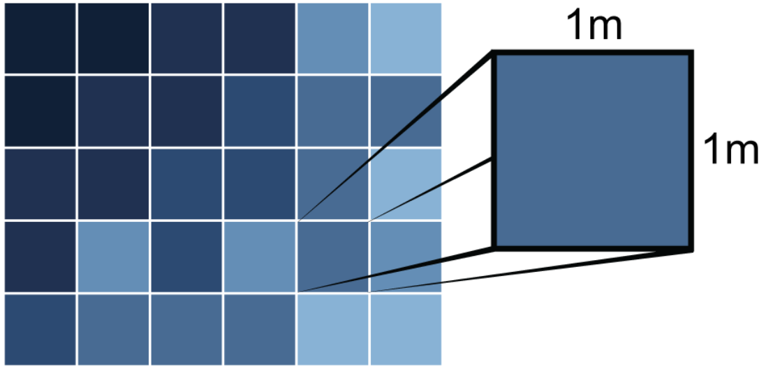

Figure 1 : Spatial Resolution (NEON Science, n.d.)

*The spatial resolution of a raster refers the size of each cell in meters. This size in turn relates to the area on the ground that the pixel represents. Source: National Ecological Observatory Network (NEON)*

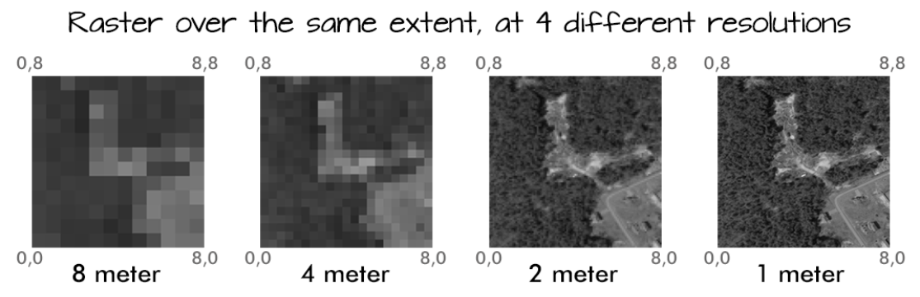

Figure 2 : A raster at the same extent, at 4 different resolutions (NEON Science, n.d.)

*A raster at the same extent with more pixels will have a higher resolution (it looks more "crisp"). A raster that is stretched over the same extent with fewer pixels will look more blury and will be of lower resolution (NEON Science, n.d.)*

In the field of remote sensing, the spatial resolution of digital elevation models (DEMs) is an important consideration. The pixel size of DEMs and derived variables is referred to as the spatial resolution, while the total area sampled or analyzed is referred to as the extent (Guillaume et al., 2021). The extent of the DEM can affect the calculations of derived variables, particularly in sites with heterogeneous terrain (Guillaume et al., 2021; Guillaume et al., 2021). It is important to carefully consider the required DEM extent to ensure the production of relevant derived variables**.**

In conclusion, the concept of spatial resolution is multifaceted, encompassing both the realm of digital photography and scientific imaging techniques. While the term consistently signifies the smallest discernible detail in an image, its implications and considerations vary based on the context. In remote sensing, it pertains to the real-world dimensions represented by each pixel, influenced by various factors such as altitude, sensor quality, and image capture angle. The delineation of spatial resolution in aerial imagery can be intuitively visualized through rasters, where every pixel corresponds to a definite ground area, as exemplified by NEON's illustrations. Concurrently, in specialized fields like atom probe tomography, spatial resolution's assessment remains complex, with challenges in definitions and measurement methodologies. Similarly, in the study of digital elevation models (DEMs), spatial resolution determines the granularity of terrain representation, where both the pixel size and the extent of the model bear significant implications for data interpretation. Collectively, while the term "spatial resolution" holds a consistent thematic core, its nuances and depths vary widely across

disciplines, each demanding its own set of meticulous considerations and understandings.

1. **If you were to create a raster data file showing the major land-use types in your county, which encoding method would you use? What method would you use if you were to encode a map of the major roads/rivers in your county and why?**

Land-use types in a county can be efficiently encoded using Run-Length Encoding (RLE) as a raster encoding method (Xin et al., 2019). RLE is a compression technique that reduces the amount of encoding required by encoding consecutive repeated values as a single value followed by the count of repetitions (Xin et al., 2019). This method is particularly effective for land-use types because they often exhibit spatial patterns with large areas of the same land-use type (Xin et al., 2019). By using RLE, the repetitive patterns can be encoded more efficiently, resulting in a smaller file size and faster processing time (Xin et al., 2019). On the other hand, for major roads and rivers, a vector representation would be more appropriate (Moehl et al., 2021). Vector representations store geometric information as a set of points, lines, and polygons, which accurately represent the shape and location of roads and rivers (Moehl et al., 2021).

Run-length encoding is a widely used compression technique for raster data. It involves utilizing pairs of values, commonly known as tuples, where each tuple consists of a pixel value and a count that signifies the consecutive occurrences of that pixel. The data is generated by systematically scanning the raster in a row-wise manner. When there is a transition in pixel values or when the end of a row is reached, a new tuple is created (Gitta, n.d.).

Describes the interior of an area by run-lengths, instead of the boundary

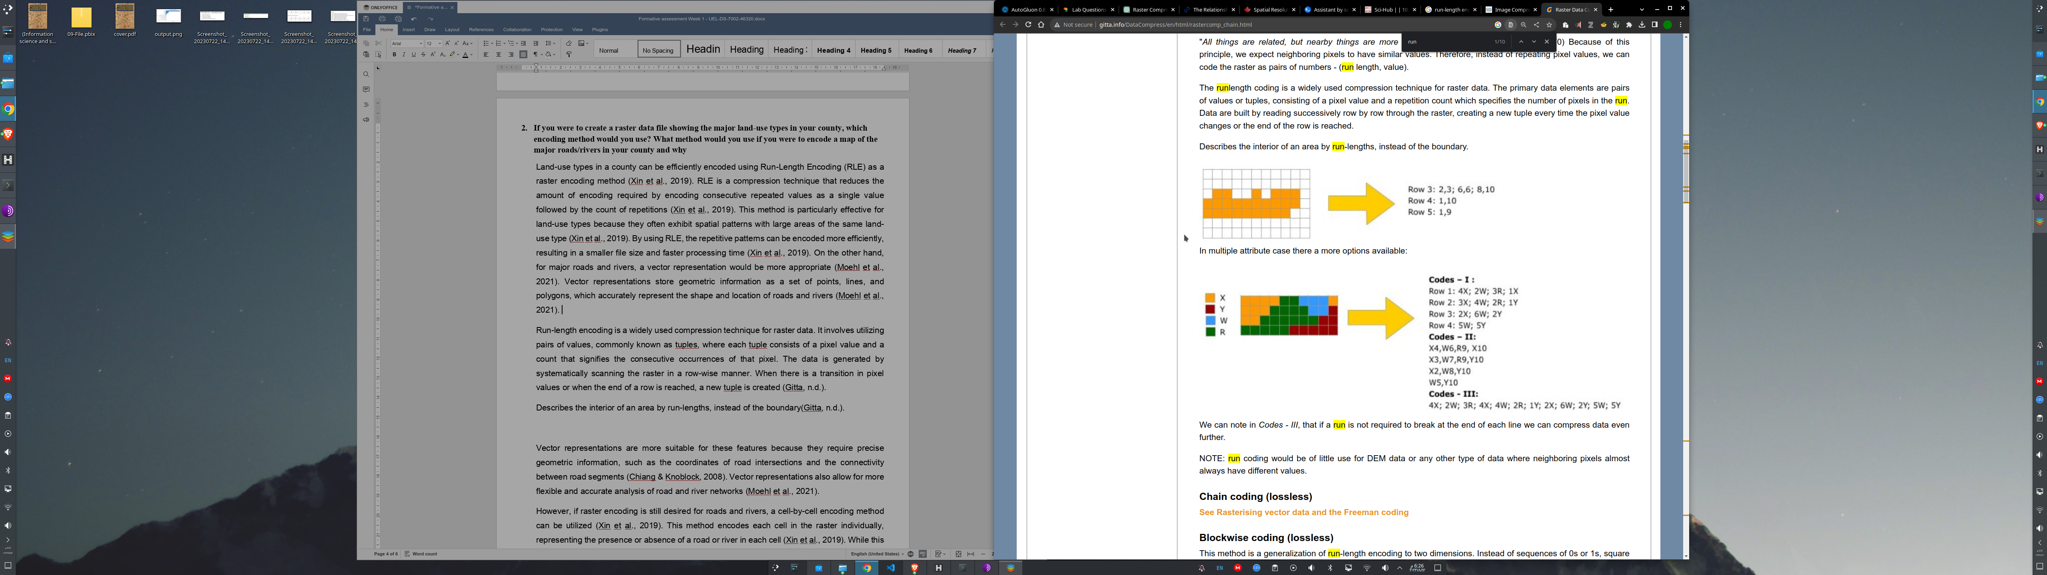

Figure 3 : Describing the interior of an area by run-lengths (Gitta, n.d.).

Vector representations are more suitable for these features because they require precise geometric information, such as the coordinates of road intersections and the connectivity

between road segments (Chiang & Knoblock, 2008). Vector representations also allow for more flexible and accurate analysis of road and river networks (Moehl et al., 2021).

However, if raster encoding is still desired for roads and rivers, a cell-by-cell encoding method can be utilized (Xin et al., 2019). This method encodes each cell in the raster individually, representing the presence or absence of a road or river in each cell (Xin et al., 2019). While this encoding method may result in larger file sizes compared to vector representations, it can still be useful in certain scenarios where a raster representation is preferred or necessary (Xin et al., 2019).

In summary, for land-use types in a county, RLE is an efficient raster encoding method due to the repetitive patterns often found in land-use data (Xin et al., 2019). For major roads and rivers, a vector representation is more appropriate, but if raster encoding is still desired, a cell-by-cell encoding method can be used (Xin et al., 2019).

1. **What is topology? Explain topological and non-topological data structures**

Topology is a branch of mathematics that deals with the properties of space that are preserved under continuous transformations, such as stretching, bending, and twisting (Bonderson & Lutchyn, 2011). It focuses on the study of the geometric properties of objects that remain unchanged even when the objects are deformed. In other words, topology is concerned with the intrinsic properties of space that are independent of the specific shape or size of the objects**.**

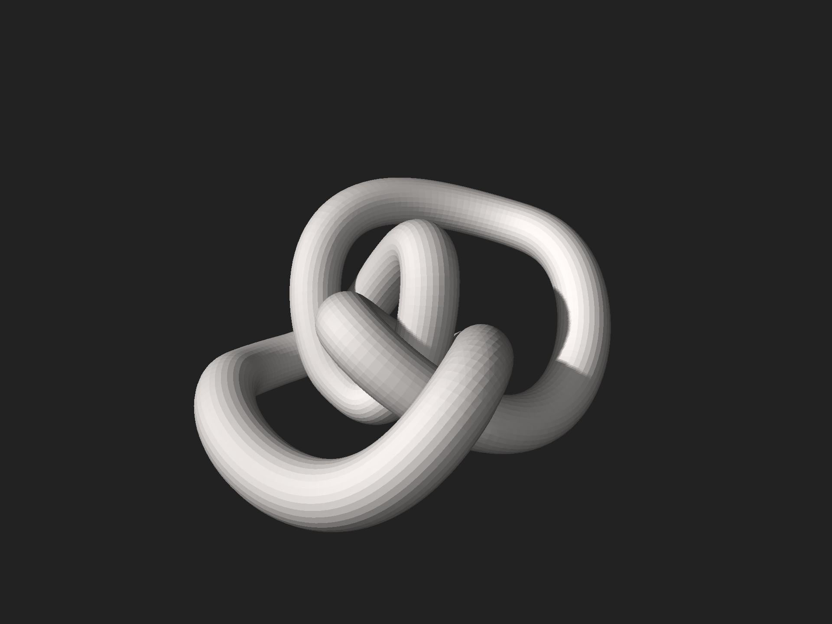

Figure 4 : A three-dimensional model of a figure-eight knot (Wikipedia, n.d.)

Topological data structures refer to data structures that are designed to preserve the topological properties of the underlying data (Padellini & Pierpaolo, 2017). These data structures are used to represent and manipulate data in a way that captures the connectivity and relationships between the data elements. They are particularly useful in applications where the topological properties of the data are important, such as in geographic information systems

(GIS), computer-aided design (CAD), and computational biology.

Non-topological data structures, on the other hand, do not explicitly capture the topological properties of the data. They are designed to efficiently store and retrieve data, but they do not provide built-in mechanisms for representing the connectivity and relationships between the data elements. Examples of non-topological data structures include arrays, linked lists, stacks, queues, and hash tables.

Topological data structures in spatial data analysis refer to the representation and organization of spatial objects based on their topological relationships. These data structures capture the connectivity, adjacency, and containment relationships between spatial objects (Ujang et al., 2019). They provide a way to efficiently store and query spatial data, enabling various spatial analysis tasks.

both topological and non-topological data structures have their own advantages and applications. Topological data structures are particularly useful when analyzing and querying spatial data based on their connectivity and adjacency relationships. They provide a more intuitive and efficient way to represent and analyze spatial objects. Non-topological data structures, on the other hand, are more suitable for tasks that primarily involve geometric properties and measurements of the objects. In summary, topology is a branch of mathematics that studies the properties of space that are preserved under continuous transformations. In spatial data analysis, topological data structures capture the connectivity and adjacency relationships between spatial objects, while non-topological data structures focus more on the geometric properties of the objects. Both types of data structures have their own applications and advantages in spatial data analysis.

1. **What are raster and vector GIS models? Give an example of objects representing point, line or polygon?**

Raster and vector GIS models are two different ways of representing spatial data in a geographic information system (GIS). A raster GIS model represents spatial data as a grid of cells, where each cell contains a value that represents a specific attribute or characteristic of the area it covers (Okabe & Miller, 1996). This model is commonly used for continuous data, such as elevation or temperature, where the values can vary continuously across the landscape. Each cell in a raster grid is assigned a unique value, and the resolution of the grid determines the level of detail in the representation. For example, a high-resolution raster grid may have smaller cells and therefore provide more detailed information about the landscape.

On the other hand, a vector GIS model represents spatial data as discrete objects with defined boundaries (Monteiro et al., 2005). These objects can be points, lines, or polygons. Points represent specific locations on the Earth's surface, such as the coordinates of a city or a sampling site. Lines represent linear features, such as roads or rivers, and are defined by a series of connected points. Polygons represent areas or regions, such as the boundaries of countries or the extent of a forest. Each object in a vector GIS model is associated with attributes that provide additional information about the object, such as its name or population.

To illustrate this, let's consider some examples of objects representing point, line, and polygon features:

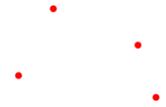

1. Point: The coordinates of a city, such as the latitude and

longitude of a location

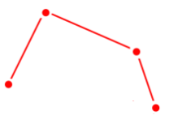

2. Line: The path of a river, represented by a series of

connected points along its course

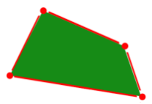

3. Polygon: The boundary of a national park, represented

by a closed shape with multiple vertices

In summary, raster and vector GIS models are two different ways of representing spatial data in a GIS. The raster model uses a grid of cells to represent continuous data, while the vector model represents discrete objects with defined boundaries. Examples of objects in a vector GIS model include points, lines, and polygons, which can represent various features on the Earth's surface.

1. **What are geospatial models? Explain raster and vector GIS models.**

Geospatial models are mathematical representations of the Earth's surface and its

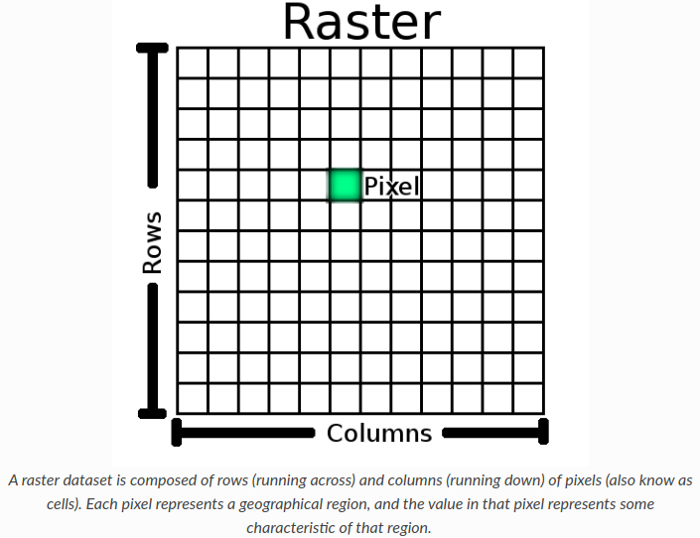

features in a geographic information system (GIS). These models are used to analyze and interpret spatial data, allowing researchers to understand and make predictions about various phenomena and processes that occur on the Earth's surface.

There are two main types of geospatial models: raster and vector GIS models.

Raster GIS models represent spatial data as a grid of cells, where each cell has a value that represents a specific attribute or characteristic of the Earth's surface.

This type of model is commonly used to represent continuous data, such as elevation, temperature, or precipitation. Raster models are well-suited for analyzing spatial variability and performing suitability assessments (Brookes, 2001). They are also used in numerical modeling and simulation, as the grid structure can be used as a finite difference mesh (Wu et al., 2013). Raster models are particularly useful for spatial analysis and data mining (Huang et al., 2008).

Figure 5 :QGIS Documentation, 2019

Vector GIS models, on the other hand, represent spatial data as points(see Figure 6) , vector (see Figure 6), and polygons(see Figure 8).

Points represent discrete locations, lines represent linear features such as roads or rivers, and polygons represent areas such as land parcels or administrative boundaries.Vector models are commonly used to represent discrete or categorical data, such as land use or land cover types. They are well-suited for accurate geo-processing and maintaining the shape characteristics of features (Huang et al., 2008). Vector models are often used for thematic mapping and land management analysis (Donnelly, 2010).

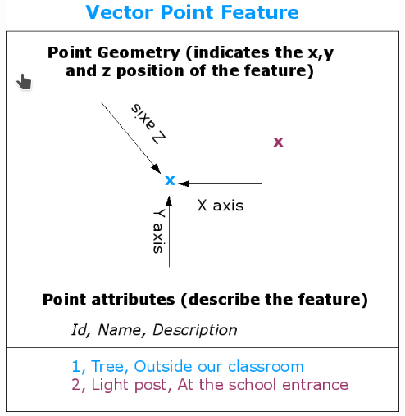

Figure 6 : Point Feature

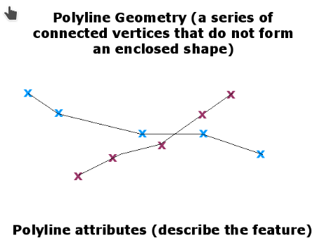

Figure 7 : Vector Feature

Both raster and vector GIS models have their advantages and disadvantages. Raster models are more suitable for representing continuous data and analyzing spatial variability, while vector models are better for representing discrete or categorical data and maintaining shape characteristics. Raster models are

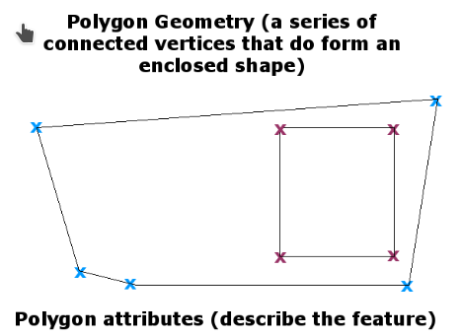

Figure 8 : Polygon Feature

computationally efficient for certain types of analysis, such as suitability assessments, while vector models provide higher accuracy (Meneses et al., 2018). The choice between raster and vector models depends on the specific research question and the type of data being analyzed.

Raster to vector conversion can be achieved by digitizing vector features backdrop layer.Another approach is to use advanced computer programs to automatically extract vector features from images. Some features such as roads show in an image as a sudden change of colour from neighbouring pixels. The computer program looks for such colour changes and creates vector features as a result. This kind of functionality is normally only available in very specialised (and often expensive) GIS software (QGIS Documentation.,2019)**.**

Sometimes it is useful to convert vector data into raster data. One side effect of this is that attribute data (that is attributes associated with the original vector data) will be lost when the conversion takes place. Having vectors converted to raster format can be useful though when you want to give GIS data to non GIS users. With the simpler raster formats, the person you give the raster image to can simply view it as an image on their computer without needing any special GIS software (QGIS Documentation.,2019)**.**

In summary, geospatial models are mathematical representations of the Earth's surface and its features in a GIS. Raster GIS models represent spatial data as a grid of cells, while vector GIS models represent spatial data as points, lines, and polygons. Each type of model has its advantages and disadvantages, and the choice between them depends on the specific research question and the type of data being analyzed.

1. **Explain the advantage and disadvantages of raster and vector GIS models. Compare both the models.**

Raster and vector models are two commonly used models in Geographic Information Systems (GIS) for representing spatial data. Each model has its own advantages and disadvantages, and understanding these can help in choosing the appropriate model for specific applications. The raster model represents spatial data as a regular grid of cells, where each cell has a value that represents a specific attribute or characteristic of the geographic area it covers. This model is based on the concept of a pixel, similar to how images are represented in digital form. One advantage of the raster model is its simplicity and ease of use. It is well-suited for representing continuous data, such as elevation or temperature, as it can capture fine-grained variations in the attribute being represented. Raster models also allow for efficient storage and processing of large datasets, as they can be easily divided into smaller tiles or chunks. Additionally, raster models are commonly used in remote sensing applications, as they can directly represent satellite or aerial imagery (Meneses et al., 2018; Wu et al., 2013; Farkas, 2019).

However, there are also disadvantages to using the raster model. One major limitation is its inability to represent discrete or vector-like features accurately. Raster data is inherently less precise than vector data, as it represents features as a collection of cells rather than as individual points, lines, or polygons. This can lead to loss of detail and accuracy, especially when representing complex or irregular shapes. Another disadvantage is the storage requirements of raster data. Since each cell in a raster grid requires storage, datasets with high spatial resolution or large extents can quickly become memory-intensive (Deckers et al., 2009; Takeyama, 1997).

On the other hand, the vector model represents spatial data as discrete geometric objects, such as points, lines, and polygons. Each object is defined by its coordinates and attributes, allowing for precise representation of features and their relationships. Vector models are well-suited for representing discrete features, such as roads, buildings, and administrative boundaries. They can accurately capture the shape, size, and topology of these features, making them suitable for detailed analysis and modeling. Vector models also allow for efficient storage of attribute data, as each object can have its own set of attributes (Bang et al., 2015; Barbeito et al., 2014).

However, there are also disadvantages to using the vector model. One limitation is its difficulty in representing continuous or raster-like data. While vector models can approximate continuous data by using a large number of points or lines, this can result in large datasets and increased processing times. Another disadvantage is the complexity of managing and processing vector data. Topological relationships between objects, such as adjacency or containment, can be computationally expensive to calculate. Additionally, vector data can be more challenging to store and process efficiently, especially for large datasets (Deckers et al., 2009; Takeyama, 1997).

In summary, the raster model offers simplicity, ease of use, and efficient storage and processing for representing continuous data, but it may lack precision and accuracy for representing discrete features. The vector model provides precise representation of discrete features and their relationships, but it can be more complex to manage and process, especially for continuous or raster-like data. The choice between raster and vector models depends on the specific requirements of the application and the nature of the spatial data being represented.

1. **Explain data structures in detail.**

Spatial data structures are a fundamental component of managing and analyzing spatial data. They enable efficient storage, retrieval, and analysis of spatial information in various fields such as geography, computer science, and urban planning (Richardson, 2014).

There are different types of spatial data structures, each designed to handle specific types of spatial data and operations. Some commonly used spatial data structures include spatial or geometric data types, spatial grids, spatial trees, and spatial lattices.

Spatial or geometric data types provide a basic abstraction for modeling the geometric structure of objects in space and building relationships among objects, properties, and their operations (Kawatra & Uppal, 2015).These data types are used to represent points, lines, polygons, and other geometric shapes in a spatial database. They allow for efficient storage and retrieval of spatial data and support various spatial operations, such as distance calculations, intersection tests, and spatial queries.

Spatial grids are another type of spatial data structure that divides the spatial domain into a regular grid of cells. Each cell in the grid represents a specific area or location in space, and spatial data is associated with the cells.

Spatial grids are commonly used for raster data, where each cell stores a value representing a specific attribute or property (Alpkocak & Ozkarahan, 1997).

They are efficient for storing and analyzing large-scale spatial data, such as satellite imagery or elevation data. Spatial trees, such as R-trees and quad trees, are hierarchical data structures that partition the spatial domain into smaller regions or nodes. Each node in the tree represents a subset of the spatial data, and the tree structure allows for efficient spatial indexing and searching (Dubey et al., 2004).

Spatial trees are commonly used for point data and spatial indexing in spatial databases. They enable fast retrieval of data based on spatial proximity and support operations like range queries and nearest neighbor searches.

Spatial lattices are a type of spatial data structure that represents spatial data on a regular lattice or grid. Each cell in the lattice represents a specific location in space, and spatial data is associated with the cells. Spatial lattices are commonly used for analyzing spatial patterns and relationships in lattice data, such as land cover data or population density data (Kurihara & Ishioka, 2022). They enable the analysis of spatial autocorrelation, clustering, and other spatial patterns.

Spatial data structures play a crucial role in various applications and domains. In geographic information systems (GIS), spatial data structures are used to store and analyze spatial data, enabling tasks like spatial querying, spatial analysis, and map visualization (Kawatra & Uppal, 2015). In urban planning and transportation, spatial data structures are used to model and analyze the spatial distribution of infrastructure, population, and other urban features (Zhang et al., 2020). In emergency management, spatial data structures are used to build comprehensive and interconnected databases for efficient information retrieval and decision-making (Bhanumurthy et al., 2014).

In summary, spatial data structures are essential tools for managing and analyzing spatial data. They provide efficient storage, retrieval, and analysis of spatial information, enabling various applications in fields like geography, computer science, and urban planning. Different types of spatial data structures, such as spatial or geometric data types, spatial grids, spatial trees, and spatial lattices, are used to handle different types of spatial data and operations. These structures facilitate tasks like spatial querying, spatial analysis, and spatial pattern recognition, contributing to the advancement of spatial data science and related disciplines.**References**

Alpkocak, A. and Ozkarahan, E. A. (1997). A Spatial Grid File For Multimedia Data Representation. Lecture Notes in Computer Science, 156-167. https://doi.org/10.1007/3-540-63371-5_17

Apriyanto, D., Jaya, I. N. S., Puspaningsih, N. (2019). Examining the Object-based And Pixel-based Image Analyses For Developing Stand Volume Estimator Model. Indonesian Journal of Electrical Engineering and Computer Science, 3(15), 1586. https://doi.org/10.11591/ijeecs.v15.i3.pp1586-1596

Barbeito, A., Painho, M., Cabral, P., O’Neill, J. S. (2014). An Integrated Model Of the Human Body. Atas Da 14ª Conferência Da Associação Portuguesa De Sistemas De Informação. https://doi.org/10.18803/capsi.v14.30-45

Bhanumurthy, V., Rao, K. J., Rao, S. V., Chandra, P., Vidhyasagar, J., Diwakar, P. G., … & Dadhwal, V. K. (2014). Enabling Heterogenous Multi-scale Database For Emergency Service Functions Through Geoinformation Technologies. The International Archives of the Photogrammetry, Remote Sensing and Spatial Information Sciences, (XL-8), 7-14. https://doi.org/10.5194/isprsarchives-xl-8-7-2014

Bonderson, P. & Lutchyn, R. M. (2011). Topological Quantum Buses: Coherent Quantum Information Transfer between Topological and Conventional Qubits. Phys. Rev. Lett., 106(13), 130505. https://doi.org/10.1103/PhysRevLett.106.130505

Brookes, C. J. (2001). A Genetic Algorithm For Designing Optimal Patch Configurations In Gis. International Journal of Geographical Information Science, 6(15), 539-559. https://doi.org/10.1080/136588101316907227

Farkas, G. K. (2019). Possibilities Of Using Raster Data In Client‐side Web Maps. Transactions in GIS, 1(24), 72-84. https://doi.org/10.1111/tgis.12588

Gault, B., Moody, M. P., Geuser, F. D., Fontaine, A. L., Stephenson, L. T., Haley, D., … & Ringer, S. P. (2010). Spatial Resolution In Atom Probe Tomography. Microscopy and Microanalysis, 1(16), 99-110. https://doi.org/10.1017/s1431927609991267

Guillaume, A. S., Leempoel, K., Rochat, E., Rogivue, A., Kasser, M., Gugerli, F., … & Joost, S. (2021). Multiscale Very-high Resolution Topographic Models In Alpine Ecology: Pros and Cons Of Airborne Lidar And Drone-based Stereo-photogrammetry Technologies.. https://doi.org/10.20944/preprints202103.0581.v1

Huang, L., Fei, L., Zheng, B. (2008). A Raster: Relation-vector: Entity Integrated Approach For Spatial Geographic Feature Retrieve. SPIE Proceedings. https://doi.org/10.1117/12.813230

Meneses, B. M., Reis, E., Reis, R. L., Vale, M. G. R. (2018). The Effects Of Land Use and Land Cover Geoinformation Raster Generalization In The Analysis Of Lucc In Portugal. ISPRS International Journal of Geo-Information, 10(7), 390. https://doi.org/10.3390/ijgi7100390

Moehl, J., Weber, E., McKee, J. (2021). A Vector Analytical Framework For Population Modeling. The International Archives of the Photogrammetry, Remote Sensing and Spatial Information Sciences, (XLVI-4/W2-2021), 103-108. https://doi.org/10.5194/isprs-archives-xlvi-4-w2-2021-103-2021

Monteiro, C., Ramirez-Rosado, I. J., Miranda, V., Zorzano-Santamaria, P. J., Garcia-Garrido, E., Fernandez-Jimenez, L. (2005). Gis Spatial Analysis Applied To Electric Line Routing Optimization. IEEE Transactions on Power Delivery, 2(20), 934-942. https://doi.org/10.1109/tpwrd.2004.839724

NEON Science. (n.d.). Raster Resolution, Extent, and Pixels. NEON Learning Hub Tutorials. https://www.neonscience.org/resources/learning-hub/tutorials/raster-res-extent-pixels-r. Accessed August 12, 2023.

Nugroho, A. K., Permadi, I., Faturrahim, M. (2022). Improvement Of Image Quality Using Convolutional Neural Networks Method. Scientific Journal of Informatics, 1(9), 95-103. https://doi.org/10.15294/sji.v9i1.30892

Okabe, A. and Miller, H. J. (1996). Exact Computational Methods For Calculating Distances Between Objects In a Cartographic Database. Cartography and Geographic Information Systems, 4(23), 180-195. https://doi.org/10.1559/152304096782438846

Padellini, T. and Pierpaolo, B. (2017). Supervised Learning With Indefinite Topological Kernels.. https://doi.org/10.48550/arxiv.1709.07100

QGIS Documentation. (2019). Raster Data. In Gentle Introduction to GIS. Retrieved August 12, 2023, from https://docs.qgis.org/3.4/en/docs/gentle_gis_introduction/raster_data.html#id1

Ujang, U., Castro, F. A., Azri, S. (2019). Abstract Topological Data Structure For 3d Spatial Objects. ISPRS International Journal of Geo-Information, 3(8), 102. https://doi.org/10.3390/ijgi8030102

Wikipedia. (n.d.). Topology. In Wikipedia. Retrieved August 12, 2023, from https://en.wikipedia.org/wiki/Topology

Wu, J., Chen, G., Zheng, L., Zhang, Y. (2013). Gis-based Numerical Modelling Of Debris Flow Motion Across Three-dimensional

# **2.Week 2 Formative Assessment**

## 2.1 Introduction

The second week of our Spatial Data Analysis course marked a significant transition, moving from basic understanding to a deeper exploration of spatial relations within Geographic Information Systems (GIS). This deeper dive was emblematic of the complexity and vastness of spatial data analysis, shedding light on the ways we perceive, interpret, and utilize geographical relationships.

A plethora of questions was tailored for this week's assessment to gauge and challenge our comprehension. These questions were not mere academic exercises but an intricate weave of practical scenarios that spatial analysts might encounter in real-world applications. They nudged learners to visualize, dissect, and articulate spatial relationships, paving the way for nuanced spatial queries and interpretations.

As we navigate through the reflections of this week, we will recount the learning trajectory – the aha moments, the challenges, the transformative insights, and the synthesis of theory into practice. The narrative seeks to capture the essence of Week 2, highlighting both the academic rigor and the practical ramifications of our explorations.

## 2.2 Assessment Summaries

For Week 2, the assessment delved deeper into the realm of spatial relations and the intricacies of spatial queries within GIS. At the forefront were questions designed to distinguish various spatial relations. While some relations, like distance-based or topological, might be familiar to those with basic GIS knowledge, others like spatial autocorrelation brought a more nuanced layer to the discussion. The aim was not merely to identify these relations but to comprehend their significance and applications in the GIS framework.

The practical application of this theoretical knowledge was tested with scenarios like determining Points of Interest (POIs) within a designated area. This kind of question illuminated the bridge between knowing a concept and applying it in a real-world context, reinforcing the importance of both theoretical understanding and practical proficiency. Furthermore, the questions ventured into understanding the very fabric of GIS – what spatial information truly entails and how it can be systematically divided and queried.

Perhaps the pinnacle of this week's assessment was the multifaceted spatial query regarding buildings, their parcel areas, and their proximity to highways. Such a question encapsulates the essence of spatial analysis: dissecting multiple layers of spatial data to derive meaningful conclusions. It highlights the complexity and richness of real-world spatial problems and underscores the value of adeptly formulating and executing spatial queries.

In sum, the Week 2 assessment offered a holistic view of spatial relations and spatial queries. It deftly combined foundational knowledge with real-world applications, ensuring a robust understanding of the topic. The array of questions served as a testament to the multifaceted nature of spatial data analysis and its vast potential in addressing diverse spatial challenges.

## 2.3 Key Findings or Insights

During Week 2, a series of enlightening findings and insights emerged from the exploration of spatial relations and their implementation in spatial queries within GIS. Firstly, it became evident that spatial relations are not just mere theoretical constructs; they are integral tools in shaping the way we analyze, understand, and visualize spatial data. The clear distinction among various spatial relations, such as distance-based, topological, and direction relations, elucidated their unique roles in spatial analysis, emphasizing that each type serves a distinct purpose and offers different insights.

One of the most compelling insights came from the practical scenario of selecting Points of Interest (POIs) within a specified region. It underscored the significance of translating real-world spatial problems into structured spatial queries. This translation isn’t just about applying technical GIS skills but involves a nuanced understanding of spatial contexts. For instance, the exercise on selecting POIs emphasized that mere knowledge of the tool isn't sufficient; one must comprehend the spatial context and intricacies involved to achieve accurate results.

Furthermore, the question regarding the nature of spatial information in GIS offered a profound understanding of the breadth and depth of spatial data. It's not merely about coordinates or physical landmarks; spatial data is a rich tapestry of relationships, patterns, and processes. The inquiry into different approaches for formulating queries highlighted the flexibility and adaptability of GIS. Different problems might necessitate varied approaches, and the capability to discern the most suitable one is pivotal.

Lastly, the multifaceted spatial query about building locations, parcel sizes, and proximity to highways provided an invaluable lesson. It was a vivid representation of the interconnectedness of spatial elements and the layers of complexity inherent in real-world spatial problems. This question reinforced that spatial data analysis is often about synergizing multiple pieces of data to weave a comprehensive narrative or to derive holistic solutions.

In essence, Week 2 was a journey that traversed from foundational concepts to intricate real-world applications, each step offering a deeper understanding and appreciation of the power and potential of spatial data analysis.

## 2.4 Challenges and Solutions

During the Week 3 Formative Assessment, I encountered several challenges that tested my understanding and application of the course material. One of the main challenges was understanding the different types of variables and their classifications. Initially, I found it difficult to distinguish between nominal, ordinal, and interval/ratio variables, particularly in complex, real-world scenarios.

During the second week's assessment, a myriad of challenges arose that required critical thinking and application of theoretical knowledge in spatial data analysis. One of the initial challenges was discerning which spatial relations are typically not utilized in spatial queries. The identification of the outlier, "Spatial autocorrelation", demanded a comprehensive grasp of spatial relationships and their usual applications.

Another intricate scenario involved translating theoretical knowledge into a practical application. Specifically, when presented with a GIS dataset of Points of Interest (POIs) and asked to select only those within a pre-defined study area. The solution necessitated not only the understanding of spatial data but also the practical skills to translate this data into actionable GIS tasks.

Furthermore, when tasked with the question concerning buildings based on parcel area and their proximity to a highway, it required a multifaceted approach. The challenge lay in integrating two different spatial criteria (area and distance) to generate a coherent and actionable spatial query. The solution was realized by breaking down the question into its basic components and sequentially applying spatial filters to arrive at the desired outcome.

In essence, the week's assessment was a valuable exercise in bridging the gap between theoretical knowledge and its practical application, and it further underscored the importance of understanding the nuances of spatial relationships and queries in GIS.

## 2.5 Skills and Knowledge Gained

The exploration during the second week of the course provided a deep dive into the intricacies of spatial relations and the utility of spatial queries in Geographic Information Systems (GIS). Several skills and knowledge areas were notably enriched:

Analytical Proficiency: The exercises, especially those centered on formulating spatial queries based on given criteria, sharpened the analytical thinking capabilities. Being able to dissect a problem, understand the spatial parameters involved, and apply the right GIS tools or functions is a skill that was significantly honed.

Understanding of Spatial Relationships: Differentiating between various spatial relations, such as distance-based, topological, and direction relations, reinforced the foundational understanding of how objects relate within a spatial environment. Recognizing "Spatial autocorrelation" as a concept not typically used in spatial queries was particularly enlightening.

Practical Application of GIS Tools: The task of selecting Points of Interest (POIs) based on specific criteria exemplified the hands-on application of GIS tools. This not only refined the technical skills but also bridged the gap between theoretical knowledge and real-world applications.

Formulating Complex Spatial Queries: The question about buildings, parcel areas, and their relation to highways introduced the complexity of merging multiple spatial criteria into a single query. This exercise enriched the capability to think multidimensionally and apply multiple filters in GIS to derive actionable insights.

In sum, the second week’s assessment acted as a crucible, melding theoretical concepts with practical scenarios, ensuring a robust understanding of spatial relationships and the power of spatial queries in GIS.

## 2.6 Future Applications

The insights and skills acquired during Week 2's exploration of spatial relations and queries open the door to a plethora of applications in various domains. Here's a projection into some potential future applications:

Urban Planning and Development: Spatial queries can be invaluable in urban planning, assisting in the identification of suitable locations for new infrastructures based on predefined criteria, such as distance from essential services or avoiding ecologically sensitive zones.

Environmental Studies: By leveraging the capability to select points of interest within specific regions, researchers can track environmentally sensitive areas, endangered species habitats, or regions prone to natural calamities, aiding in conservation efforts and disaster management planning.

Transportation and Logistics: Understanding spatial relationships is key to efficient route planning. For instance, locating all commercial zones within a certain distance from highways can guide logistics planning and infrastructure development.

Real Estate and Land Use: By using the complex spatial query capabilities, real estate developers can identify parcels of land that meet specific criteria, such as proximity to amenities, size, and zoning regulations, optimizing their investments and development strategies.

Crime Analysis and Public Safety: Law enforcement agencies can utilize spatial queries to track crime hotspots, study patterns, and allocate resources more efficiently based on real-time data and historical trends.

Healthcare: Public health officials can map out the spread of diseases or the availability of medical facilities in specific areas, ensuring resources are directed where they're most needed.

As technology advances and datasets become even more intricate, the potential applications of spatial relationships and queries in GIS are boundless. The foundational knowledge gained in Week 2 is not only pertinent to current scenarios but also forms a bedrock for future innovations in the realm of spatial data analysis.

## 2.7 Conclusion

Week 2's journey into the world of spatial relations and queries in GIS brought to light the intricate dance of theory and application. From the nuances of distinguishing between various spatial relationships to the practicalities of crafting spatial queries, the importance of this facet of spatial data analysis became ever more apparent.

Spatial queries, as revealed, aren't just technical jargon reserved for GIS professionals; they're pivotal tools that drive decisions across industries. They shape cities, inform conservation strategies, dictate transportation routes, and even influence where businesses set up shop. It's not just about plotting points on a map, but weaving a narrative of interrelations, proximities, and connections.

Reflecting upon the assessment, the synthesis of knowledge garnered presents an exciting premise: that with the right tools and understanding, we can interpret, predict, and shape the spatial stories that mold our world. As we progress in this academic endeavor, each week

further reinforces the profound impact and potential of spatial data analysis in comprehending and bettering our interconnected world.

## Week 2 Formative Assessment Submission

1. **Which of the following is not a spatial relation that can be used in spatial queries?**
   1. **◼ Distance-based relation**
   2. **◼ Spatial autocorrelation**
   3. **◼ Topological relation**
   4. **◼ Direction relation**

The spatial relation that is not listed as one of the options for spatial queries is "Spatial autocorrelation." Spatial autocorrelation refers to the statistical analysis of spatial data to determine if there is a pattern of similarity or dissimilarity among neighboring locations (Hellige & Michimata, 1989). It is not a specific type of spatial relation that can be used in spatial queries.

The other options listed, namely "Topological relation," "Distance-based relation," and "Direction relation," are all valid spatial relations that can be used in spatial queries.

Topological relation refers to the spatial relationship between objects based on their connectivity, adjacency, containment, or intersection (Fu et al., 2020). It is commonly used in spatial analysis and spatial reasoning tasks.

Distance-based relation refers to the spatial relationship between objects based on their proximity or distance from each other (Fu et al., 2020). It is often used in spatial queries such as nearest neighbor queries or range queries.

Direction relation refers to the spatial relationship between objects based on their relative orientation or direction (Fu et al., 2020). It is used to describe the directional relationship between objects, such as north, south, east, west, or angles of rotation.

**In summary, spatial autocorrelation is not a specific spatial relation** that can be used in spatial queries. The other options, topological relation, distance-based relation, and direction relation, are valid spatial relations that can be used in spatial queries.

1. **There is a GIS dataset of points of interest (POIs) in a region, and you would like to select only those located within a pre-defined study area. How will you translate it into a spatial query?**

If I want to select POIs located within a predefined study area, I'd typically use a "within" or "contains" spatial relation depending on my GIS tool or software.

For instance, if I were using a SQL-like language or platform that supports spatial queries, it might be as below:

SELECT

*

FROM

POIs

WHERE

ST_Within(POIs.geometry, StudyArea.geometry);

Here:

* + POIs is the table or dataset of Points of Interest.
  + StudyArea is the predefined study area.

ST_Within is a function that checks if one geometry (in this case, the POIs) is

* + within another geometry (the study area).

The exact syntax and function names may vary based on the GIS software or database system I'm using. I should always refer to the specific documentation of the software in question for precise details.

Considering a city named "GeoCity." In GeoCity, there are several Points of Interest (POIs) such as restaurants, museums, parks, and theaters. Now, let's assume we have a neighborhood in GeoCity named "Maple District," and we want to find out which of these POIs are located within Maple District.

**POIs Table:**

|  |  |  |  |
| --- | --- | --- | --- |
| D | Name | Type | Geometry (Lat, Long) |
| 1 | GeoCafe | Restaurant | (34.123, -75.456) |
| 2 | HistoryHub Museum | Museum | (34.126, -75.458) |
| 3 | Central Park | Park | (34.125, -75.454) |
| 4 | Starscreen Theater | Theater | (34.122, -75.459) |

**StudyArea** Table **(representing Maple District):**

|  |  |  |
| --- | --- | --- |
| ID | Area Name | Geometry (Polygon) |
| 1 | Maple District | Polygon defined by a set of coordinates that draw its boundaries |

Using the spatial query we previously discussed:

SELECT

FROM POIs

WHERE

ST_Within(POIs.geometry, StudyArea.geometry);

The result of this query would give us the POIs located within Maple District.

In our hypothetical example, let's assume all of the given POIs are within Maple District. So, the result would be the entire POIs table.

However, if, say, only GeoCafe and Central Park were within Maple District, then only those two entries would be returned by the spatial query.

Given our hypothetical scenario and assuming only GeoCafe and Central Park are within the Maple District based on their geometries, the result of the spatial query would look like this:

**Result Table:**

|  |  |  |  |
| --- | --- | --- | --- |
| ID | Name | Type | Geometry (Lat, Long) |
| 1 | GeoCafe | Restaurant | (34.123, -75.456) |
| 3 | Central Park | Park | (34.125, -75.454) |

above table represents the subset of the original POIs table, filtered to only include the points of interest that fall within the boundaries of Maple District. The ID, Name, Type, and Geometry columns provide information on each POI, as specified in the original table. The exact appearance and formatting of this table may vary based on the GIS software or database system being used, but conceptually, it would look similar to the table above.

1. **What does the spatial information in a GIS mainly consist of?**

Spatial information in a Geographic Information System (GIS) mainly consists of two core components:

1. **Spatial Data (or Geometry)**
   * Points: Represent specific locations, like the locations of fire hydrants, landmarks, or trees. Each point is defined by a pair of (x, y) coordinates, and in the case of 3D data, (x, y, z) coordinates.
   * Lines (or Polylines): Represent linear features and their shape, such as roads, streams, or electrical lines. They are a connected sequence of points.
   * Polygons: Represent areas, like the boundaries of a city, a lake, or forested regions. They are a closed sequence of points that define an area.
   * Multi-part Features: Some spatial data, like archipelagoes, may be represented as multi-part features, which allow multiple geometries to be considered as a single feature.
   * Raster Data: Grid-based data where each cell in the grid has a value representing information like elevation, temperature, or land cover type.
2. **Attribute Data**

This is the information that describes the properties or characteristics of the spatial features. For example, for a point representing a school, the attribute data might include the school's name, number of students, grades offered, and so on.

* + Attribute data is typically stored in tables, with each row representing a feature and each column representing an attribute or characteristic of that feature. These tables are linked to the spatial data, allowing users to query and analyze features based on their spatial and non-spatial characteristics.

Together, the spatial data (geometry) and the attribute data provide a comprehensive view of the information represented in a GIS. This combination allows for intricate analyses and visualizations, such as producing maps that highlight regions of interest based on specific criteria or running queries to understand spatial relationships and patterns.

1. **How can space related information be divided?**

Space-related information, especially within the context of Geographic Information Systems (GIS) and spatial analysis, can be divided based on several criteria. Here's a generalized breakdown:

1. **Based on Dimensionality:**
   1. 0D (Zero Dimensional): Points, representing specific locations.
   2. 1D: Lines or polylines, representing linear features.
   3. 2D: Polygons, representing areal or planar features.
   4. 3D: Volumes, representing three-dimensional features.
   5. 4D: Space-time, where the temporal dimension is considered alongside the three spatial dimensions.
2. **Based on Representation:**
   1. Vector Data: Uses points, lines, and polygons to represent the shape and location of geographic features.
   2. Raster Data: Represents data as a matrix of cells or pixels, often used for continuous data like elevation or temperature.
3. **Based on Nature of Data:**
   1. Discrete Data: Features that are distinct from one another, like buildings or roads.
   2. Continuous Data: Data that exists everywhere, like temperature or elevation.
4. **Based on Source:**
   1. Primary Data: Obtained directly from the field or source, such as survey data.
   2. Secondary Data: Derived or compiled from other sources, often processed or analyzed data.
5. **Based on Temporality:**
   1. Static Data: Remains unchanged over time, such as land ownership boundaries.
   2. Dynamic Data: Changes over time, like the movement of vehicles or changing weather patterns.
6. **Based on Scale/Resolution:**
   1. Macro-scale Data: Broad view, often representing large areas like continents or countries (e.g., 1:1,000,000 scale data).
   2. Meso-scale Data: Intermediate view, like state or regional maps.
   3. Micro-scale Data: Detailed view, such as city or street-level data.
7. **Based on Topology:**

Topological Data: Contains information about spatial relationships, like

* 1. connectivity and adjacency. Common in certain vector databases.
  2. Non-topological Data: Lacks explicit information about spatial relationships.

1. **Based on Usage:**
   1. Base Data: Provides the foundational spatial context, like a base map.
   2. Thematic Data: Focuses on specific topics or themes, such as population density, vegetation cover, or crime rates.

Dividing space-related information in these ways facilitates the understanding, management, and analysis of the data. Knowing the nature and type of spatial data is crucial for ensuring appropriate processing and analysis techniques are applied.

1. **Which approaches can be used to formulate a query?**

In QGIS (Quantum GIS), a popular open-source GIS application, users can formulate queries primarily through two main tools: the "Attribute Table" and the "Select by Location" tool. Here's a breakdown of approaches for query formulation in QGIS:

1. **Attribute Query:**

Attribute Table: Users can open the attribute table of a layer and use the "Select features using an expression" tool. This lets users query the data based on attribute values using a structured expression.

For example, if you have a layer of cities, you can formulate a query like "population" > 10,000,000 and city is shall be capital.

Layer Styling: Though not strictly a query in the traditional sense, you can use rule-based styling to visually represent features based on attribute conditions. Steps are shown as below

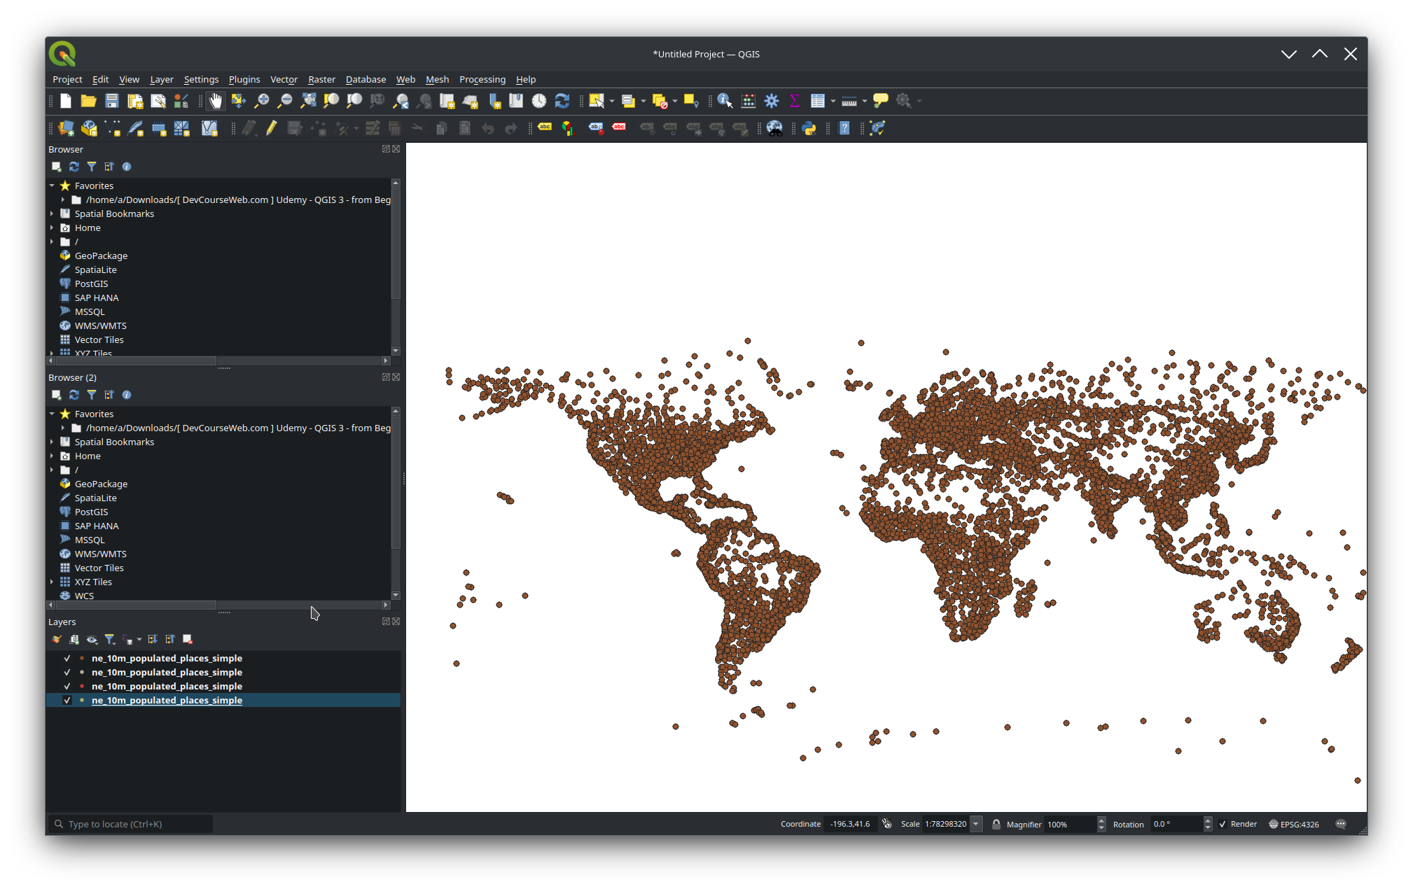

Figure 1 : Select population layer

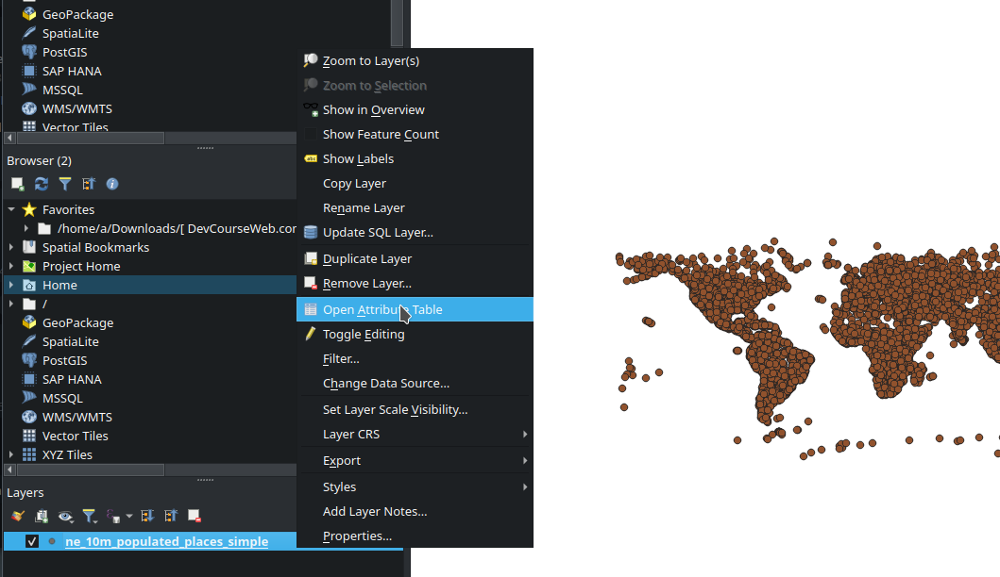

Figure 2 : Open attribute Table by right click

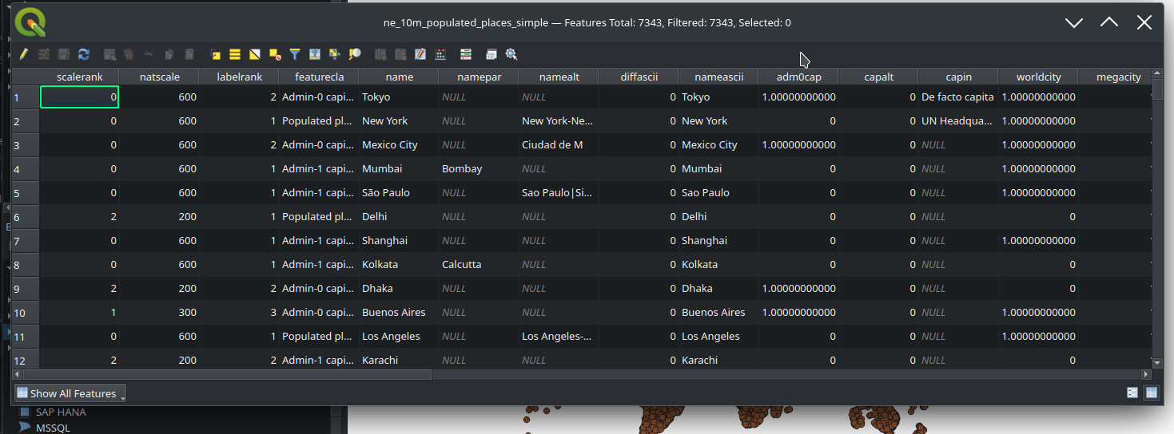

Figure 3 : This interface is showing all the features

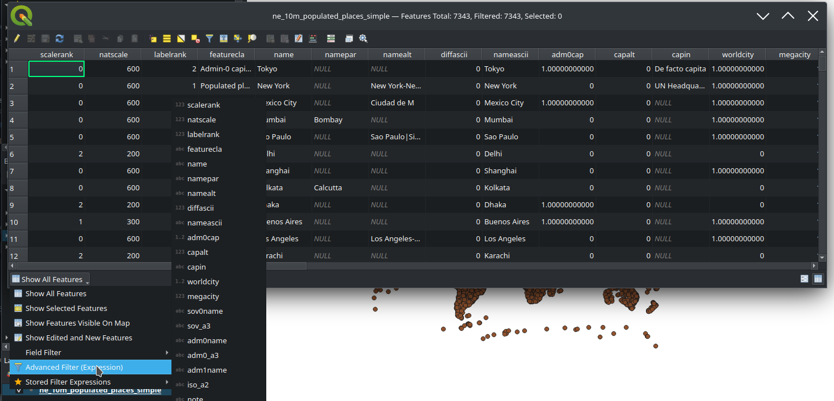

Figure 4 : select Advanced Expression from the drop-down menu

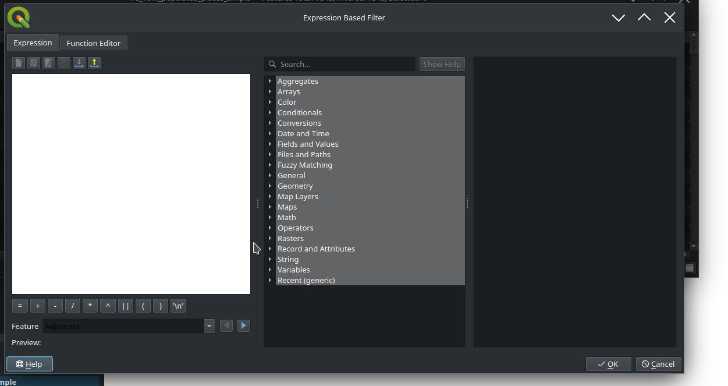

Figure 5 : Expression UI

Based on layer data and prebuilt or user defined functions, Expressions offer a powerful way to manipulate attribute value, geometry and variables in order to dynamically change the geometry style, the content or position of the label, the value for diagram, the height of a layout item, select some features, create virtual field, …etc

A list of the default functions and variables for writing expressions can be found at List of functions, with detailed information and examples. For the list of functions please go to <https://docs.qgis.org/3.28/en/docs/user_manual/expressions/functions_list.html>

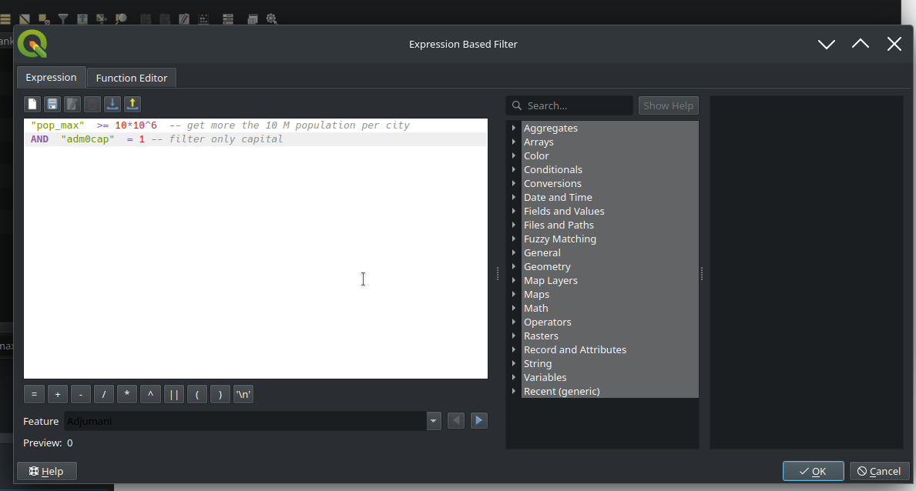

Figure 6 : Expression for filter or select attributes based on condition

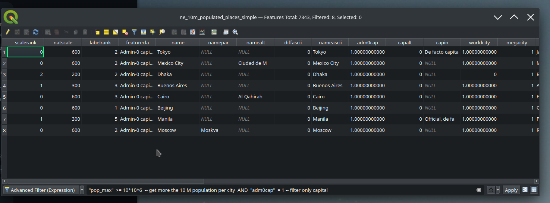

Figure 7 : Expression results

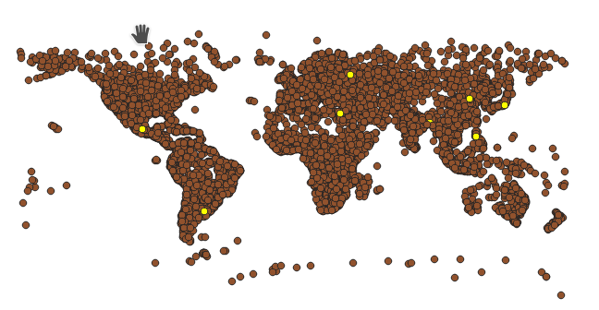

Figure 8 : cities that match the conditions are highlighted in yellow

1. **Spatial Query:**

Select by Location: This tool allows users to select features based on their spatial relationship with features from another layer. For instance, you can select all points that fall within a specific polygon.

Processing Toolbox: The toolbox contains more advanced spatial query tools such as "Clip", "Intersect", and "Difference" that operate based on spatial

relationships.

1. **Expression Builder:**

QGIS's expression builder is a powerful feature that allows for complex queries combining both attribute and spatial elements. It's accessible from many parts of the application, including the attribute table, layer styling, and various tools in the processing toolbox.

1. **SQL Queries with Virtual Layers:**

You can create a virtual layer in QGIS using SQL (Structured Query Language). This allows for more complex queries and joins that combine both spatial and attribute data from multiple layers.

1. **Plugins:**

The QGIS plugin ecosystem offers additional tools and functionalities for querying. One notable plugin is "QuickFinder" which allows for rapid searching and locating of features based on attributes.

1. **Python Console:**

For more advanced users, QGIS provides a Python console where you can use the PyQGIS API to write scripts to query and manipulate data in more customized ways.

When working with QGIS, the approach you choose largely depends on the nature of your data and the complexity of the query you wish to execute. Always ensure that your data is appropriately structured and formatted to get accurate results from your queries.

1. **Describe the inputs which should be used to answer the following questions and what would the outputs look like:**

***"Find all buildings which are located on parcels with a minimal area of 1000 m2 and a distance of more than 250m to the highway".***

To answer the given question using a GIS application like QGIS, the following are the necessary inputs and the expected outputs:

**Inputs:**

**Buildings Layer:**

* + A layer containing polygons or points representing buildings.
  + Attributes: May include building type, address, height, etc., but these are not strictly necessary for this query.

**Parcels Layer:**

* + A layer containing polygons representing parcels or land lots.
  + Attributes: Must include an area attribute (or the data should allow for the calculation of area, e.g., via geometry calculations).

**Highway Layer:**

* + A linear layer representing highways.
  + Attributes: Highway name, type, etc., but again, these are not strictly necessary for this particular query.

**Process:**

**Filter P**

**arcels by Area:**

* + Using the attribute query, filter out parcels that have an area less than 1000 m^2.

**Proximity Analysis:**

* + Generate a buffer of 250m around the highway layer to identify regions within 250m of the highways.

**Select Parcels Outside Buffer:**

* + Using a spatial query, select parcels from the filtered list that do not intersect with the highway buffer. This will give you parcels with a minimal area of 1000 m^2 and located more than 250m away from the highway.

**Select Buildings on Parcels:**

* + With the filtered parcels selected, use another spatial query to select buildings located on these parcels.

**Outputs:**

**Selected Buildings Layer:**

* + A subset of the original buildings layer that meets the criteria. This will show buildings that are on parcels with a minimal area of 1000 m^2 and a distance of more than 250m from the highway.

**Visualization :**

* + A map visualization could display the selected buildings with a distinct symbology or color compared to the other buildings. Additionally, the buffer zone around the highway could be visualized with a semi-transparent color, helping to provide context.

**Attribute Table:**

A

* + n attribute table or a list of the selected buildings with relevant details (if available in the initial input), such as building name, type, address, etc.

To summarize, the query requires layers representing buildings, parcels, and highways and involves both attribute and spatial queries. The result is a subset of the building layer that meets the specified criteria.

**References**

Hellige, J. B. and Michimata, C. (1989). Categorization versus distance: hemispheric differences for processing spatial information. Memory &Amp; Cognition, 17(6), 770-776. <https://doi.org/10.3758/bf03202638>

Fu, Y., Li, M., Zhang, X., Zhang, S., Wei, C., Guo, W., … & Zha, F. (2020). Spatial topological relation analysis for cluttered scenes. Sensors, 20(24), 7181. https://doi.org/10.3390/s20247181

# **3.Week 3 Formative Assessment**

## 3.1 Introduction

The third week's academic endeavors transported us to the vast and diverse landscape of Brazil, offering a unique blend of geographical exploration intertwined with sociological insights. As a nation renowned for its immense size, cultural richness, and economic importance, Brazil provided the perfect backdrop for a series of GIS-centric exercises, helping bridge the gap between theory and real-world application.

The heart of these exercises beat with the rhythm of São Paulo, the country's most populous state. The tasks demanded meticulous mapping of the centroids of each municipality within this vibrant state, extending to delineating the boundaries that encompassed the entirety of São Paulo. But the journey did not stop there. The assessments stretched beyond, capturing the broader spectrum of Brazil, from its socio-economic parameters such as the Human Development Index to the spatial proximity of housing projects.

Moreover, this week's focus was not merely on generating maps or crunching numbers. It was about understanding the stories these maps tell, the narratives behind socio-economic indices, and the implications of spatial distributions. By the end of this week, it was evident that GIS is not just about points, lines, and polygons; it's about the tales of communities, development, and regions waiting to be discovered and understood. The week's exercises reiterated the power of spatial data analysis in unravelling the multifaceted dynamics of a nation as diverse and intricate as Brazil.

## 3.2 Assessment Summaries

The Week 3 assessment delved deep into the expansive territories of Brazil, navigating through its vast municipalities and the intriguing socio-economic parameters that shape its unique identity. Beginning with the state of São Paulo, the tasks were twofold: pinpointing the centroids of each municipality and highlighting the outer boundaries of the state itself. This exercise underscored the critical role of spatial orientation in understanding and analyzing geographical entities within larger administrative units.

As the assessment journeyed on, the focus shifted to a nation-wide scale, exploring the Human Development Index (HDI) of Brazilian municipalities. By querying the mean HDI across states, the exercise presented an analytical panorama of development and well-being across Brazil. From there, the lens narrowed onto the municipality of 'Gaucha do Norte', dissecting the intersection of its boundaries with the indigenous territory “Parque do Xingu”. This task accentuated the intricate interplay of indigenous territories and administrative demarcations.

Further challenges encompassed the state of Acre (AC), diving into the realm of social housing projects, specifically the Minha Casa Minha Vida (MCMV) initiative. The assessment aimed to discern which two MCMV housing projects lay in closest proximity to one another, culminating in the creation of a 10km buffer zone around each. This exercise was a testament to the practical applications of GIS in urban planning and housing policy analysis.

The week concluded with an expansive visual exploration of Brazil, spotlighting municipalities housing the lowest and highest number of MCMV units. This culminating task demanded the synthesis of large-scale data, morphing it into a coherent, visual map that portrayed housing unit distributions, encapsulating the week's essence of translating raw data into insightful, actionable geospatial information. 3.3 Key Findings or Insights

## 3.4 Challenges and Solutions

Navigating Week 3’s assessment presented an assortment of challenges, each bringing to the fore the complexities and nuances inherent in geospatial data analysis. One of the prime challenges was the extraction of specific geographical features, such as the centroids of municipalities in São Paulo. The vast number of municipalities, combined with their intricate shapes and sizes, made it a demanding task to accurately identify and plot each centroid without overlap or misrepresentation.

Another significant challenge arose when examining the Human Development Index (HDI) across Brazilian states. With variations in data collection methodologies and potential discrepancies in the reporting, ensuring the accuracy and reliability of the HDI values required meticulous cross-referencing and validation.

When dealing with the task related to 'Gaucha do Norte' and the “Parque do Xingu” intersection, the overlap of administrative boundaries with indigenous territories posed complexities. Indigenous lands, often not adhering to standard administrative demarcations, required a specialized approach to accurately capture their boundaries and subsequent overlaps.

Lastly, the analysis within the state of Acre (AC) involving the proximity of social housing projects was not without its challenges. Identifying the closest projects necessitated a precise distance calculation between multiple points, ensuring no project was overlooked. Furthermore, creating a 10km buffer around each housing project demanded precision to avoid potential overlap or under-representation.

Despite these challenges, solutions emerged by leveraging advanced GIS tools and techniques. Utilizing specialized centroid extraction methods streamlined the plotting process for São Paulo municipalities. Cross-referencing HDI data with reputable sources ensured accuracy. For the indigenous territories, collaborative tools which accounted for non-standardized boundaries were employed. And for the Acre housing project challenge, iterative proximity algorithms coupled with buffer zone visual checks guaranteed precision. These solutions not only addressed the challenges head-on but also underscored the indispensable role of advanced GIS tools in resolving complex geospatial dilemmas.

## 3.5 Skills and Knowledge Gained

The third week's curriculum and the ensuing assessment turned out to be a goldmine of insights and skill development for any aspiring geospatial analyst. Here's a breakdown of the invaluable skills and knowledge I acquired:

First and foremost, the exercise of mapping centroids of municipalities in São Paulo significantly bolstered my understanding of geographical centroids and their significance in spatial analysis. I learned to navigate a variety of GIS tools to extract and represent these central points accurately. This process underscored the importance of precision and spatial awareness, especially when dealing with a high density of data points.

Secondly, the task involving the Human Development Index (HDI) across Brazilian states familiarized me with socio-economic data integration in GIS. Analyzing HDI values across municipalities illuminated the disparities in development across regions and heightened my awareness of the socio-economic nuances that exist within a large and diverse nation like Brazil.

The assignment focused on 'Gaucha do Norte' and the intersection with the indigenous territory “Parque do Xingu” provided a profound understanding of the overlay techniques in GIS. I garnered insights into the complexities surrounding indigenous territories, the overlaps of administrative and traditional boundaries, and the significance of capturing these details accurately in spatial datasets.

The proximity analysis within the state of Acre (AC) enriched my skills in distance calculations between spatial features, especially when determining the relative distances between multiple points. This exercise emphasized the utility of GIS in urban planning and housing sector analyses.

Finally, mapping the distribution of housing units by municipality across Brazil familiarized me with thematic mapping techniques. I came to appreciate the power of visual representation in conveying dense data in an easily comprehensible and insightful manner.

In sum, Week 3's assessment was pivotal in refining my technical skills in GIS, deepening my understanding of socio-economic spatial data, and highlighting the critical role of precision and meticulousness in geospatial analyses.

## 3.6 Future Applications

Delving into the multifaceted realm of spatial analysis during the third week has unveiled a plethora of potential applications that extend far beyond the classroom's confines. The skills and knowledge acquired have far-reaching implications in various sectors and domains:

Urban Planning and Infrastructure Development: The tasks related to the mapping of housing units across municipalities, as well as proximity analyses of housing projects, are directly applicable in urban planning scenarios. These insights can guide the establishment of new housing projects, ensuring they are strategically located to maximize accessibility and minimize potential congestion or resource strain.

Socio-economic Analysis: The exercise on the Human Development Index (HDI) across Brazilian states can be extrapolated to broader socio-economic analyses. Policymakers and researchers can utilize similar methods to identify areas requiring increased attention or investment. This understanding can be the foundation for formulating targeted policies that address regional disparities in development.

Conservation and Land Rights: The task that centered on the intersection of 'Gaucha do Norte' with the indigenous territory “Parque do Xingu” offers insights into land rights and conservation efforts. Identifying and preserving indigenous territories or environmentally sensitive zones becomes feasible with such spatial analyses. This knowledge is particularly crucial for governments and NGOs focused on conservation and indigenous rights.

Emergency Response and Disaster Management: The ability to swiftly map centroids, establish buffers, and analyze proximity can be invaluable during emergency response situations. For instance, determining which areas are most vulnerable during natural disasters or identifying optimal locations for emergency shelters can leverage these GIS techniques.

Real Estate and Commercial Planning: Beyond public planning, the private sector, particularly in real estate and retail, can use proximity analyses to determine optimal locations for new ventures or assess the value of properties based on their surroundings.

In essence, the methodologies and techniques mastered in Week 3 are not merely academic exercises. They hold the potential to drive tangible change in diverse sectors, from public policy to private enterprise, ensuring that decisions are data-driven, strategic, and cognizant of the intricate spatial relationships that define our world.

## 3.7 Conclusion

The third week of the Spatial Data Analysis course elucidated the complexities and nuances of geospatial assessments, revealing the profound depth and breadth of spatial analysis in the context of real-world applications. From capturing the intricate socio-economic metrics of regions, like the Human Development Index, to delving into spatial relationships of specific territories and understanding their juxtaposition within larger contexts, the exercises pushed the boundaries of traditional classroom learning.

The questions crafted for this week were not just academic prompts; they were windows into larger societal, economic, and environmental challenges. Whether it was understanding the unique dynamics of a state like Säo Paulo or grasping the intricate relationships of housing projects within Acre, each task required a blend of technical acumen, analytical prowess, and a profound appreciation for the contextual implications of the findings.

This week served as a testament to the transformative power of spatial data analysis. Beyond its technical facets, it underscored the discipline's potential to influence policymaking, urban development, conservation efforts, and a myriad of other domains. As the digital age continues to evolve, the importance of spatial data will only magnify, and the insights garnered from this week will undoubtedly play a pivotal role in shaping the decisions of tomorrow.

In reflection, Week 3 was not just about mastering software or techniques; it was about understanding the narratives, stories, and implications that these tools can unveil. It was about the symbiotic relationship between data, space, and the human experience.

## **Week 3 Formative Assessment Submission**

**Produce a map showing the centroids of each municipality in just the state of Säo Paulo, and**

1. **add the outer boundary of Säo Paulo state.**

Download ,add the exercise file to the Favorites and open municipality file, new layer will be

generated as shown below

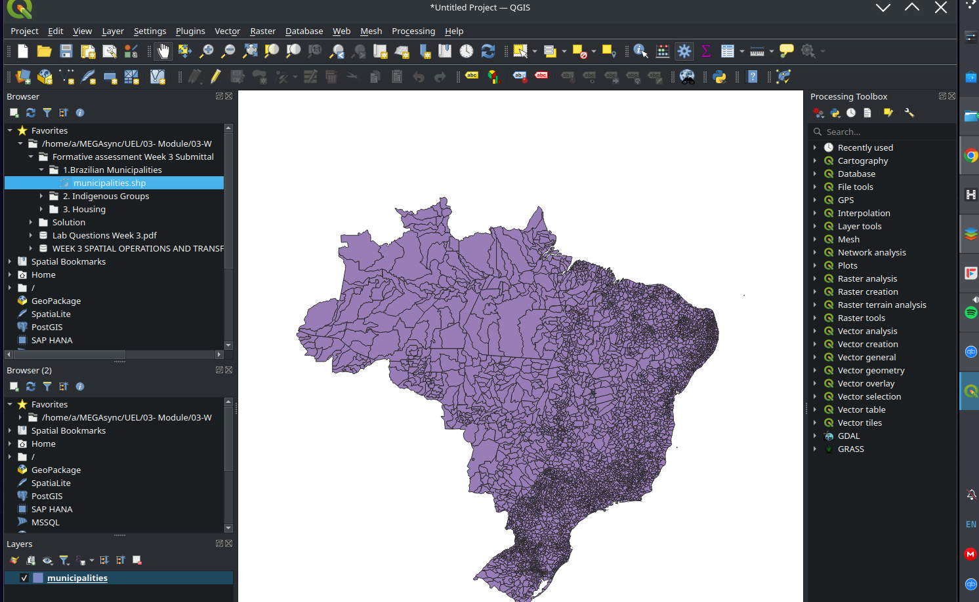

**Right click to open attribute table**

The attribute table displays information on features of a selected layer. Each row in the table represents a feature (with or without geometry), and each column contains a particular piece of information about the feature.

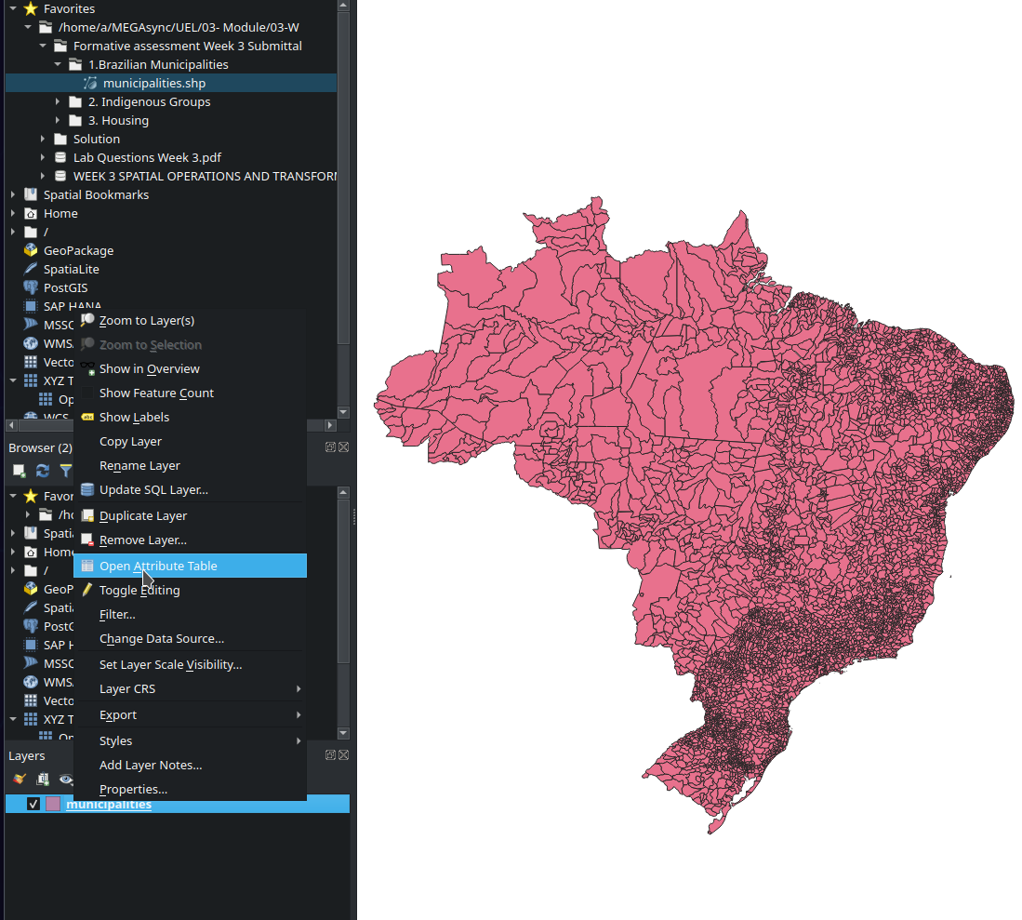

**Use Filter/Select features using form for Ctrl + F**

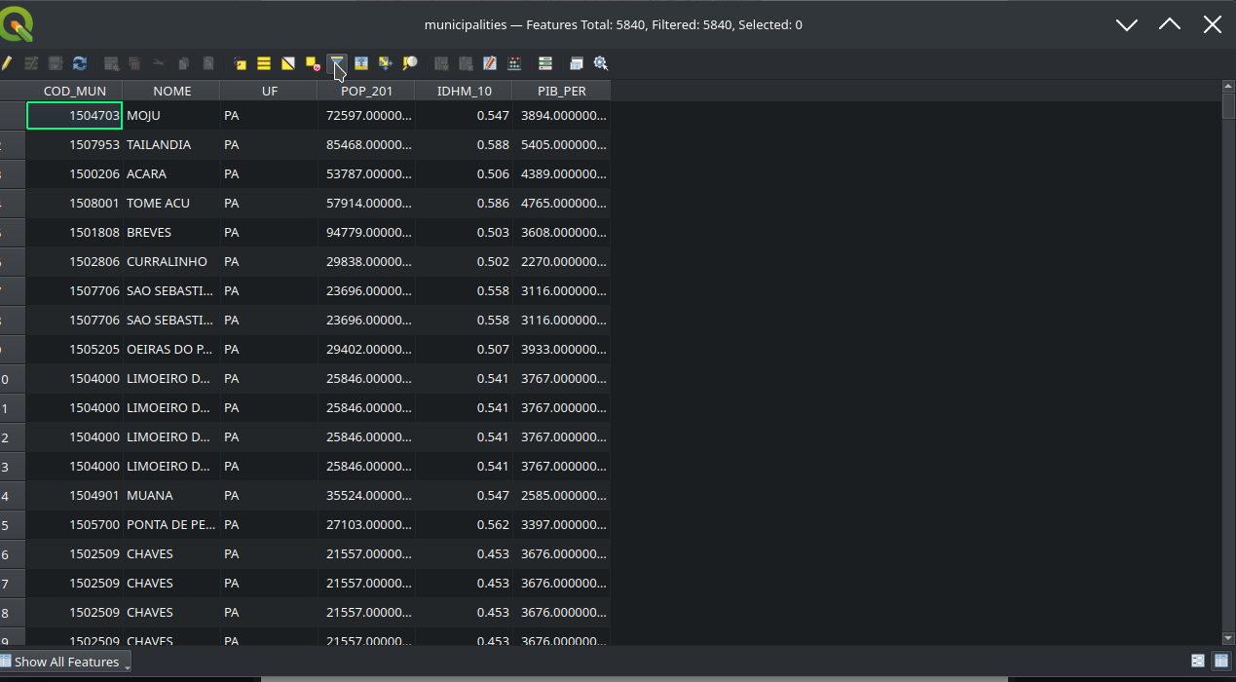

**Apply filter to the required data**

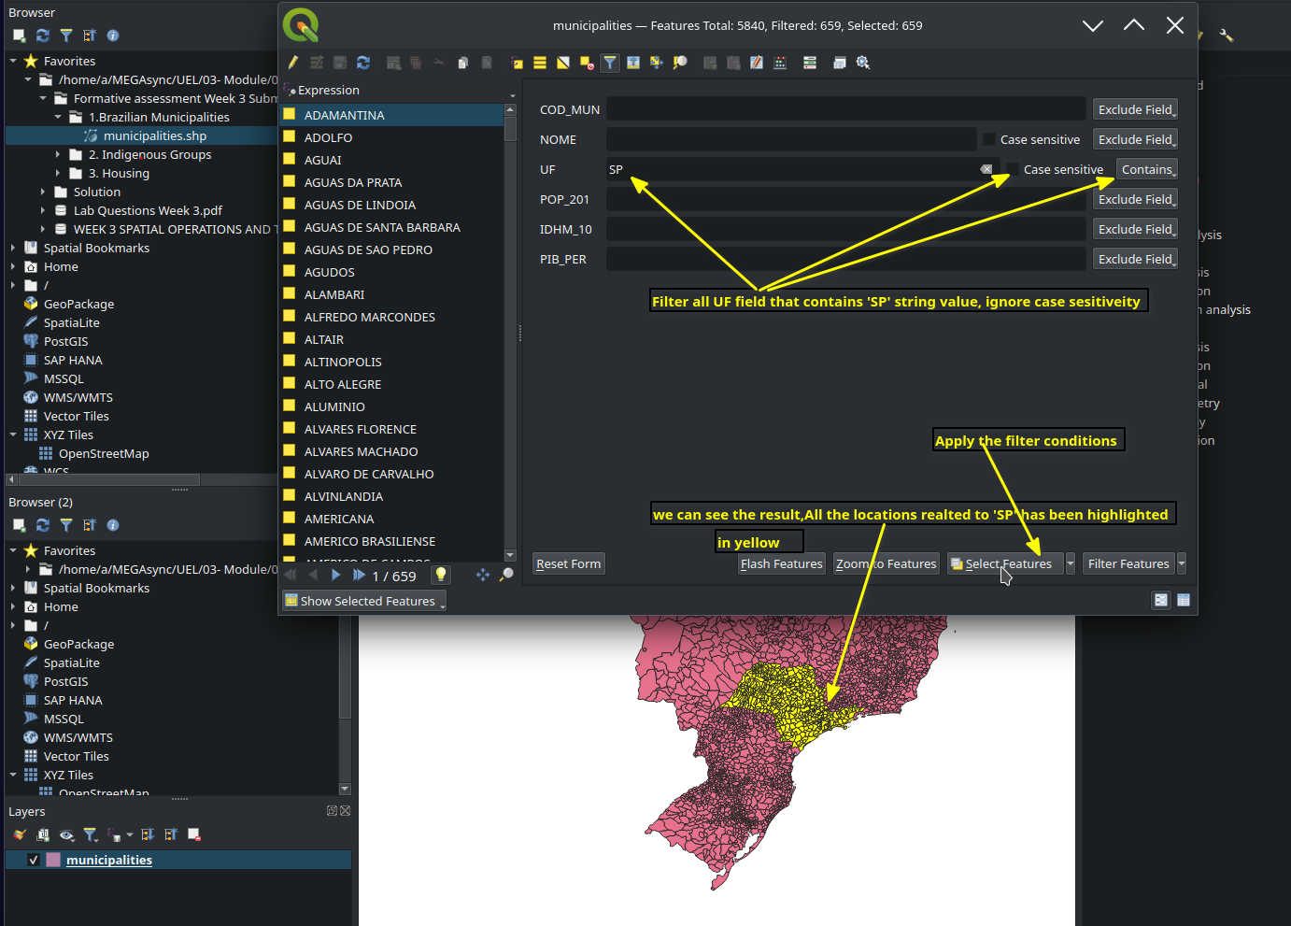

**Next we are going to export and save the filtered data into separated layer as below**

QGIS allows us to create new layers in different format

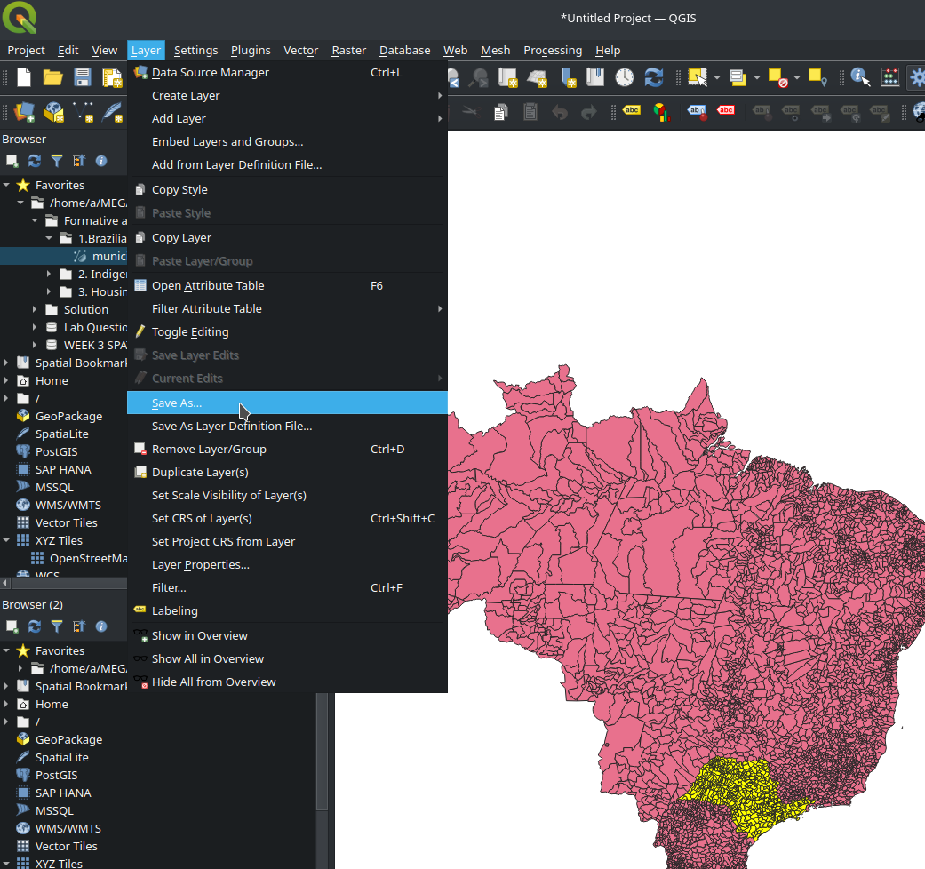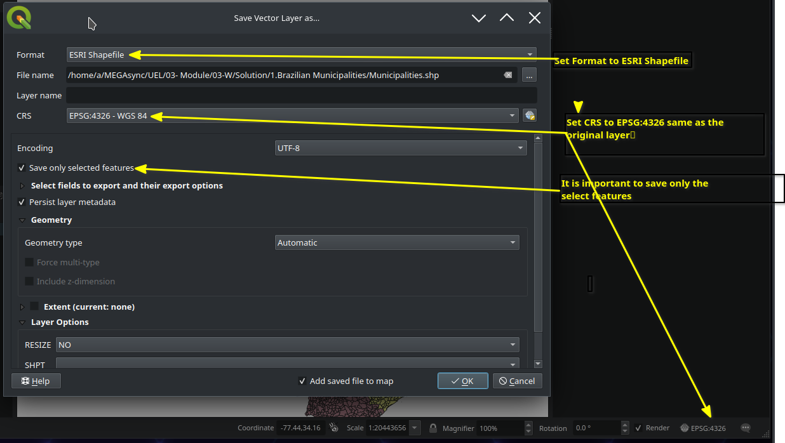

After savibg we can select the original layer and leave only the the new layer as shown below

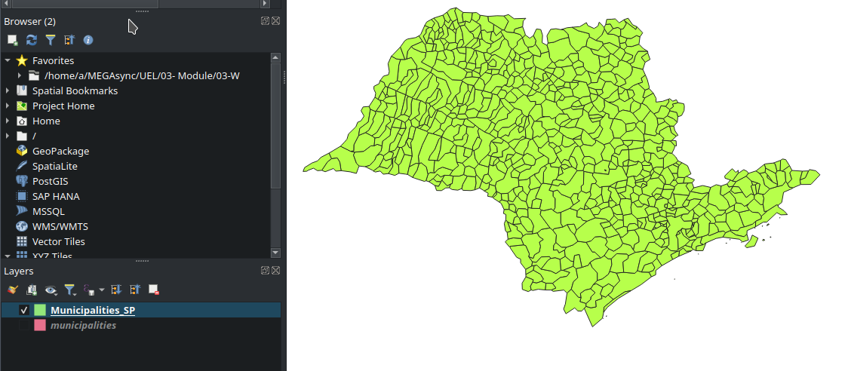

**Next we are going to process the polygons to obtain the centroids**

To obtain the centroids of each municipality we need QGIS processing toolbox as below ;

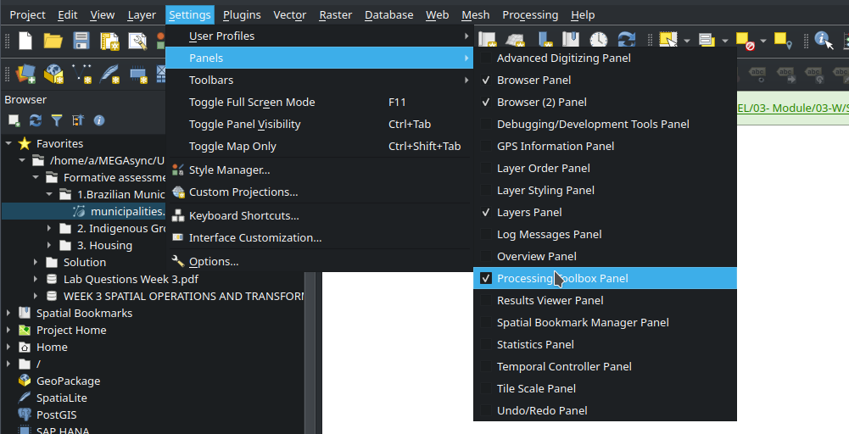

Search for Centroids under Vector geometry

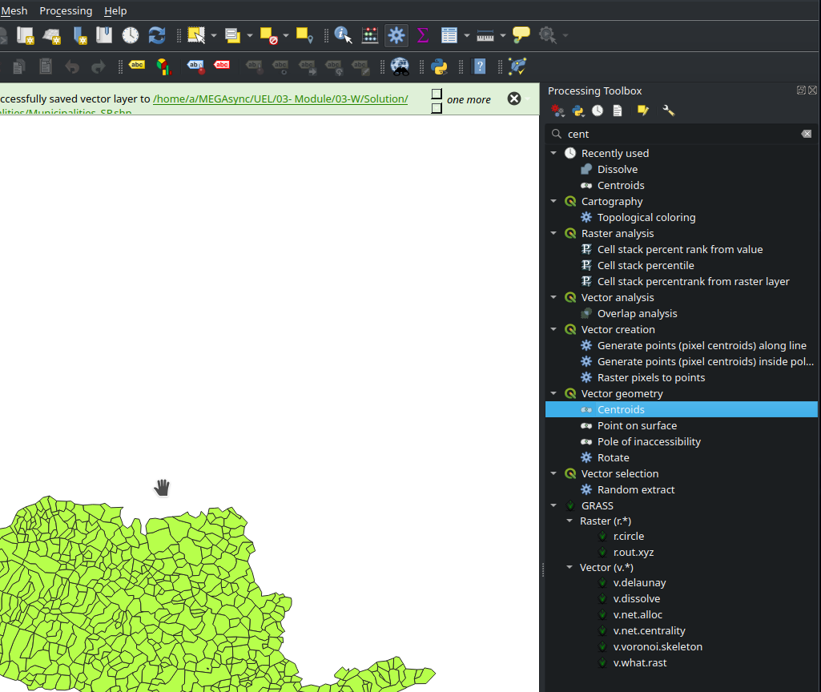

Creates a new point layer, with points representing the centroids of the geometries of the input layer.

This algorithm creates a new point layer, with points representing the centroid of the geometries in an input layer.The attributes associated to each point in the output layer are the same ones associated to the original features.

The centroid is a single point representing the barycenter (of all parts) of the feature, so it can be outside the feature borders. But can also be a point on each part of the feature.The attributes of the points in the output layer are the same as for the original features.

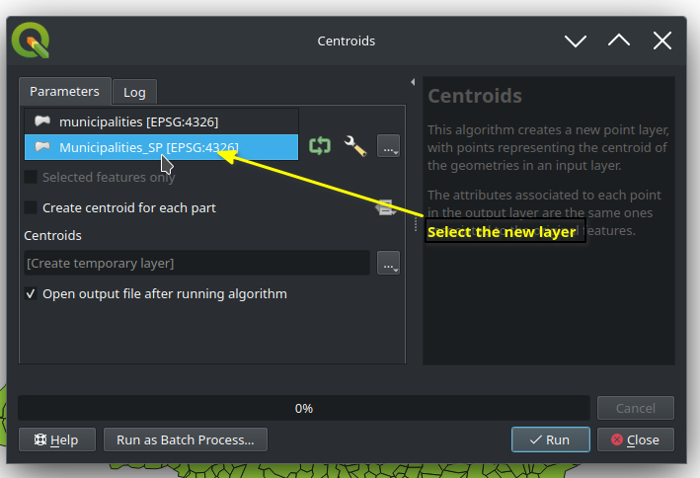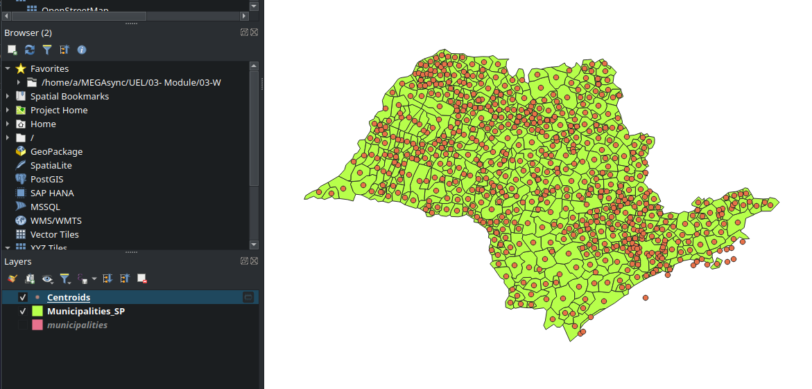

Unselect all except Centroid layer as above

Next we are going to resolve the Centroid layer into one shape

Dissolve takes a vector layer and combines its features into new features. One or more attributes can be specified to dissolve features belonging to the same class (having the same value for the specified attributes), alternatively all features can be dissolved to a single feature.All output geometries will be converted to multi geometries. In case the input is a polygon layer, common boundaries of adjacent polygons being dissolved will get erased.The resulting attribute table will have the same fields as the input layer. The values in the output layer’s fields are the ones of the first input feature that happens to be processed.

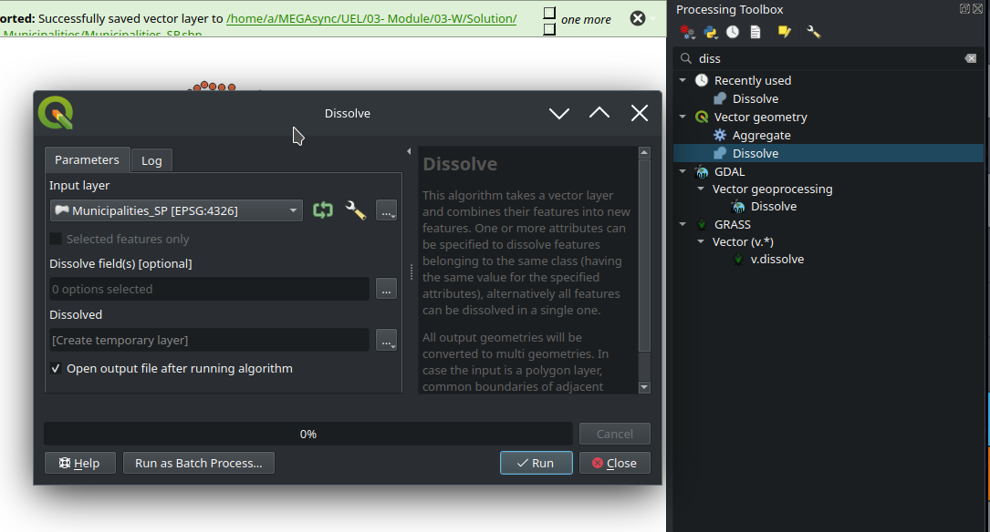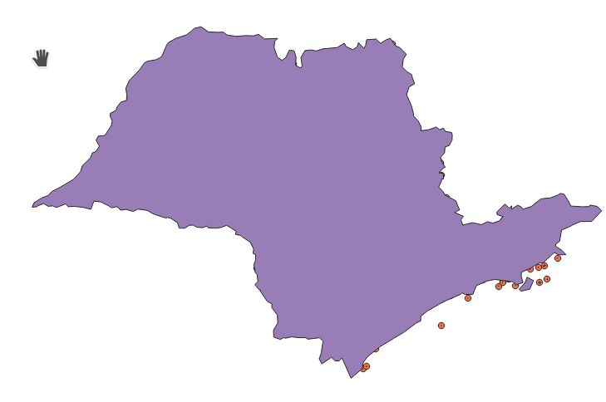

Above is the result of layer dissolve process

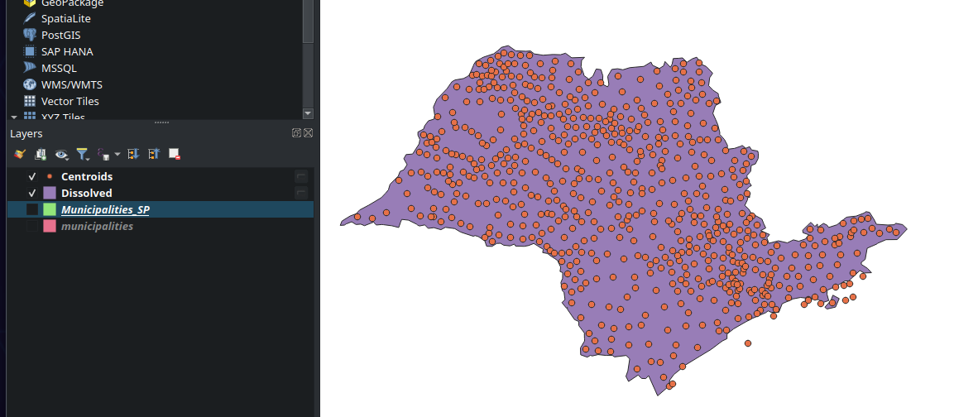

Reordering the layers to place the centroids on top of the resolved polygon

1. **What is the mean Human Development Index of municipalities in each state of Brazil?**

The calculation of the mean Human Development Index (HDI) for each state in Brazil requires an aggregation process using Geographic Information System (GIS) tools like QGIS. Initially, data on the HDI of individual municipalities must be grouped by their respective states. Within QGIS, this involves clustering data by municipality and subsequently aggregating the HDI values to produce an average for each state. This mean value reflects the average human development for the municipalities within that particular state, providing a more comprehensive view of development patterns across Brazil.

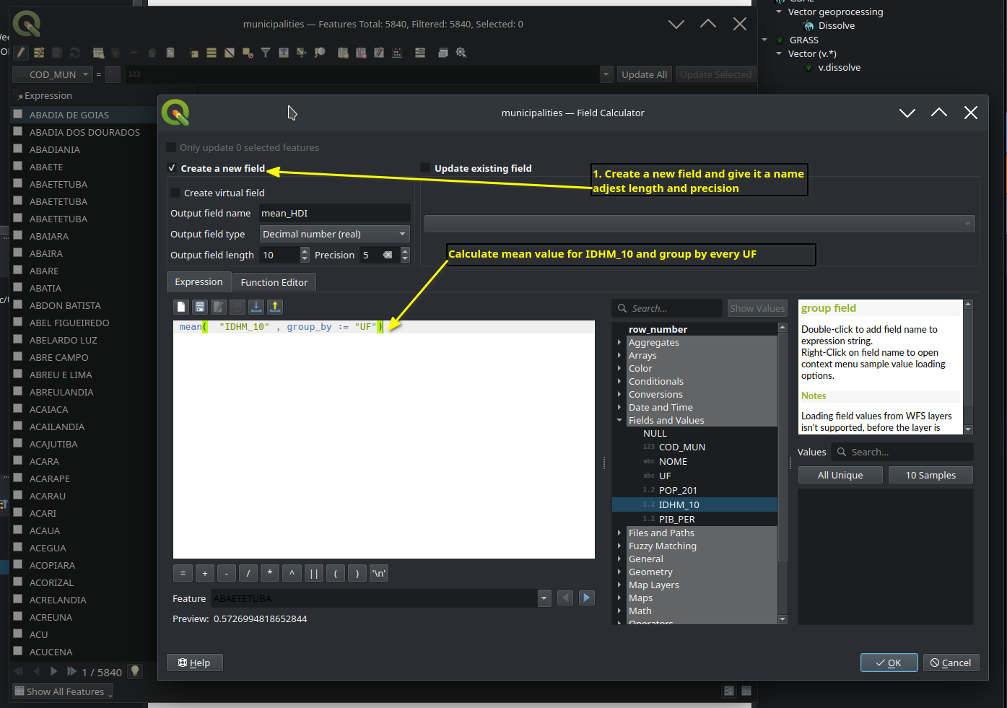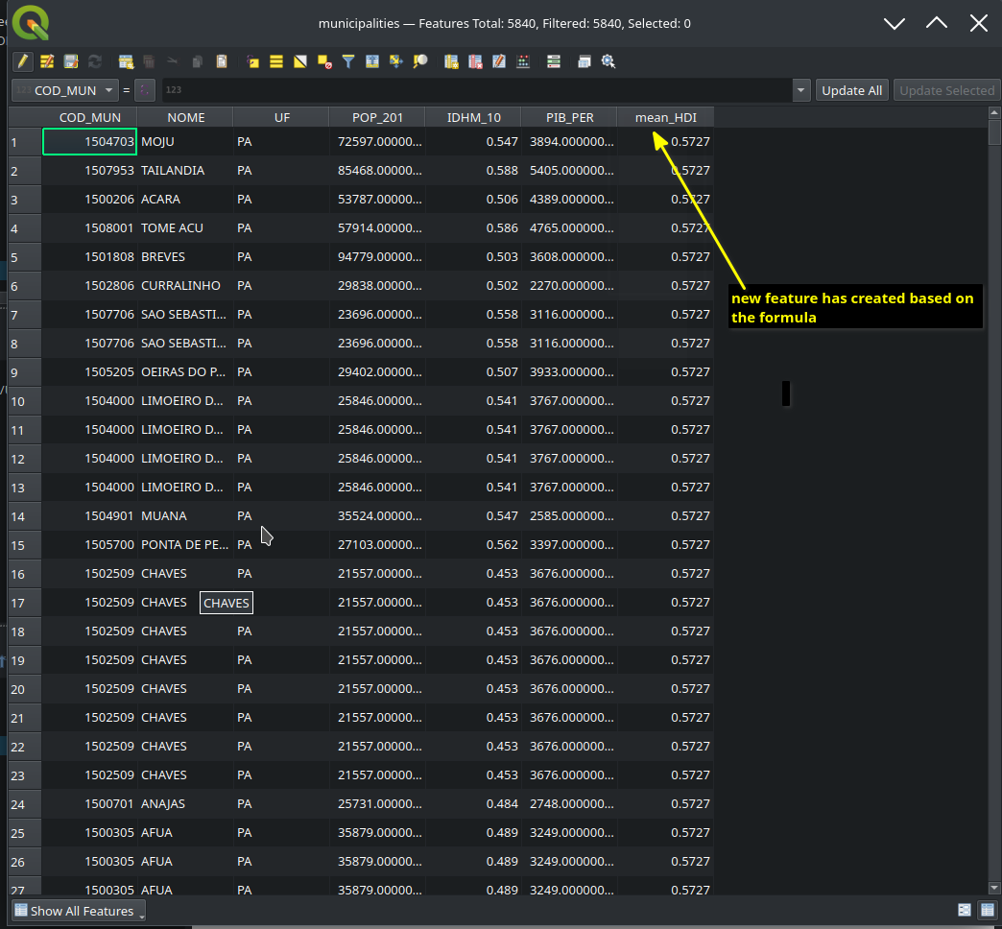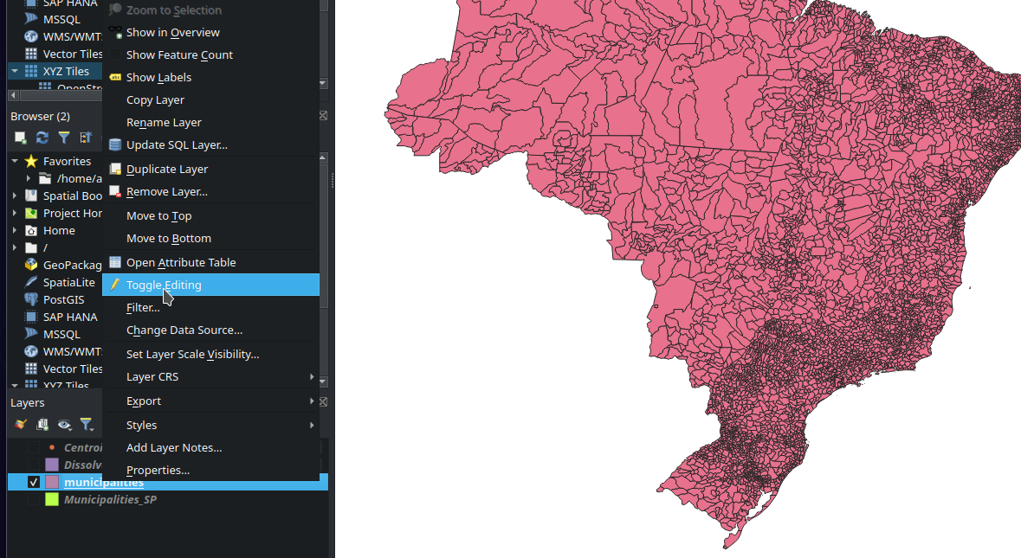

**Disable tangle Editing**

**Visualizing the aggregated value by UF feature**

Visualizing aggregated HDI values by UF (Unidade Federativa) in Brazil using QGIS involves loading municipality-level HDI data alongside a Brazilian UF shapefile. Once integrated, QGIS can aggregate HDI values for each UF by grouping municipalities, which can then be visualized using a graduated color scheme. This color-coded representation highlights regional development disparities, assisting policymakers in identifying areas of progress or in need of further support.

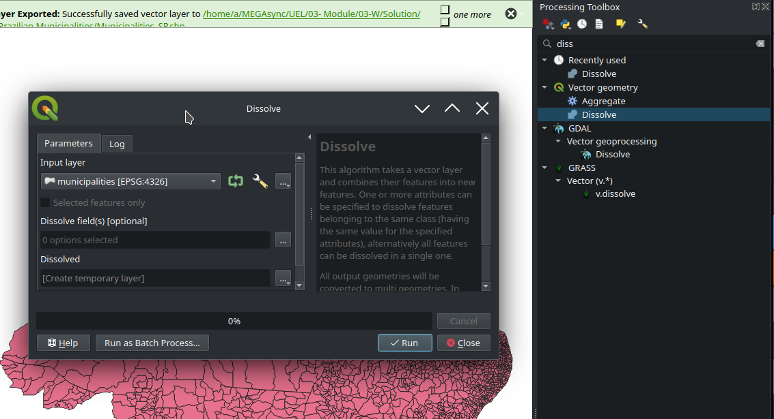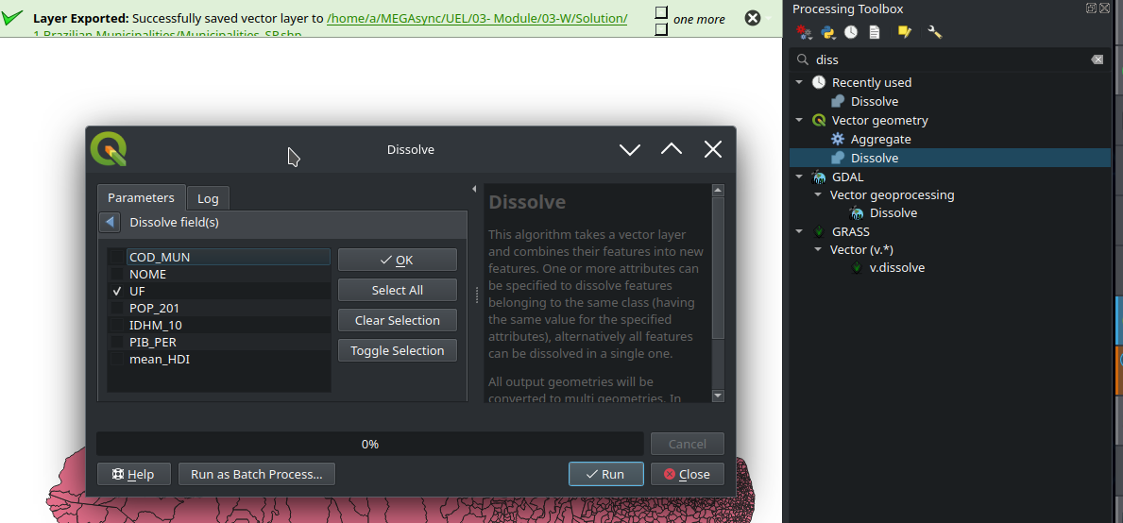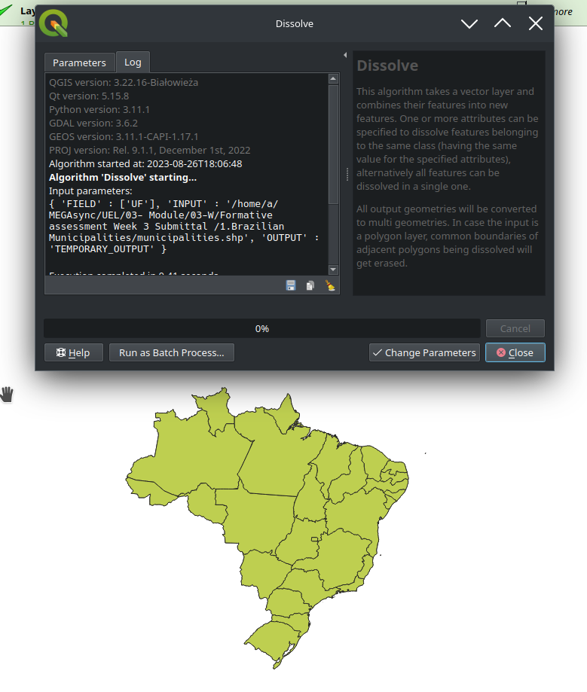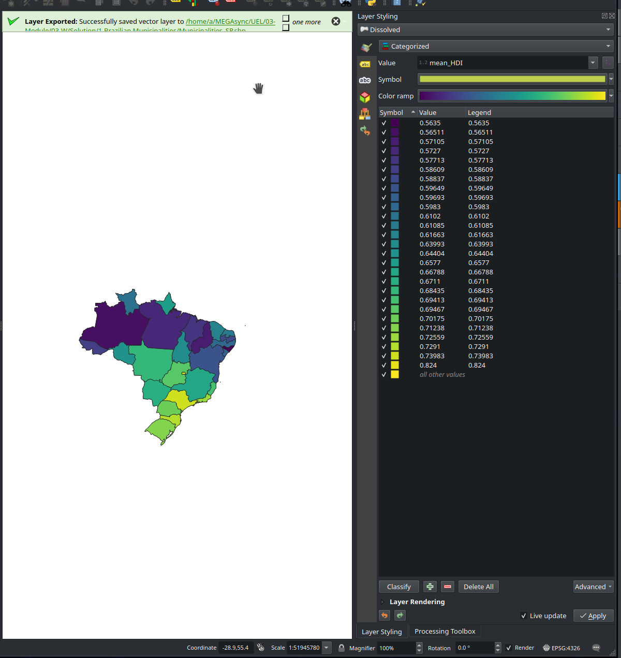

**Prod**

1. **uce a polygon/shapefile mapping the area of the municipality ‘Gaucha do Norte’ that is in the indigenous territory “Parque do Xingu”.**

First, import “BC250_Terra_Indigena_A” and dissolve the original municipalities by state as below;

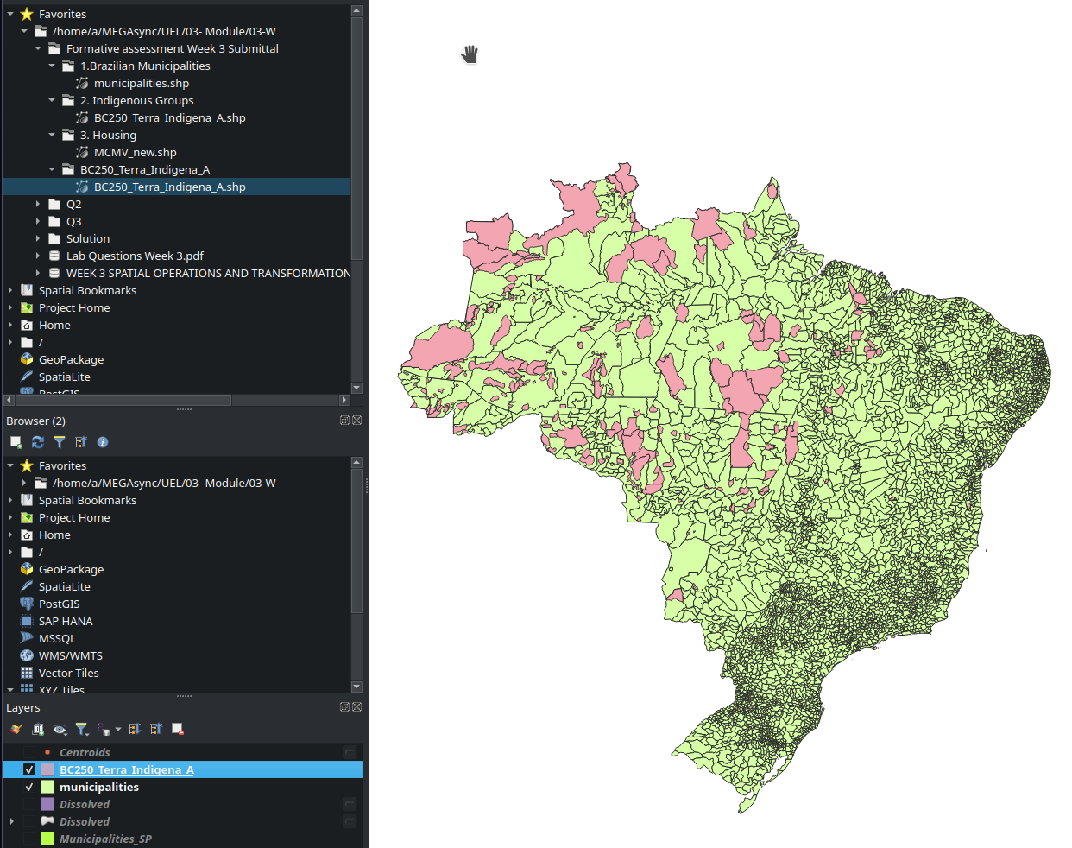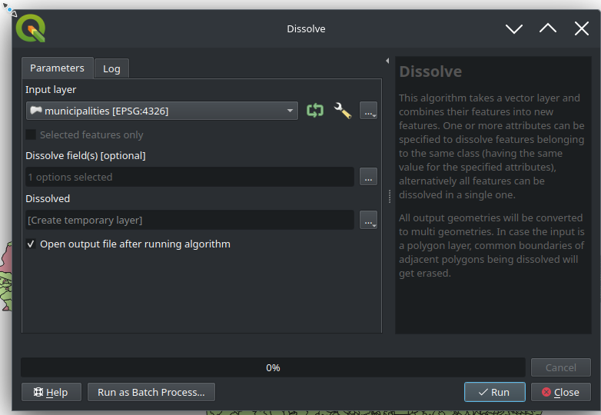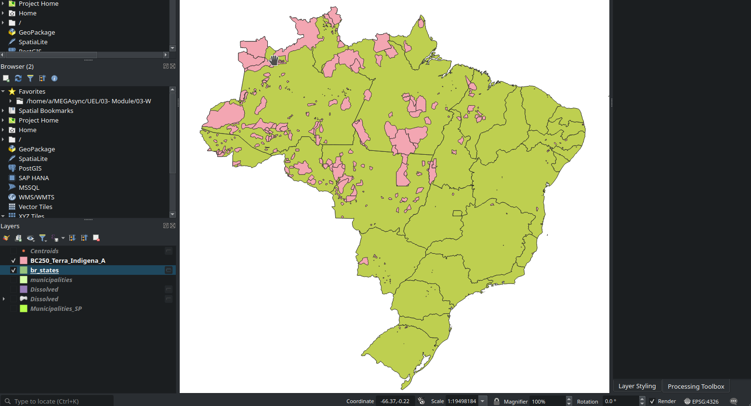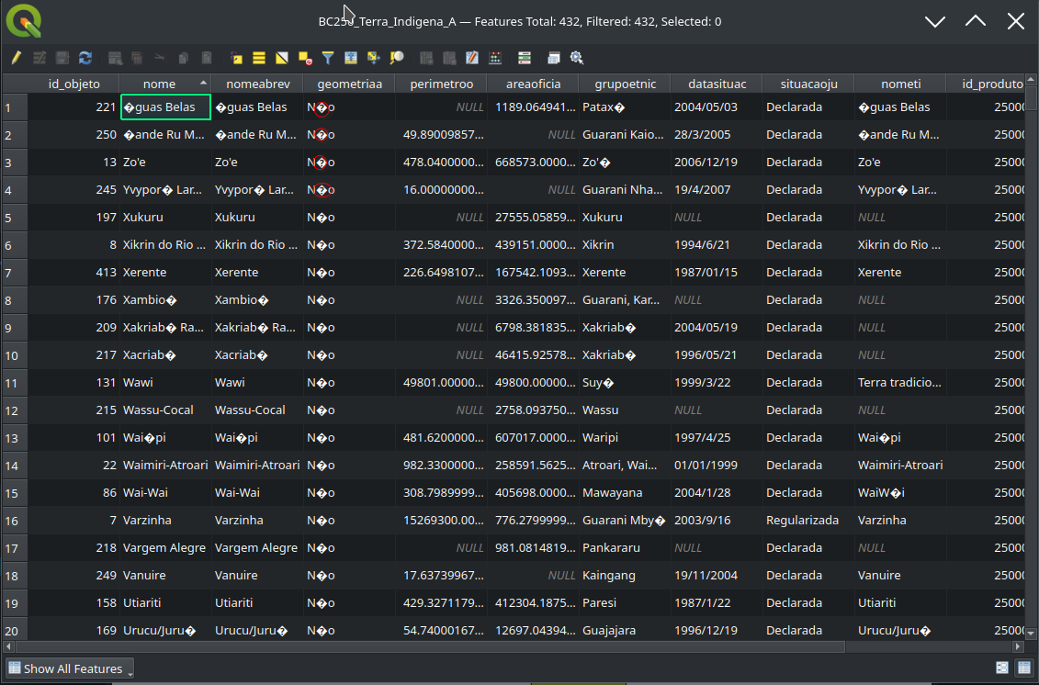

layer encoding needs to be changed, as we can see QGIS is trying to infer the text as highlighted in red, to solve it, go to layer properties to change it into the appropriate data source encoding.

above is applying query to filter only Parque do Xingu territory, note we used like operator for safe search if the d

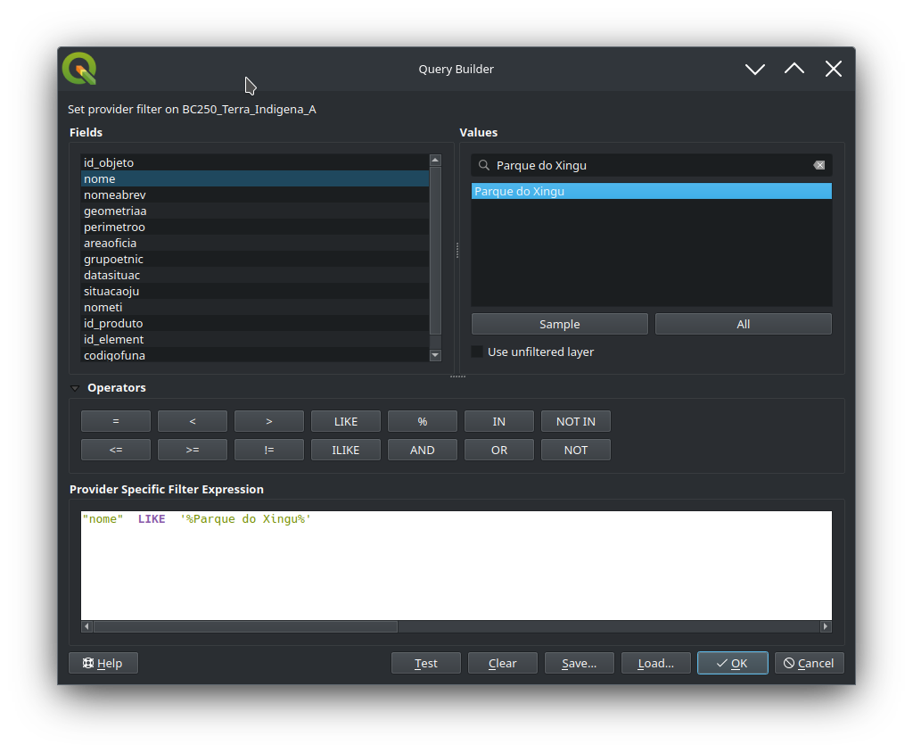

ata is not trimmed

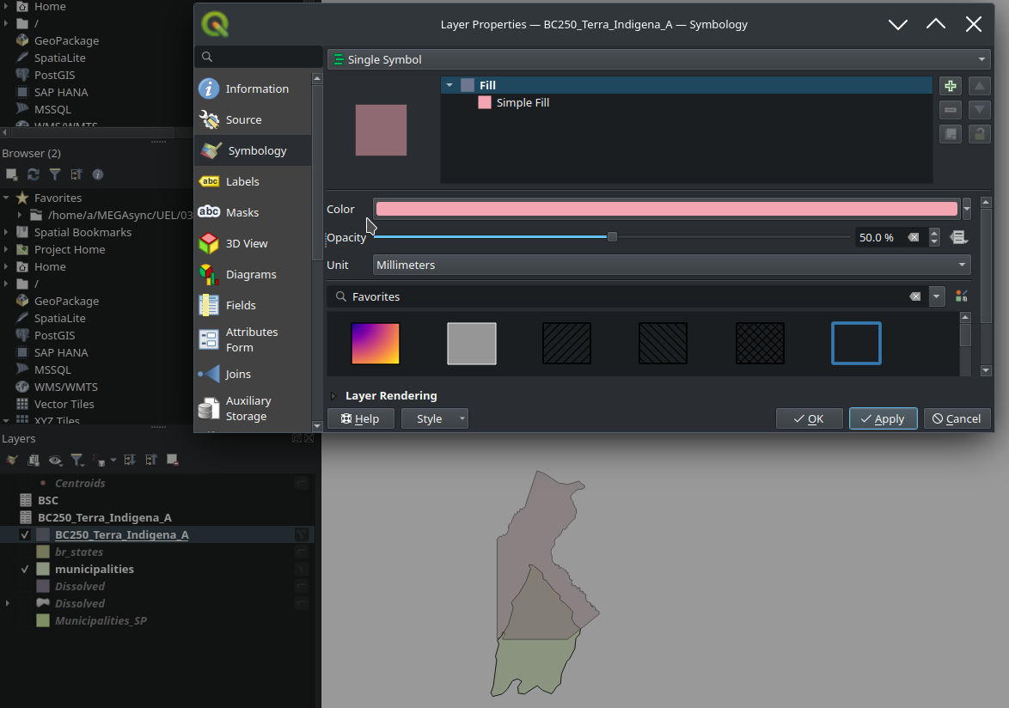

Since the two layers are overlapped, we have changed the top layer to 50 % Opacity.

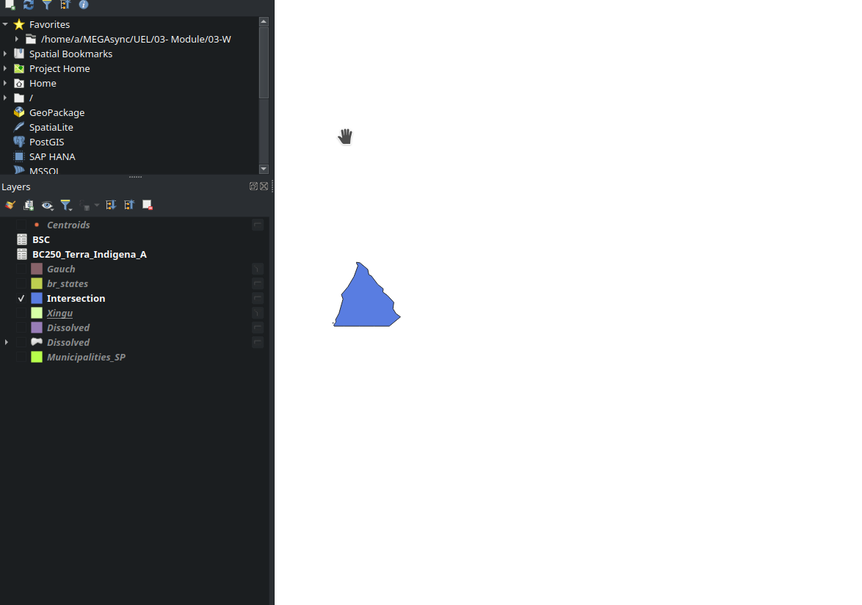

Here is the new layer that intersects the two layers

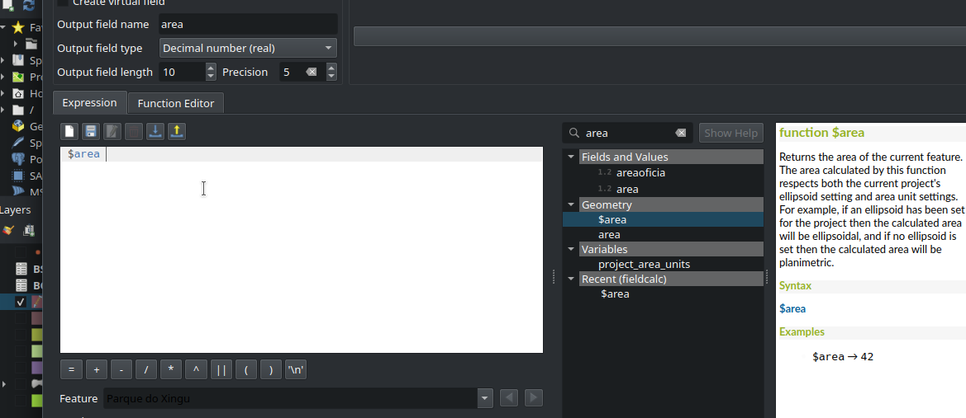

Above is the calculating the area of the polygon using $area as above and store the value in a new field as below

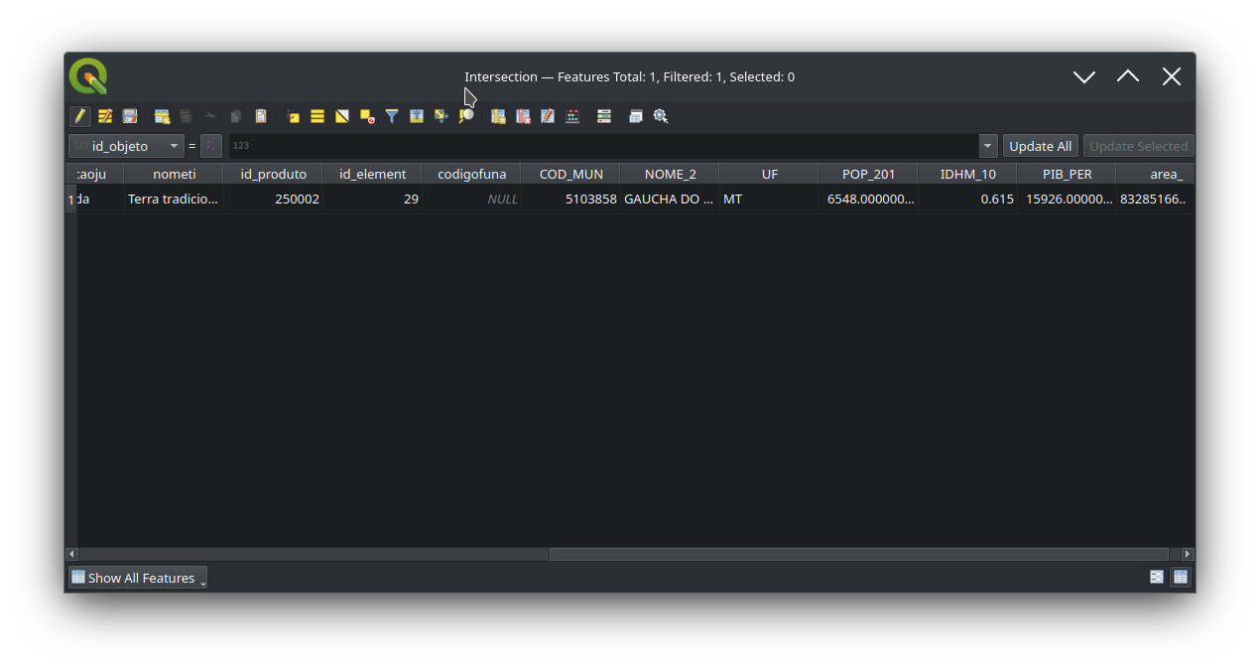

1. **In the state of Acre (AC), which two social housing (MCMV) projects are closest to each other? Create a 10km buffer around each housing project.**

First importing the required files as below

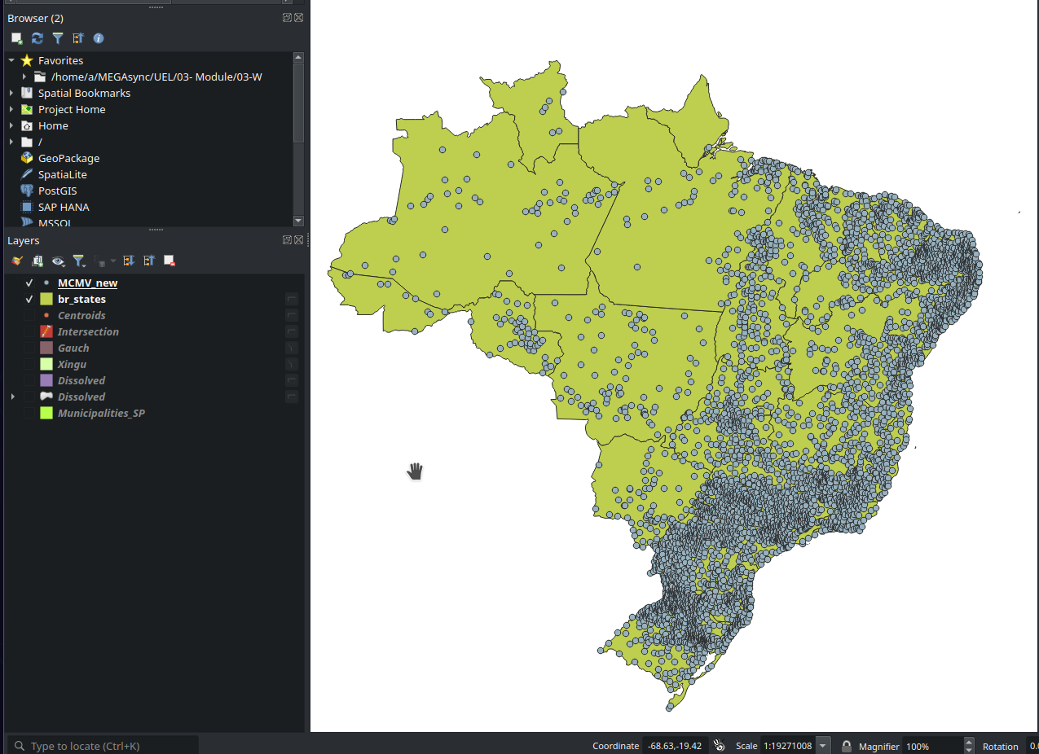

Filter where state is `AC` in MCMV_new layer

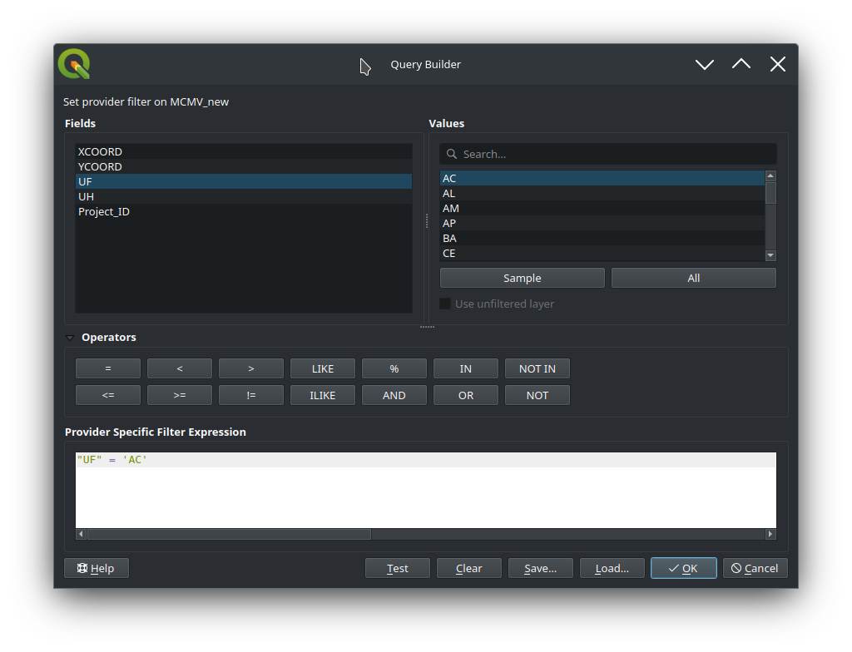

The result as below of filtering where state is `AC` in MCMV_new layer

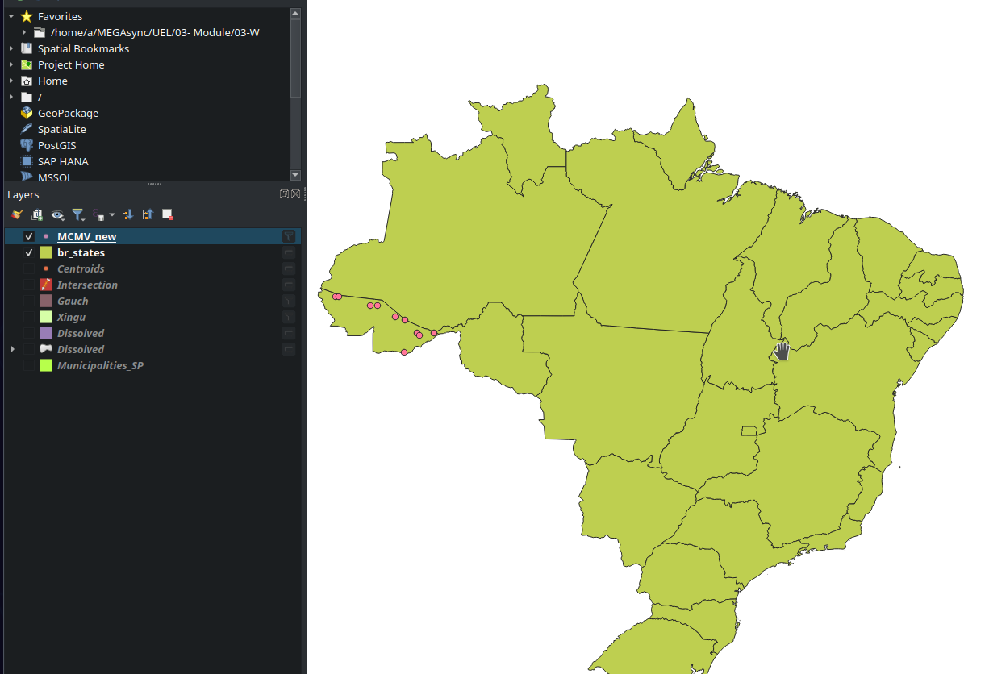

Applying the same filter to br_states layer as below

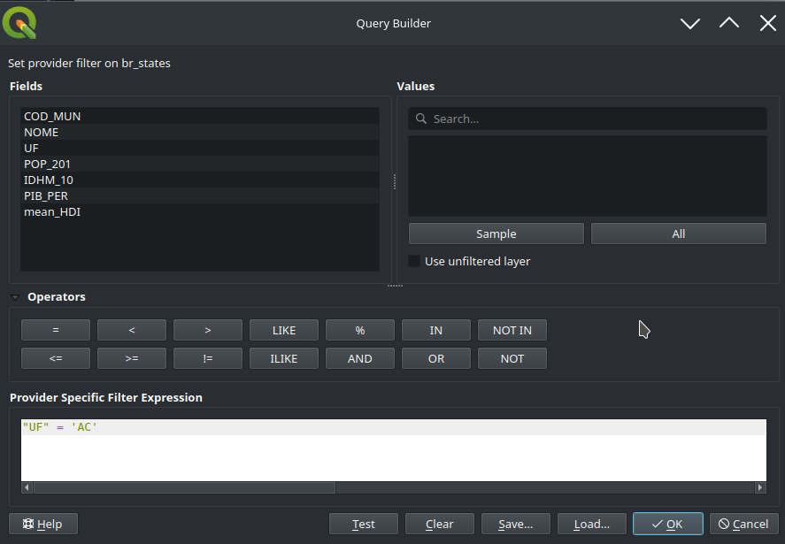

The result of applying filter to both layers as below

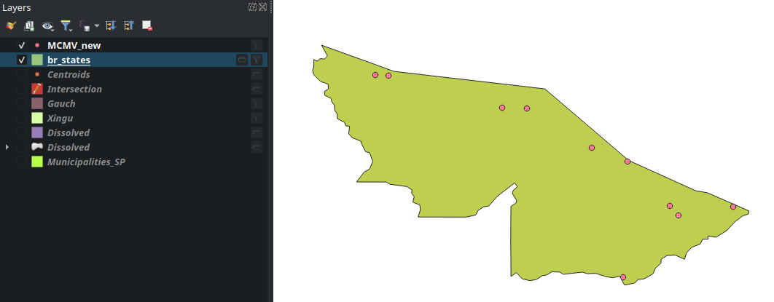

Every project in QGIS also has an associated Coordinate Reference System. The project CRS determines how data is projected from its underlying raw coordinates to the flat map rendered within your QGIS map canvas.

QGIS supports “on the fly” CRS transformation for both raster and vector data. This means that regardless of the underlying CRS of particular map layers in your project, they will always be automatically transformed into the common CRS defined for your project. Behind the scenes, QGIS transparently re-projects all layers contained within your project into the project’s CRS, so that they will all be rendered in the correct position with respect to each other!

It is important to make an appropriate choice of CRS for your QGIS projects. Choosing an inappropriate CRS can cause your maps to look distorted, and poorly reflect the real-world relative sizes and positions of features. Usually, while working in smaller geographic areas, there will be a number of standard CRSs used within a particular country or administrative area. It’s important to research which CRSs are appropriate or standard choices for the area you are mapping, and ensure that your QGIS project follows these standards.

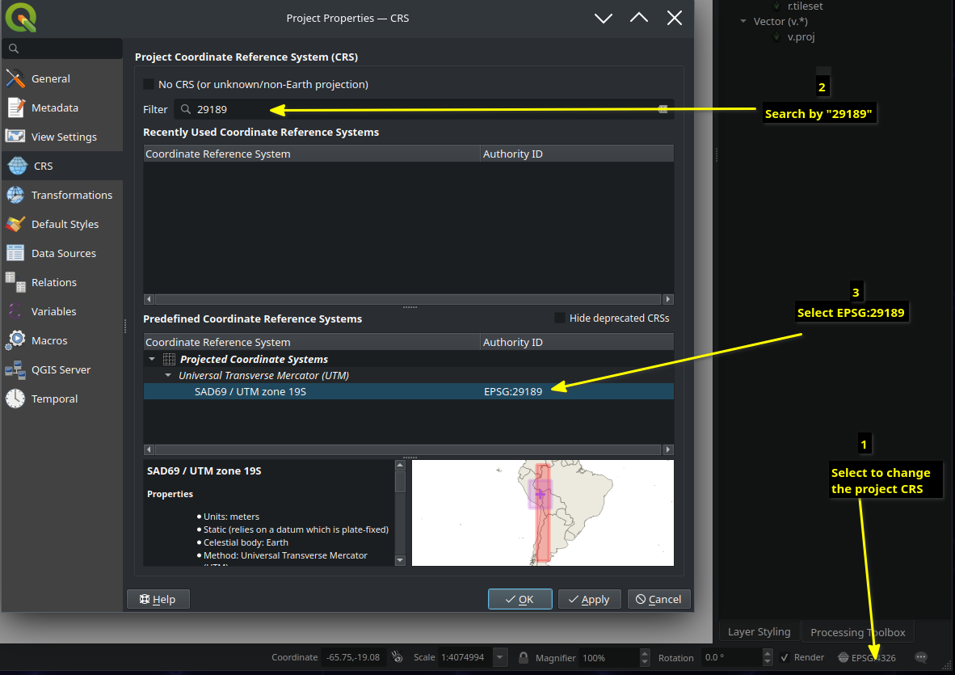

The we are going to project the layer. Re-project layer is an algorithm re-projects a vector layer. It creates a new layer with the same features as the input one, but with geometries reprojected to a new CRS. Attributes are not modified by this algorithm.

We are re-projecting the Housing_AC layer into the the project default layer which is EPSG 29189

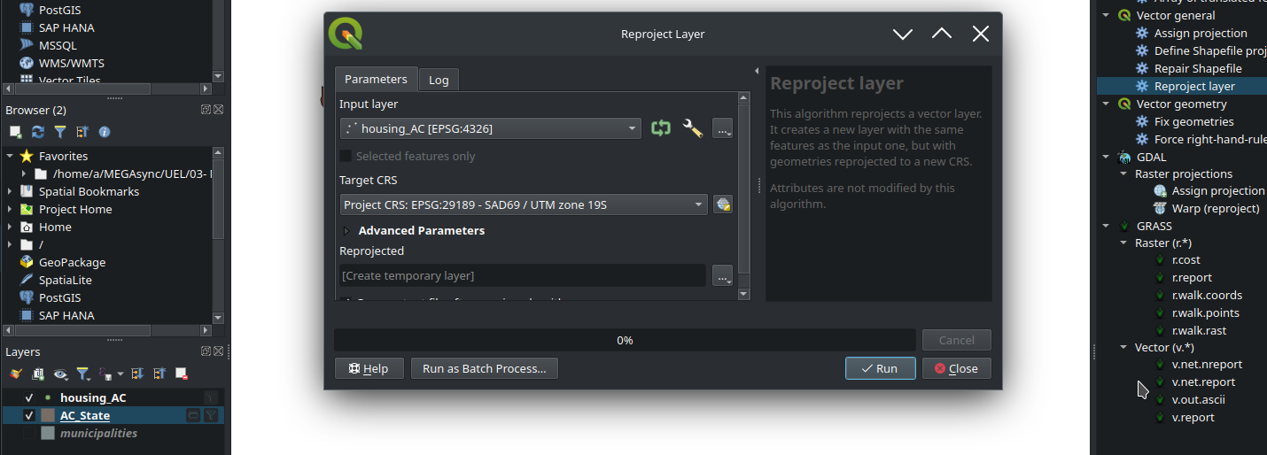

**Calculating Distance**

We are going to use Distance matrix,it calculates for point features distances to their nearest features in the same layer or in another layer. Below are the parameters briefly explained as in QGIS documentation

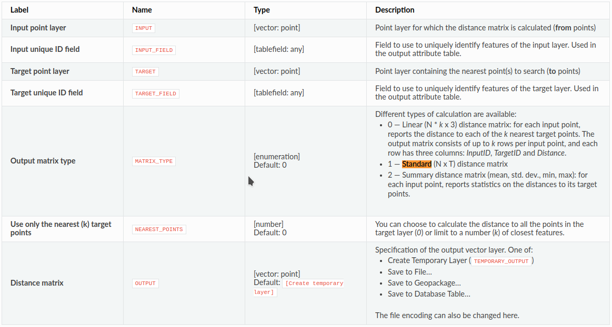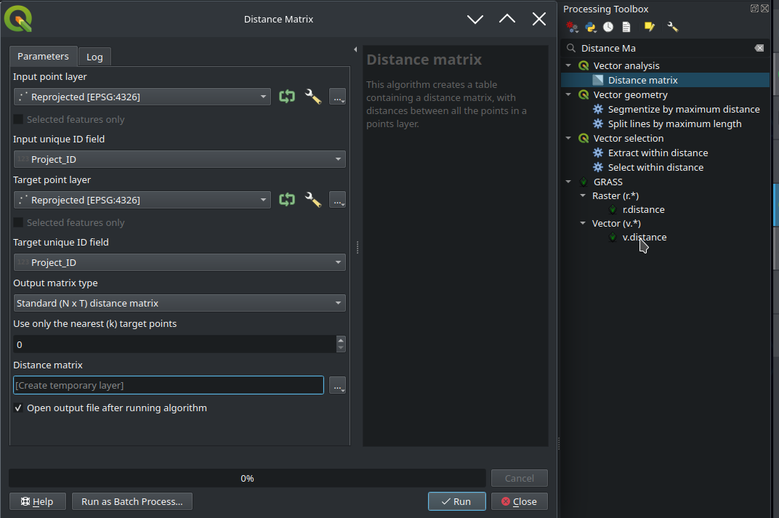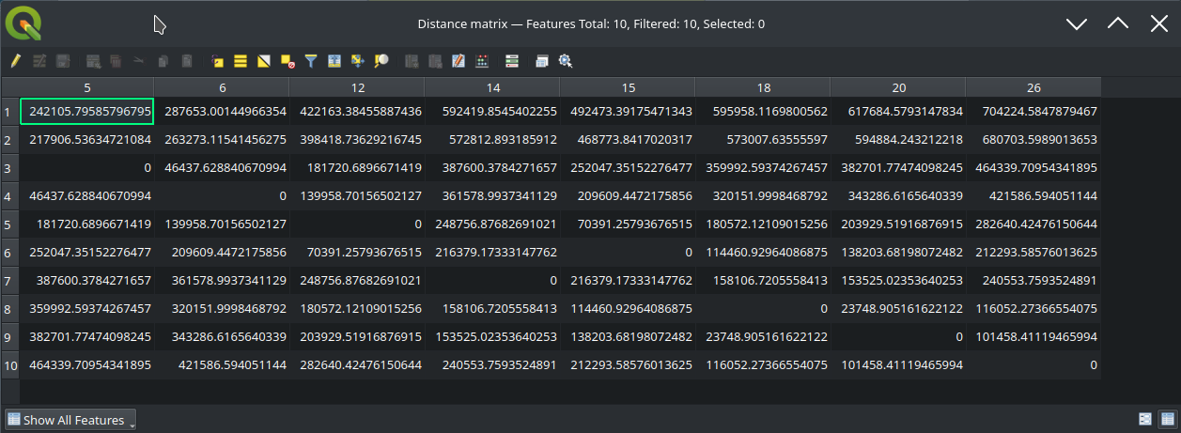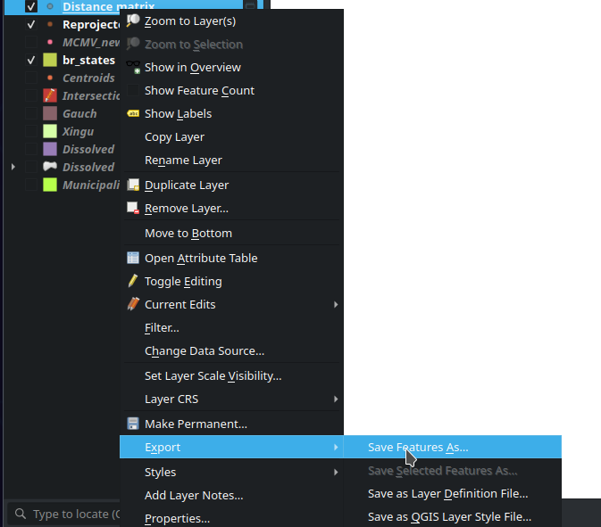

After saving the distance results, we are going to make buffer with fixed distance around reach point, using Multi-ring- buffer (constant distance ) algorithm, This algorithm computes multi-ring ('donuts') buffer for all the features in an input layer, using a fixed or dynamic distance and rings number. Below are the parameters Multi-ring- buffer (constant distance) as in Qgis documentation

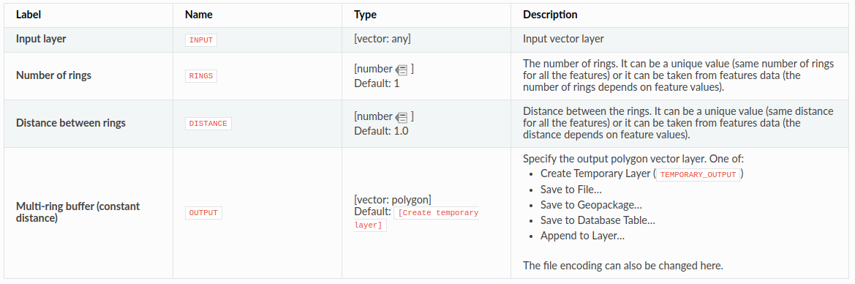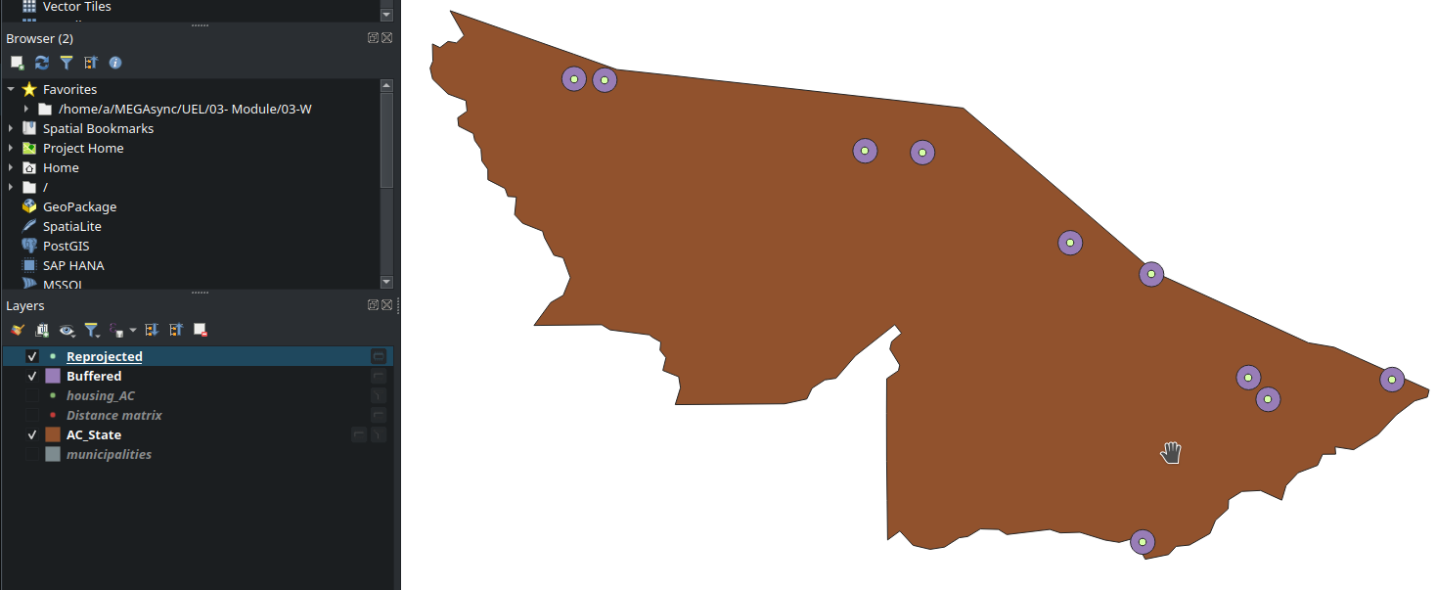

**Across Brazil, which municipalities have the lowest and highest number of MCMV housing units (UH) in its territory? Create a map of the distribution of total housing units by municipalityy.**

* 1. First importing the required layers

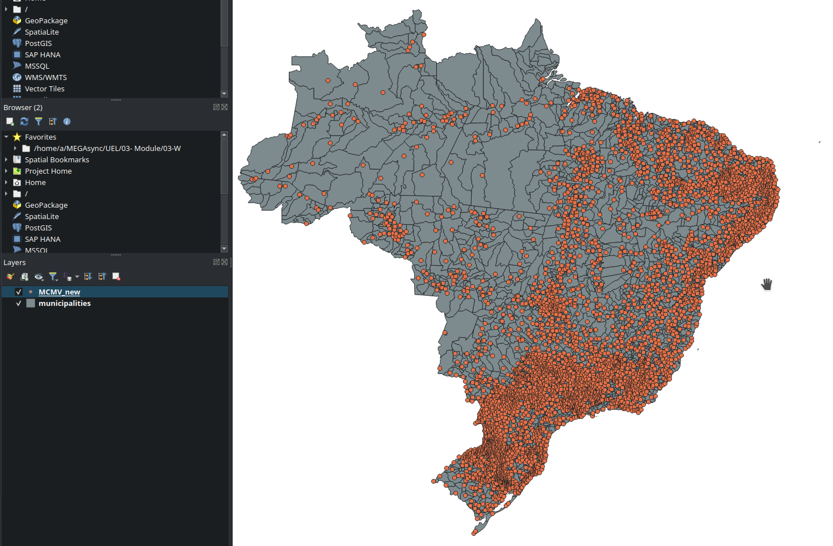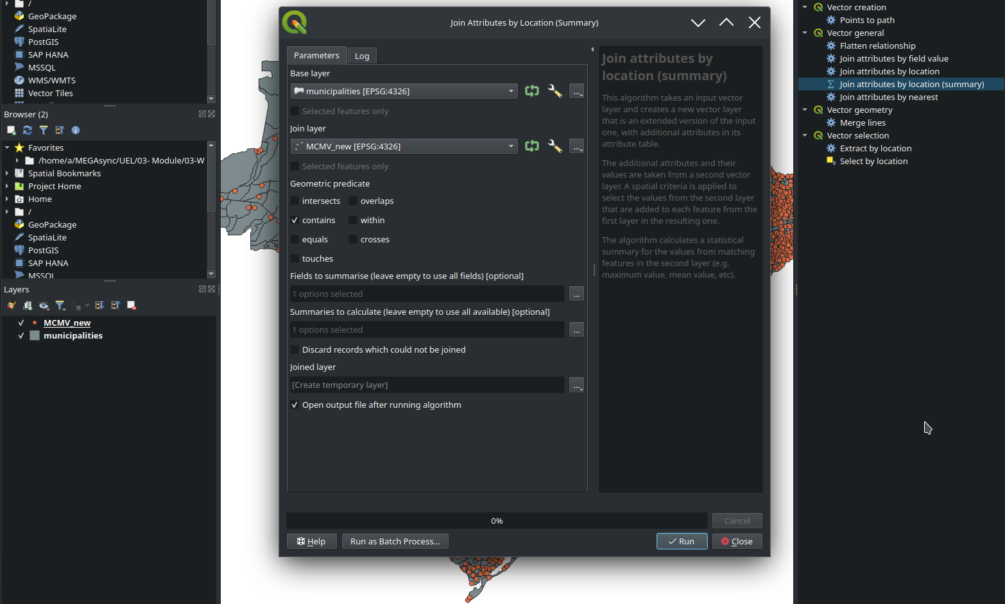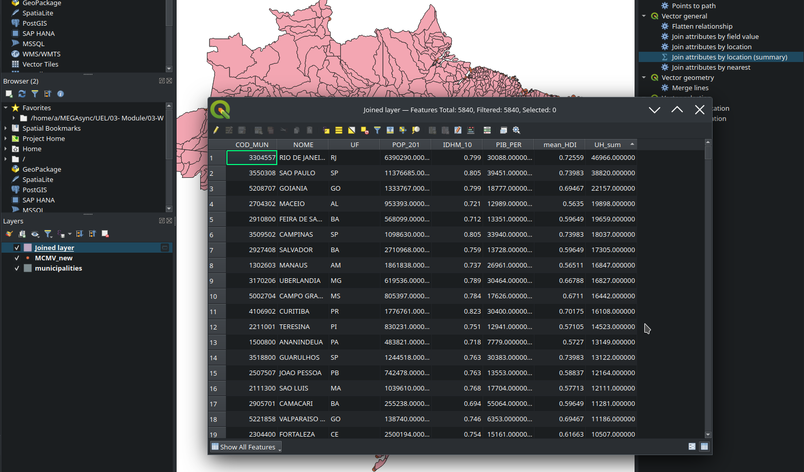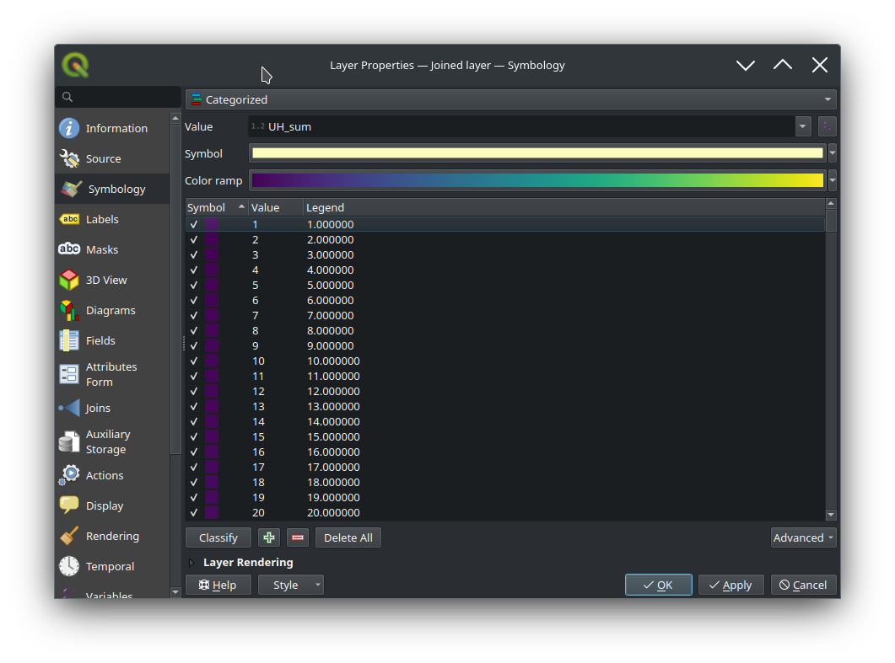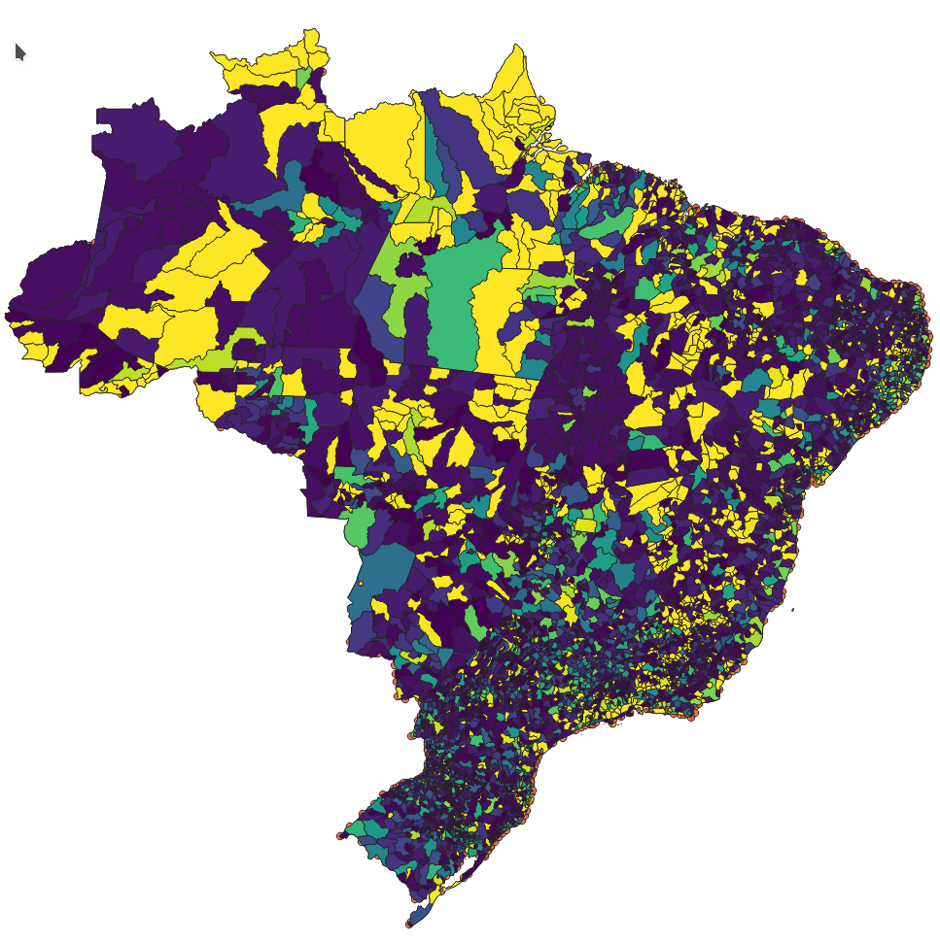

# **4.Week 4 Formative Assessment**

## 4.1 Introduction

Week 4's exploration into the intricacies of thematic mapping stands as a testament to the depth and breadth of spatial data representation. Thematic maps, in essence, are a visual representation of data variations across a specific geographical area. Unlike general reference maps that show general geographical details, thematic maps are designed to emphasize the spatial variation of one or two specific data distributions. This week's focus, therefore, has been not just on understanding these thematic maps but on diving deep into the methods of representation, their pros and cons, and their application in real-world scenarios.

The array of questions posed this week reflects a broad spectrum of learning objectives. From the basic comparisons between different map types to the intricacies of designing legends for specific datasets, the assessment was methodically structured to encapsulate the crux of thematic mapping. Moreover, by juxtaposing multiple mapping techniques for the same dataset, the questions aimed at invoking a deeper understanding of how different visualization methods can lead to different interpretations of the same data.

A recurrent theme this week was the representation of population density and unemployment rates. These are, undoubtedly, vital socio-economic parameters that policymakers, researchers, and academicians often grapple with. Their representation, if skewed or misunderstood, can lead to misguided policies or flawed research. It was, hence, imperative to understand not just the 'how' but also the 'why' behind the choice of one map type over another.

Lastly, the week was also about the art and science of map designing. An effective map is not just about accurate data representation; it's about ensuring that the reader can easily and accurately interpret the information. This balance between aesthetics, accuracy, and ease of interpretation was a major learning objective, as reflected in the question about sketching legends for different map types.

## 4.2 Assessment Summaries

The fourth week of assessments embarked on a comprehensive exploration of thematic maps, delving into their types, characteristics, and application nuances. Here is a brief overview of the topics addressed:

The initial question set the tone by prompting a comparison between the advantages and limitations of different thematic map types. This foundationally established the understanding of when and where each map type would be most suitable. As the progression continued, the next task was to discern the most fitting methods to visually represent population density, a parameter frequently mapped due to its socio-economic significance.

A major highlight was the deep dive into choropleth maps. The query about why choropleth maps often show derived data illuminated the importance of normalized data representation in spatial visualizations. This, coupled with the directive to design a choropleth map showcasing unemployment rates, demonstrated the practical application of this understanding.

Another insightful aspect of the assessment was the exploration of classification in thematic maps. The discussion encompassed why certain thematic maps necessitate classification while others don't, emphasizing the need for accurate data depiction without compromising simp

licity or leading to misinterpretation.

The week's exercises culminated in hands-on tasks, such as creating proportional symbol maps and graduated symbol maps for identical datasets. This direct juxtaposition enabled a clear understanding of how distinct visualization techniques can impact data interpretation. Lastly, the directive to sketch legends for a gamut of thematic map types served as a testament to the significance of effective map legends in guiding readers in their interpretation of spatial data.

Overall, the week was a blend of theoretical understanding, practical application, and the artistry involved in map design and representation.

## 4.3 Key Findings or Insights

The exploration of thematic maps in the fourth week unveiled a plethora of enlightening findings and insights:

Depth of Thematic Maps: Thematic maps are not just simple visual representations. Their designs, types, and applications are deeply rooted in the principles of geography, cartography, and even psychology, as they cater to human understanding and interpretation.

Map Selection Matters: Not all maps are created equal, and the choice of map type can heavily influence the clarity and accuracy of the information conveyed. For instance, population density can be most effectively represented using dot density maps or choropleths, while a proportional symbol map may not be the best choice for such data.

Normalization in Choropleth Maps: A standout insight was the significance of using derived data in choropleth maps. Raw data, if not standardized or normalized, can lead to misleading interpretations. For example, mapping the absolute number of unemployed individuals might not be as insightful as mapping the unemployment rate, which provides context based on population size.

Classification is Key but Contextual: The need to classify data for certain thematic maps while abstaining for others reiterated the importance of context. Classifying continuous data might simplify the visualization but could also omit nuanced details.

Visual Variables & Symbols: Different thematic maps employ varied visual variables and symbol dimensionalities. The choice of color, size, shape, and position can greatly affect a map's effectiveness. For example, a graduated symbol map uses size as a primary visual variable, while an isoline map might depend more on color and position to represent data variability.

Legends as Essential Guides: One crucial realization was that legends aren't just supplementary elements; they are central to map interpretation. A well-designed legend can aid clarity, while a poor one can render even the most meticulously crafted map ineffective.

Comparison Enhances Understanding: Creating both a proportional symbol map and a graduated symbol map for the same dataset showcased how different visualizations can lead to varied interpretations. It reinforced the notion that the medium (in this case, the map type) can significantly influence the message.

In essence, this week's exploration underscored the significance of thoughtful map creation and the myriad considerations that cartographers and geographers must keep in mind to ensure effective spatial communication.

## 4.4 Challenges and Solutions

This week's assessment illuminated various challenges associated with thematic map creation and interpretation. However, with each obstacle arose an opportunity to find innovative solutions:

Choosing the Right Map Type: One of the primary challenges was discerning which thematic map type best represents specific data. Using population density as an example, while several map types can depict this information, not all do so with the same effectiveness. Solution: Through a process of trial and error, and understanding the nuances of each map type, the decision was made that dot density maps or choropleths are optimal choices for such data representation.

Derived Data in Choropleth Maps: The dilemma of using raw versus derived data in choropleth maps was evident. Without normalization, raw data could paint a misleading picture. Solution: By always using derived data, such as rates or percentages, more context-aware representations were ensured, leading to more accurate interpretations.

Classifying Data: While classification can simplify the visualization process, it can also potentially omit significant details, leading to loss of nuanced information. Solution: Understanding when to classify and when not to is essential. For continuous data, natural breaks or quantile classifications were utilized, ensuring a more intuitive data representation.

Designing Effective Legends: Crafting a legend that accurately complements the map proved challenging, as it required balancing clarity with brevity. Solution: Keeping the legend simple, clear, and intuitive while ensuring it effectively conveys the map's scale and data distribution proved effective.

Visual Variables and Symbol Dimensionalities: With a plethora of visual variables available, deciding on which ones to employ for specific thematic map types was daunting. Solution: A systematic approach was adopted, ensuring, for instance, that size was the primary visual variable for a graduated symbol map, and color and position were prioritized for isoline maps.

Comparing Maps: When creating both a proportional symbol map and a graduated symbol map using the same dataset, the challenge lay in understanding the subtle differences in their representations. Solution: By juxtaposing the two and analyzing their legends side by side, the contrasts became evident, reinforcing the importance of selecting the appropriate map type for specific data.

In conclusion, while thematic map creation is fraught with challenges, they can be overcome with a deep understanding of cartographic principles, combined with practical experience and a dash of creativity.

## 4.5 Skills and Knowledge Gained

The week's engagement with thematic mapping provided an enriching journey, imparting both theoretical knowledge and practical skills, which broadened my understanding and appreciation for cartographic representation. Here's a detailed breakdown:

Understanding of Thematic Map Types: The assessment offered a deep dive into the variety of thematic maps available. I not only learned the differences between choropleth, proportional symbol, graduated symbol, isoline, dot density, dasymetric, and flow maps but also recognized their specific applications.

Data Representation Techniques: Grappling with the best methods to represent population density, for example, underscored the significance of selecting the correct map type to ensure data is not just visualized but also contextualized appropriately for the intended audience.

Importance of Derived Data: Through the exercise with choropleth maps, I discerned the crucial role of derived data, such as rates and percentages, in preventing the misinterpretation of raw data, ensuring a more accurate and context-aware representation.

Classification Techniques: The task shed light on the complexities and nuances of classifying data for thematic maps. I became proficient in discerning when to employ natural breaks, quantiles, or even when to avoid classification altogether.

Design Principles: Creating legends and selecting visual variables honed my design skills. I understood the need for clarity, simplicity, and effectiveness in design choices to ensure that maps are easily interpretable.

Comparative Analysis: By creating both proportional and graduated symbol maps for the same dataset, I learned the art of juxtaposition. This taught me not only to analyze data in isolation

but also to compare and contrast varying representations to glean more profound insights.

Technical Proficiency: The hands-on tasks, like sketching legends and producing various thematic maps, enhanced my technical skills in map creation, making me adept at using GIS tools with increased efficiency and precision.

Critical Thinking: The tasks demanded not just rote application but critical thinking – questioning choices, foreseeing potential pitfalls in representation, and constantly aligning the representation with the intended message or insight.

In reflection, this week's endeavors were not just about producing maps but understanding the science, art, and philosophy behind them. I am now better equipped to approach cartography with a balance of technical know-how, design sensibility, and a critical mindset.

## 4.6 Future Applications

Gleaning insights from Week 4's deep immersion into thematic maps and their intricacies has opened a vista of potential applications across diverse fields and scenarios. Here's a projection of the numerous future uses and implications:

Data Journalism and Storytelling: With an enhanced grasp of the nuances between different thematic maps, there's an opportunity to use these maps in journalism to tell compelling stories. Whether it's showcasing socio-economic disparities or highlighting environmental concerns, the right thematic map can make data-driven stories resonate with a broader audience.

Public Policy and Governance: Understanding the advantages, limitations, and appropriate contexts for different map types, such as choropleth vs. dot density, can aid in formulating clearer, more effective public policies. When decision-makers can visualize issues like unemployment or crime rates accurately, they can devise more targeted interventions.

Tourism and Heritage Conservation: Maps like dasymetric or isoline can be used to highlight tourist hotspots or culturally significant zones, facilitating better conservation efforts and more immersive travel experiences.

Disaster Management: In times of crises like floods, earthquakes, or wildfires, the capability to represent data efficiently can be life-saving. By comparing proportional symbol maps with graduated ones, for instance, response teams can pinpoint vulnerable areas and allocate resources more effectively.

Real Estate and Infrastructure: The property market can benefit immensely from a well-crafted thematic map. By showcasing aspects like population density, accessibility, or even environmental factors, potential buyers, investors, and developers can make informed choices.

Environmental Advocacy: NGOs and environmental groups can use thematic maps like choropleth or flow maps to highlight areas of environmental concern, such as deforestation zones or water scarcity regions, driving both awareness and action.

Healthcare Planning: With the ongoing challenges in global health, having the ability to visually represent data like disease outbreaks or healthcare facility distribution using the most apt thematic map can guide public health strategies.

Transport and Urban Development: Building on Week 3's learnings, the deeper dive of Week 4 further emphasizes the potential of flow maps and dot density maps in understanding traffic patterns, optimizing public transportation routes, and planning urban expansions.

Academic Research: In academia, the knowledge gained can be applied to present findings in a more accessible and visually appealing manner, enhancing both understanding and dissemination.

In conclusion, Week 4 has not just been an academic exercise but a gateway to applying these map-making techniques in real-world scenarios. Equipped with this enriched perspective, I am poised to harness the power of thematic mapping to illuminate, engage, and inspire across myriad sectors and contexts.

## 4.7 Conclusion

Week 4's journey into the realm of thematic maps has been nothing short of transformative. Delving beyond the surface, the week's activities facilitated a more profound understanding f the complexities, nuances, and potentialities inherent in cartographic representation.

It became evident that maps are not just passive tools for spatial visualization but active instruments that shape understanding, influence decisions, and drive narratives. The importance of making informed choices – from selecting the right type of map to the finer aspects of design, classification, and data representation – cannot be overstated. Such choices determine not just the accuracy but also the integrity and efficacy of the information conveyed.

The exercises, comparisons, and practical applications underlined the versatility and indispensability of thematic maps in diverse sectors, be it urban planning, public policy, environmental advocacy, or data journalism. Furthermore, the hands-on experience of creating and interpreting various map types underscored the significance of both the science and the art of cartography.

In retrospect, Week 4 has not just enriched the toolkit of cartographic skills but has also instilled a deeper appreciation for the role of thematic maps in our interconnected, data-driven world. As the journey of learning continues, this week serves as a solid foundation, inspiring both confidence and curiosity to explore further, innovate, and make impactful contributions in the world of cartography and beyond.

## **Week 7 Formative Assessment Submission**

1. **Compare and contrast the advantages and limitations of different thematic map types.**

Thematic maps are a type of map that depict the distribution of one or several

geographic phenomena, using a base reference information as context for interpreting spatial variation in the thematic information (Roth et al., 2019). They are widely used in various fields such as biology, geology, geography, and business (Roth et al., 2019; Słomska-Przech & Gołębiowska, 2021). Thematic maps can be classified into different

types based on the visual variables used to encode the thematic information and the visual metaphor they evoke in the relationship between the thematic symbol and the reference context (Roth et al., 2019).

One common type of thematic map is the choropleth map, which uses color to represent the variation in a thematic attribute of interest (Roth et al., 2019). Choropleth maps are particularly suitable for representing continuous and abrupt phenomena, such as tax rates or population density (Roth et al., 2019). They are visually effective in highlighting spatial patterns and can provide a quick overview of the distribution of a particular variable (Tennekes, 2018). However, choropleth maps have limitations. They can be influenced by the choice of color scheme and may lead to misinterpretation if the color ramp is not carefully chosen (Tennekes, 2018). Additionally, choropleth maps may not be suitable for representing discrete or smooth phenomena (Roth et al., 2019).

Another type of thematic map is the dot density map, which uses a combination of arrangement and size to represent the thematic information (Roth et al., 2019). Dot density maps are commonly used to represent discrete and smooth phenomena, such as population distribution or social phenomena (Roth et al., 2019). They can effectively show the density or numerosity of a particular variable in different areas (Roth et al., 2019). However, dot density maps can be visually cluttered and may require careful design to avoid overlapping dots and maintain readability (Słomska-Przech & Gołębiowska, 2021).

Proportional symbol maps are another type of thematic map that use size to represent the thematic information (Roth et al., 2019). Proportional symbol maps are suitable for representing discrete and abrupt phenomena, such as economic sites of production (Roth et al., 2019). They can effectively show the relative magnitude of a variable in different locations (Roth et al., 2019). However, proportional symbol maps may not be suitable for representing continuous or smooth phenomena (Roth et al., 2019). Isoline maps are a type of thematic map that use location to represent the thematic information (Roth et al., 2019).

Isoline maps create a new set of geographic linework based on the thematic information and can also include a color ramp between isolines similar to choropleth maps (Roth et al., 2019). Isoline maps are commonly used to represent continuous and smooth phenomena, such as environmental or physical phenomena (Roth et al., 2019). They can effectively show the spatial variation and gradients of a variable (Roth et al., 2019). However, isoline maps may not be suitable for representing discrete or abrupt phenomena (Roth et al., 2019).

Each type of thematic map has its own advantages and limitations. Choropleth maps are visually effective in highlighting spatial patterns and providing a quick overview of the distribution of a variable, but they can be influenced by color choices and may not be suitable for representing discrete or smooth phenomena. Dot density maps can effectively show the density or numerosity of a variable, but they can be visually cluttered and require careful design. Proportional symbol maps can effectively show the relative magnitude of a variable, but may not be suitable for representing continuous or smooth phenomena. Isoline maps can effectively show the spatial variation and gradients of a variable, but may not be suitable for representing discrete or abrupt

phenomena (Roth et al., 2019).

In conclusion, different thematic map types have their own advantages and limitations. The choice of map type depends on the nature of the data and the purpose of the map. It is important to carefully consider the visual variables used and the visual metaphor evoked by the map type to ensure accurate and effective representation of the thematic information.

1. **Identify and discuss the best methods to represent population density in a thematic map.**

When representing population density in a thematic map, there are several methods that can be used. The choice of method depends on the nature of the data and the goals of the map. Here, we will discuss some of the best methods to represent population density in a thematic map.

One commonly used method is the choropleth map.Choropleth maps use color to represent the variation in population density across different regions or administrative units (Roth et al., 2019). The color scheme used in choropleth maps should be carefully chosen to accurately represent the population density and avoid misinterpretation (Chen et al., 2019). Progressive colors from red to yellow are often adopted to represent population density, with darker colors indicating higher density (Chen et al., 2019). Choropleth maps are effective in highlighting spatial patterns and providing a quick overview of population density across different areas (Roth et al., 2019). However, it is important to note that choropleth maps may be influenced by the choice of color scheme and can be limited in representing discrete or smooth phenomena (Roth et al., 2019).

Another method is the dot density map. Dot density maps use a combination of arrangement and size to represent population density (Roth et al., 2019). Each dot on

the map represents a certain number of people, and the density of dots in a particular area indicates the population density (Roth et al., 2019). Dot density maps are particularly suitable for representing discrete and smooth phenomena, such as population distribution (Roth et al., 2019). However, dot density maps can be visually cluttered and may require careful design to avoid overlapping dots and maintain readability (Roth et al., 2019).

Proportional symbol maps are another method that can be used to represent population density. Proportional symbol maps use the size of symbols to represent the population density in different areas (Roth et al., 2019). Larger symbols indicate higher population density, while smaller symbols indicate lower density (Roth et al., 2019). Proportional symbol maps are effective in showing the relative magnitude of population density across different locations (Roth et al., 2019). However, like dot density maps, proportional symbol maps may also suffer from visual clutter if the symbols are too close together (Roth et al., 2019).

Isoline maps can also be used to represent population density. Isoline maps create a new set of geographic linework based on the population density, with lines connecting areas of equal density (Roth et al., 2019). Isoline maps are particularly suitable for representing continuous and smooth phenomena, such as population gradients (Roth et al., 2019). They effectively show the spatial variation and gradients of population density (Roth et al., 2019). However, isoline maps may not be suitable for representing discrete or abrupt phenomena (Roth et al., 2019).

In conclusion, there are several methods to represent population density in a thematic map, including choropleth maps, dot density maps, proportional symbol maps, and isoline maps. The choice of method depends on the nature of the data and the goals of the map. Choropleth maps are effective in highlighting spatial patterns, while dot density maps and proportional symbol maps are suitable for representing discrete and smooth phenomena. Isoline maps are effective in showing population gradients. It is important to carefully consider the strengths and limitations of each method when selecting the most appropriate one for representing population density in a thematic map.

**Why should a choropleth map (almost) always show derived data? Provide a mapping example when the exception to this rule applies.**

A choropleth map is a commonly used method to represent derived data, particularly when it comes to statistical or aggregated information that is summarized based on polygon boundaries (Koo et al., 2018). Choropleth maps use color or shading to represent the variation in a particular attribute across different regions or administrative units (Roth et al., 2019). This method is effective in visually highlighting spatial patterns and providing a quick overview of the distribution of the derived data (Słomska-Przech & Gołębiowska, 2021).

The reason why a choropleth map is often used to represent derived data is that it simplifies complex information and makes it easier to understand and interpret. By dividing the geographic area into discrete regions and assigning colors or shades to each region based on the derived data, choropleth maps provide a clear visual representation of the data distribution (Patterson et al., 2015). This allows viewers to quickly grasp the general patterns and variations in the derived data across different regions (Słomska-Przech & Gołębiowska, 2021).

However, it is important to note that choropleth maps have limitations and may not always be the best choice for representing certain types of data. One exception to the rule of using derived data in choropleth maps is when the data being represented are already discrete and do not require aggregation or summarization. For example, if the data being represented are already at the individual level, such as the location of specific events or points of interest, it may be more appropriate to use a different type of thematic map, such as a dot density map or a proportional symbol map (Słomska-Przech & Gołębiowska, 2021).

Dot density maps use a combination of arrangement and size to represent discrete data, such as the distribution of individual events or points of interest. Each dot on the map represents a certain number of occurrences, and the density of dots in a particular area indicates the concentration or intensity of the data. Proportional symbol maps, on the other hand, use the size of symbols to represent discrete data, with larger symbols indicating higher values or frequencies. These types of maps are more suitable when the focus is on the individual occurrences or discrete values, rather than aggregated or derived data.

In conclusion, a choropleth map is a powerful method for representing derived data, as it simplifies complex information and provides a clear visual representation of the data distribution across different regions. However, there are exceptions to this rule, particularly when the data being represented are already discrete and do not require aggregation or summarization. In such cases, dot density maps or proportional symbol maps may be more appropriate for representing the individual occurrences or discrete values. The choice of map type should always consider the nature of the data and the goals of the map.

1. **Describe why you should classify some thematic map types but not others.**

The classification of thematic map types is influenced by several factors, including the nature of the data, the goals of the map, and the visual variables used to represent the thematic information. While some thematic map types require classification, others do not.

Thematic map types that typically require classification include choropleth maps, proportional symbol maps, and isoline maps. These map types involve the representation of continuous or discrete data that need to be grouped or categorized into distinct classes or ranges. Classification is necessary to simplify complex data and make it easier to interpret and understand. For example, in a choropleth map representing population density, the population values are classified into different ranges or categories, and each category is assigned a specific color or shade to represent the density level Fauvel et al. (2013). This classification allows viewers to quickly identify areas with high or low population density and understand the spatial patterns.

On the other hand, thematic map types such as dot density maps may not require classification. Dot density maps use the arrangement and size of dots to represent discrete data, such as the distribution of individual events or points of interest (Roth et al., 2019). Each dot on the map represents a certain number of occurrences, and the density of dots in a particular area indicates the concentration or intensity of the data. In this case, the data are already discrete and do not need to be classified into different categories.

The decision to classify or not classify a thematic map type depends on the nature of the data and the goals of the map. If the data are continuous or discrete and need to be grouped into distinct categories or ranges, classification is necessary to simplify the data and enhance its visual representation. However, if the data are already discrete and do not require further categorization, classification may not be needed.

It is important to note that the classification process in thematic mapping should be carefully considered. The choice of classification method, such as equal interval, quantile, or natural breaks, can significantly impact the interpretation of the map (Foody, 2008). The classification should be based on the characteristics of the data and aim to effectively communicate the patterns and variations in the thematic information.

In conclusion, the classification of thematic map types depends on the nature of the data and the goals of the map. Thematic map types such as choropleth maps, proportional symbol maps, and isoline maps often require classification to simplify complex data and enhance their visual representation. However, thematic map types like dot density maps may not require classification if the data are already discrete. The choice of classification method should be carefully considered to ensure accurate and meaningful representation of the thematic information.

1. **What visual variables and symbol dimensionalities are used for each thematic map type and how do these differences impact their design and use?**

Thematic maps utilize various visual variables and symbol dimensionalities to represent different types of data. The choice of these variables and dimensions impacts the design and use of thematic maps, as they influence how the data is perceived and understood by map users.

Choropleth maps typically employ the visual variable of color, particularly color value, to represent the variation in a thematic attribute across different regions or administrative units (Roth et al., 2019). The color scheme used in choropleth maps can range from single-hue to multi-hue or saturation, and the choice of color ramp can significantly impact the interpretation of the map (Tennekes, 2018). The use of color in choropleth maps allows for the quick identification of spatial patterns and variations in the data (Roth et al., 2019). However, it is important to consider the potential influence of the basemap color on the perception of the thematic map layers (Tennekes, 2018).

Dot density maps, on the other hand, use the visual variables of arrangement and size to represent discrete data (Roth et al., 2019). Each dot on the map represents a certain number of occurrences, and the density of dots in a particular area indicates the concentration or intensity of the data (Roth et al., 2019). The arrangement and size of the dots allow for the visualization of the numerosity or density of the data, providing a clear understanding of the distribution (Roth et al., 2019).

Proportional symbol maps utilize the visual variable of size to represent the thematic information (Roth et al., 2019). The size of symbols is proportional to the attribute being represented, allowing for the comparison of relative magnitudes across different locations (Roth et al., 2019). Proportional symbol maps are effective in highlighting the spatial variation and patterns of the data (Roth et al., 2019). Isoline maps use the visual variable of location to represent the thematic information (Roth et al., 2019).

Isolines are created by connecting areas of equal value, and the spacing or density of isolines indicates the rate of change or gradient of the data (Roth et al., 2019). Isoline maps effectively show the continuous and smooth variation of the data across space (Roth et al., 2019).

The differences in visual variables and symbol dimensionalities impact the design and use of thematic maps in several ways. Firstly, the choice of visual variables affects the perceptual salience of the data. For example, color is a highly effective variable for highlighting patterns and variations, while size can be used to compare magnitudes. The selection of appropriate visual variables ensures that the map effectively communicates the intended message to the map users (Roth et al., 2019).

Secondly, the symbol dimensionalities used in thematic maps influence the level of detail and complexity conveyed to the map users. For instance, dot density maps can provide a more granular representation of discrete data by showing individual occurrences, while choropleth maps simplify the data by aggregating it into predefined regions (Roth et al., 2019). The choice of symbol dimensionality should align with the nature of the data and the goals of the map. Furthermore, the visual variables and symbol dimensionalities impact the interpretability and readability of thematic maps. The effective use of visual variables can enhance the legibility of the map and facilitate the understanding of the data patterns (Jürgens, 2020). On the other hand, inappropriate or excessive use of visual variables can lead to visual clutter and confusion, making it difficult for map users to extract meaningful information (Jürgens, 2020).

In conclusion, the visual variables and symbol dimensionalities used in thematic maps play a crucial role in their design and use. The selection of appropriate visual variables ensures effective communication of the data, while the choice of symbol dimensionalities influences the level of detail and complexity conveyed. By carefully considering these factors, map designers can create thematic maps that effectively represent and communicate the intended information to map users.

1. **Create a choropleth map showing the unemployment rate within a selected country. Design an appropriate legend for the map.**

Creating a choropleth map in QGIS to show unemployment rates within for US by each State. Here's a general step-by-step steps:

* Obtain spacial data for USA .This file will provide the geometries (like borders of states, districts, or other administrative divisions).
* You also need unemployment rate data for each of the respective regions within that country. This can come in a variety of formats (like CSV, of Excle). Ensure you have a unique identifier in both datasets that can be used to join them.

To Obtain spacial data for USA we can find it here <https://www.bls.gov/web/laus/laumstrk.htm>

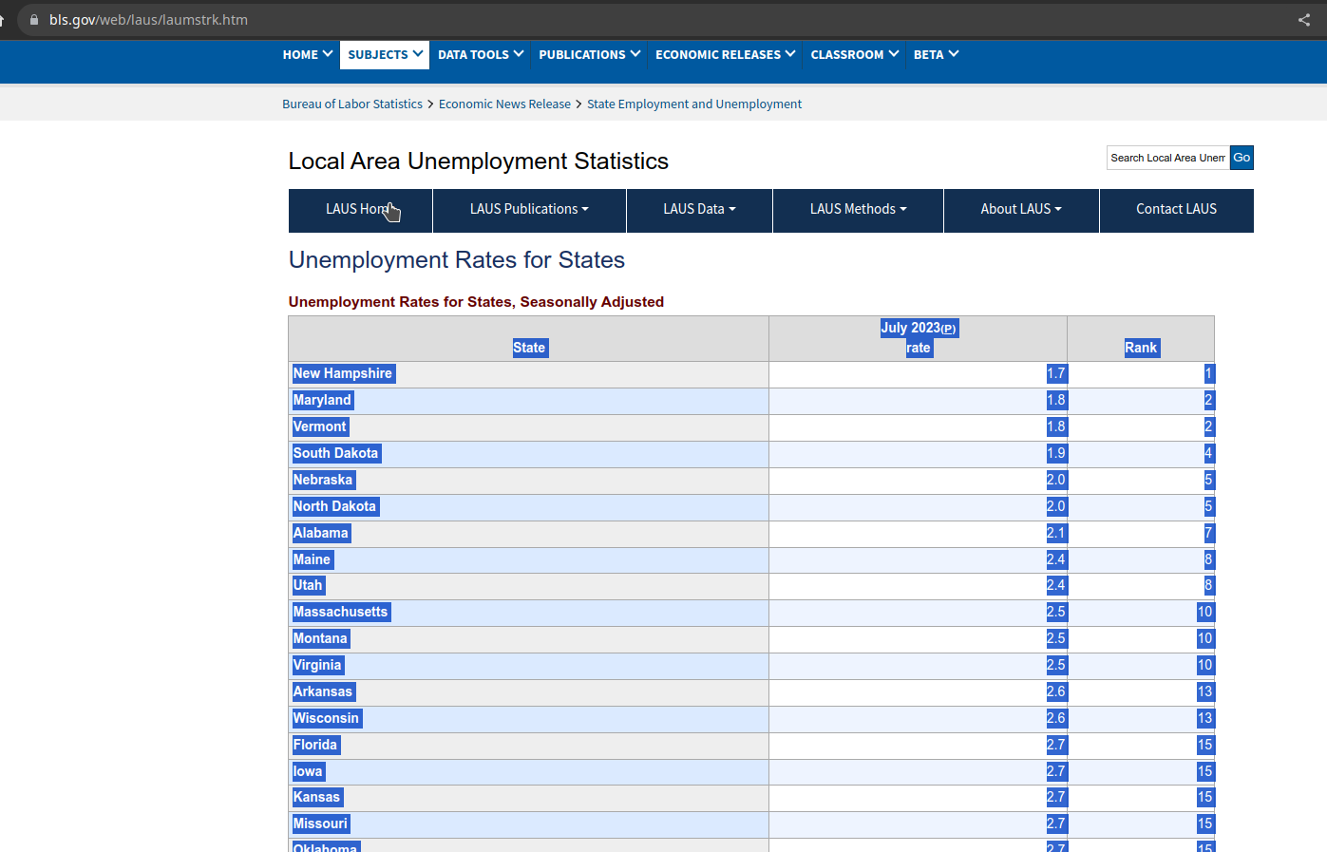

By coping the data into spread sheet as shown below , note we removed the Rank colum since is not needed

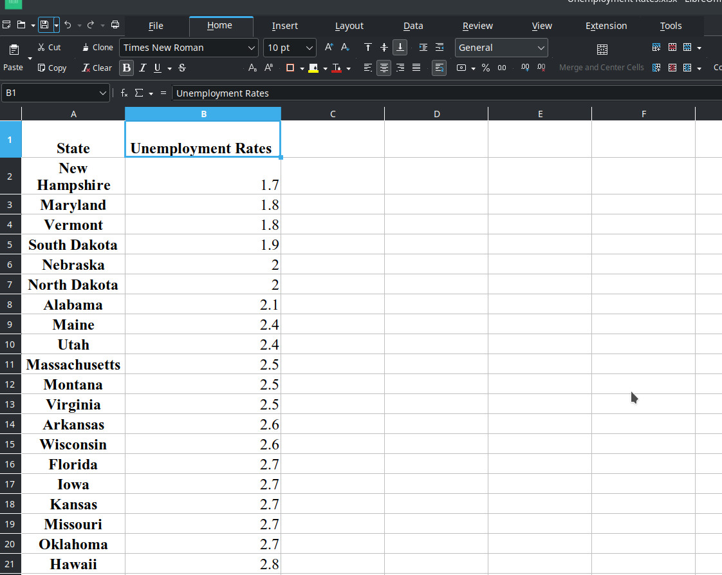

WE can obtain US shap map by state from the official website of the United States government <https://catalog.data.gov/dataset/tiger-line-shapefile-2017-nation-u-s-current-state-and-equivalent-national> as shown below

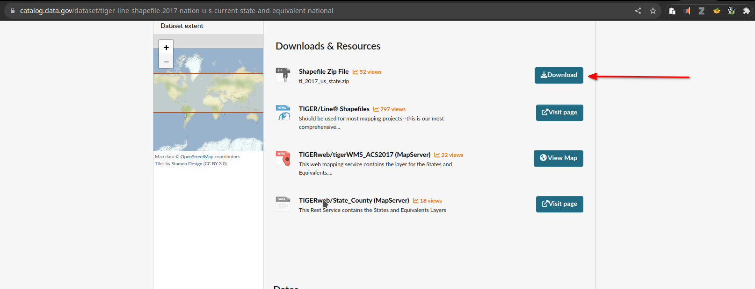

Then importong Both files into QGIS.

Below is the impoted excell sheet layer

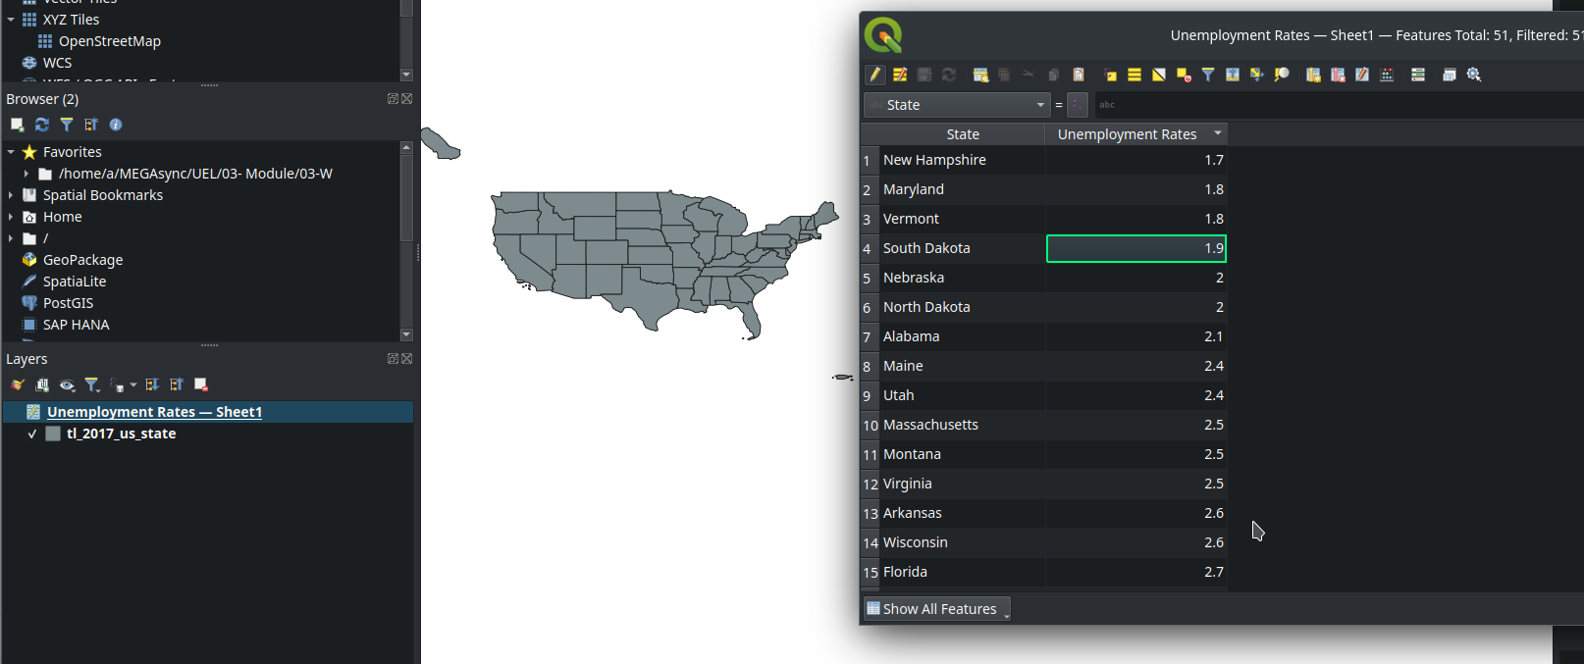

There is US shape layer by state

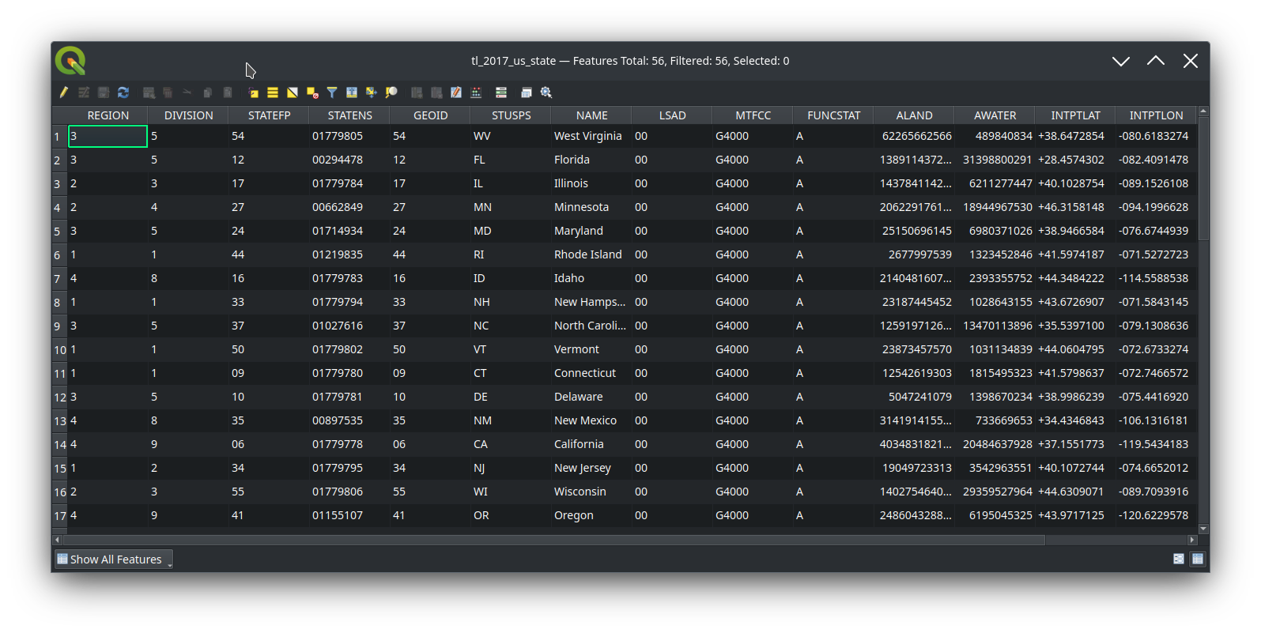

Then joining the two layer by state name in both using State name as key in both layers



Now the the unimpoyment rate has been maped for each state as below

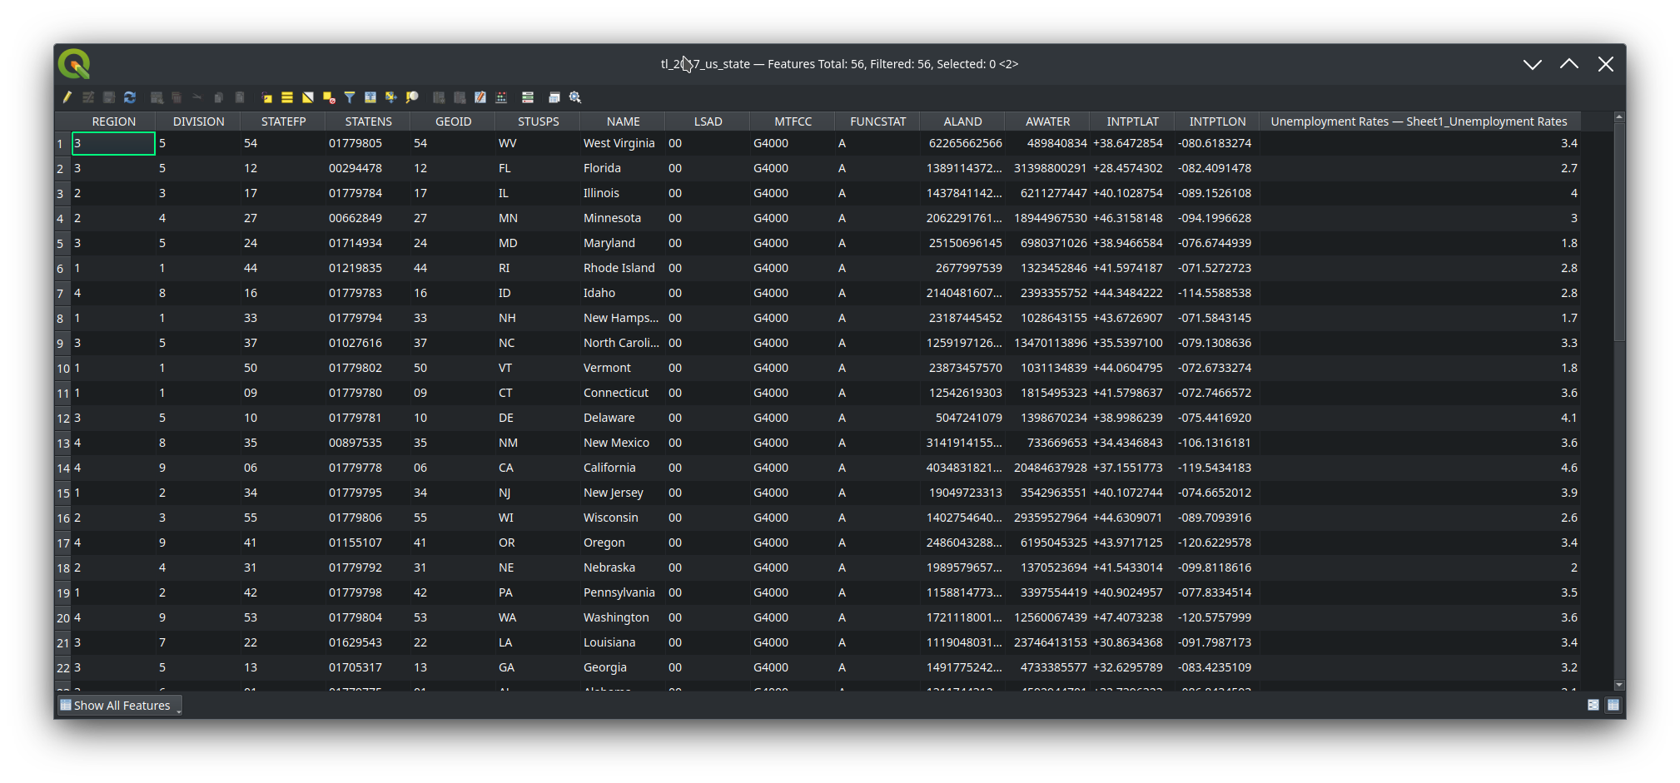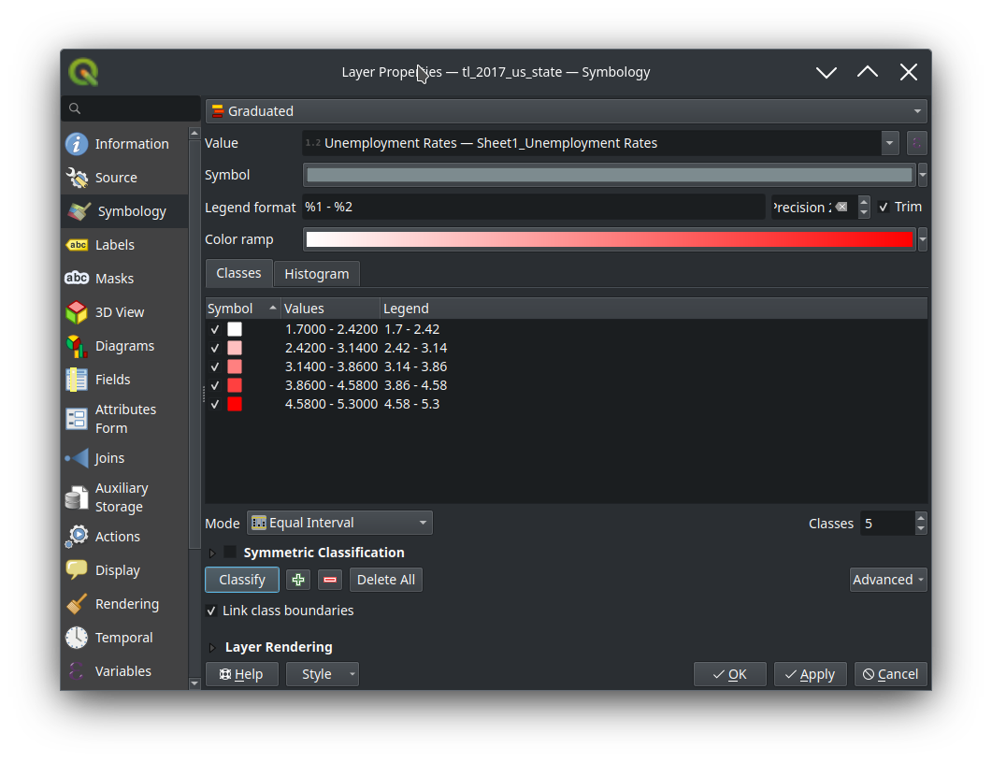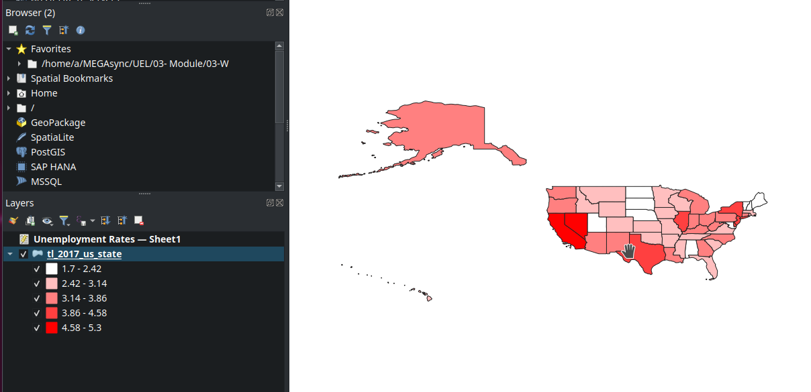

Then we can add the legand to the map as below

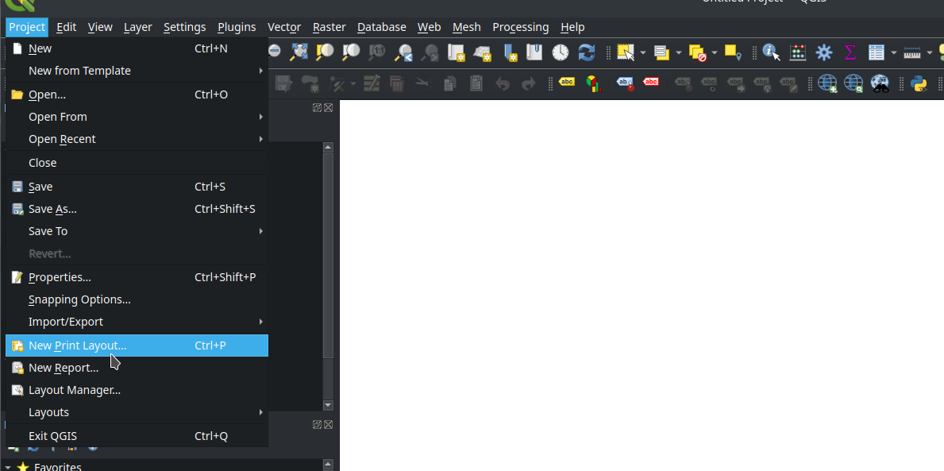

Creat a new Print layout

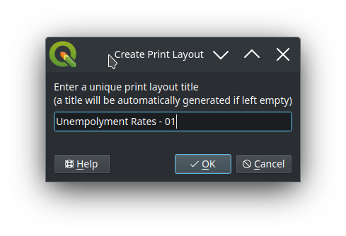

Add the map to the layout

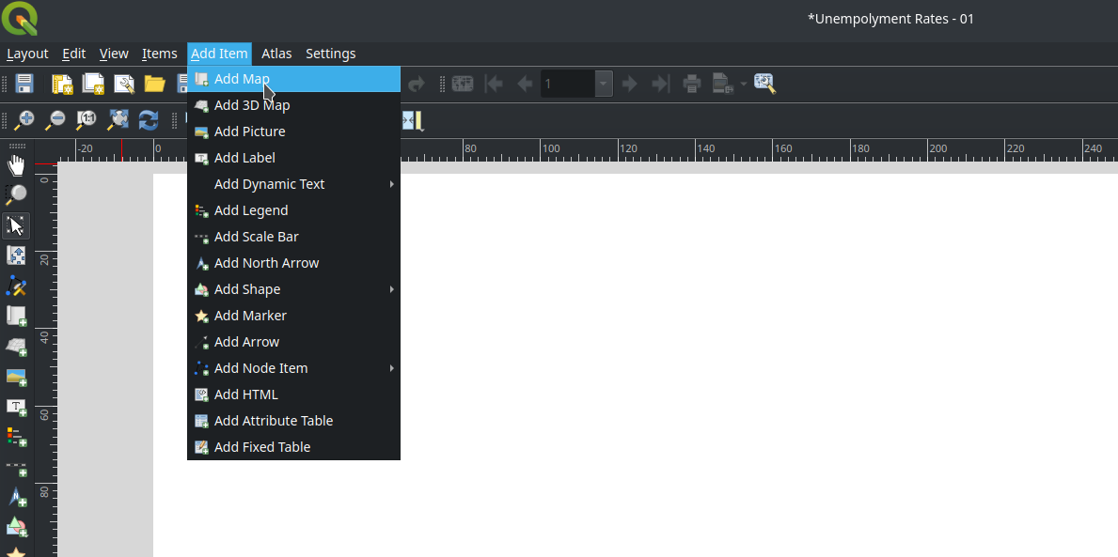

Add legend to the map layout

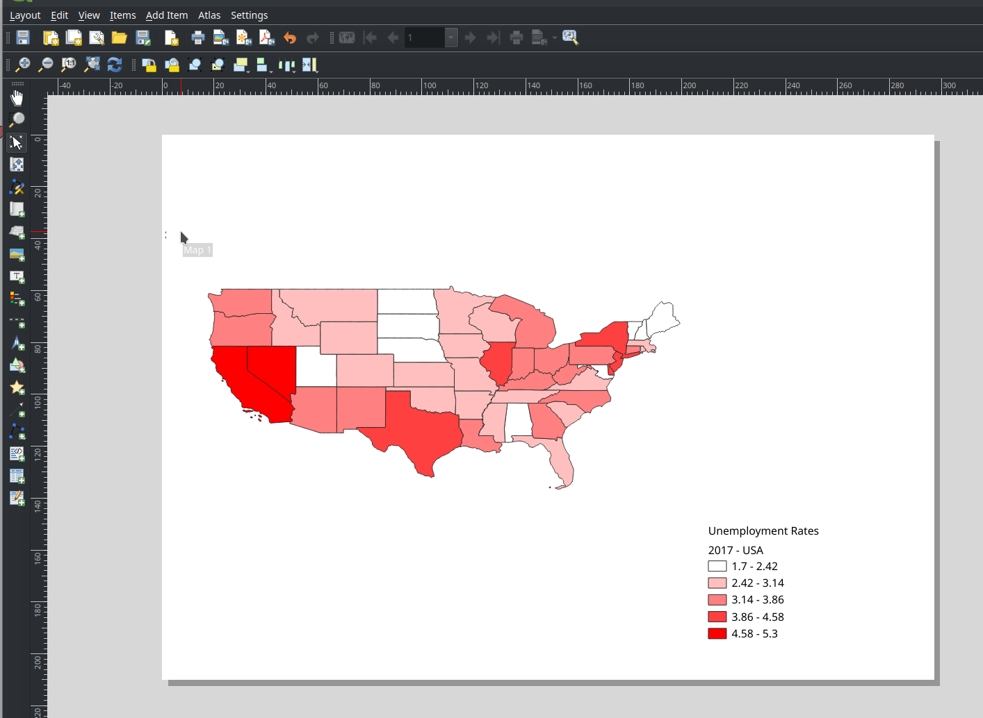

1. **Create a proportional symbol map and a graduated symbol map for the same dataset and discuss the differences between the maps. Design an appropriate legend for both maps.**

We need to estimate the position of each symbol using centroid for each state

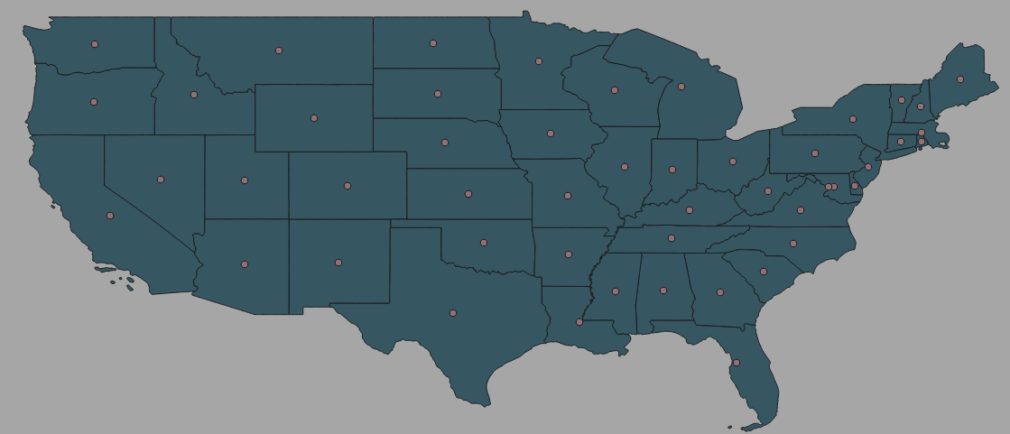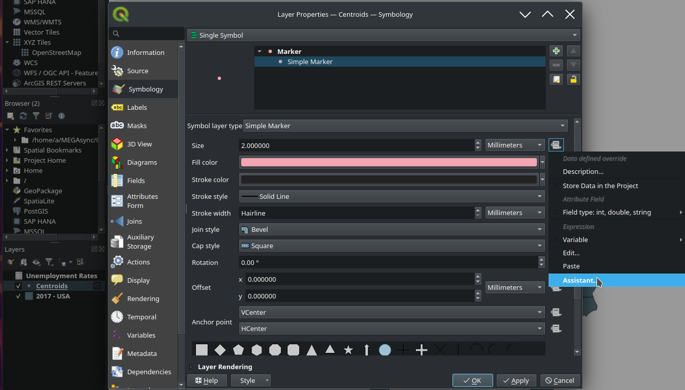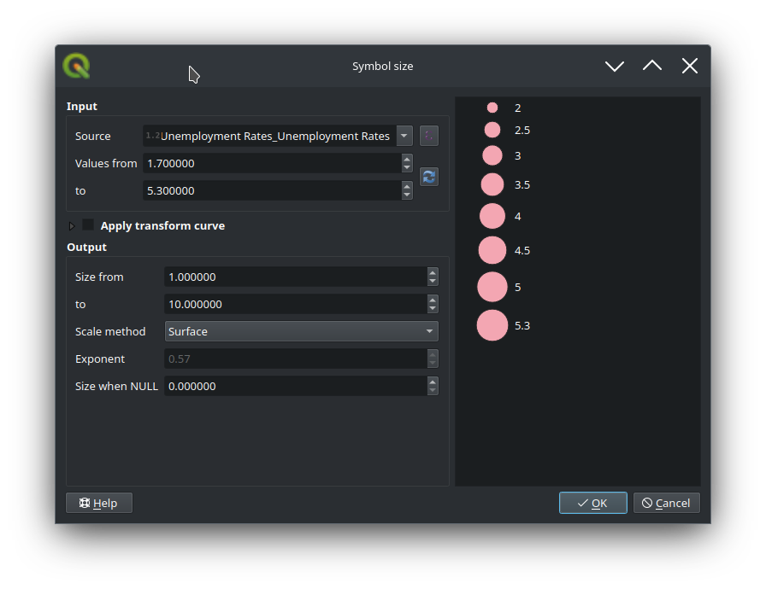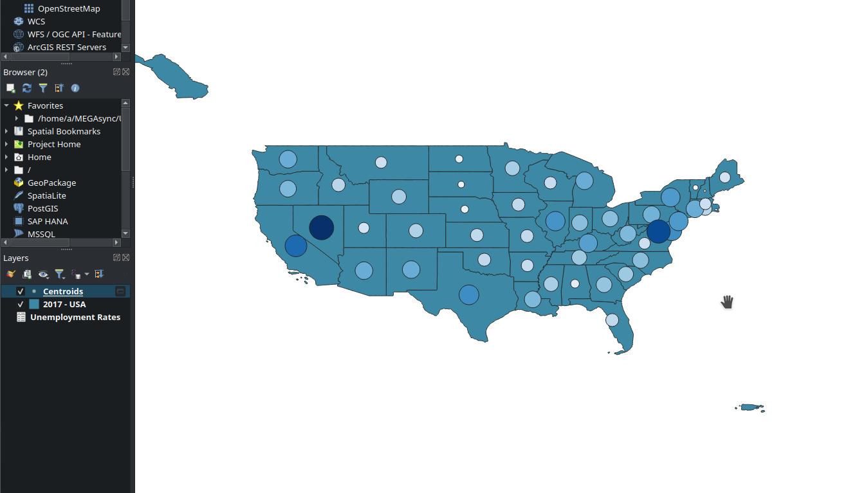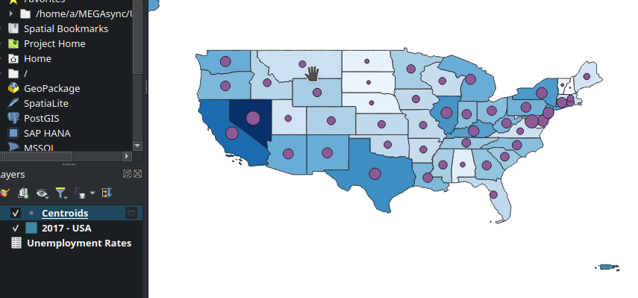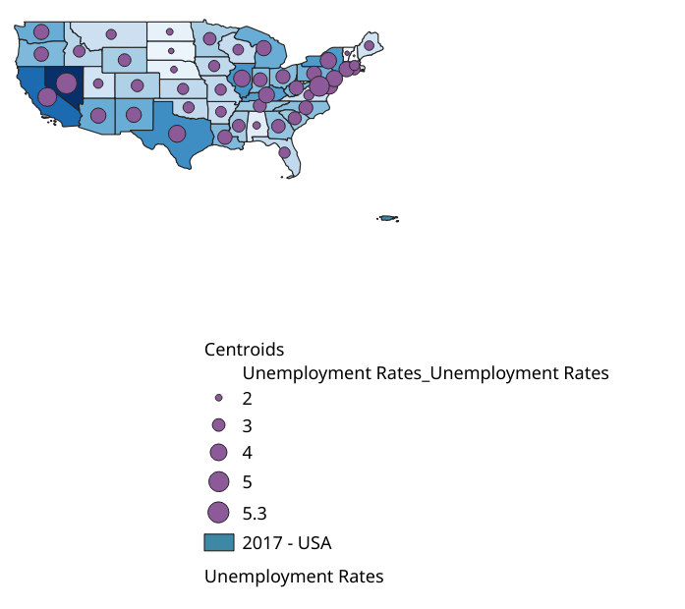

1. **Sketch a legend for each of the following thematic map types: choropleth, proportional symbol, graduated symbol, isoline, dot density, dasymetric, and flow.**

**1. Choropleth Map:**

**Description**: Represents data through color variations in predefined areas such as counties,

states, or countries.

**Legend Sketch:**

Rectangular color swatches (varying shades from light to dark).

Each swatch labeled with a value range (e.g., 0-10, 10-20).

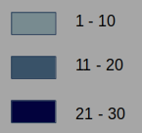

**2. Proportional Symbol Map:**

**Description**: Uses symbols, often circles, that vary in size based on the data value they represent.

**Legend Sketch:**

Circles of increasing sizes.

Each circle labeled with the value it represents.

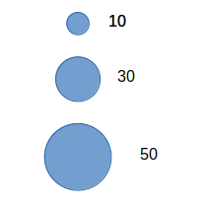

**3. Graduated Symbol Map:**

**Description**: Symbols vary in size and are grouped into classes.

**Legend Sketch:**

Symbols (like circles) of varying sizes.

Each size labeled with a value range.

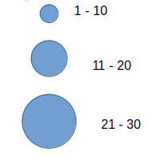

**4. Isoline Map:**

**Description**: Represents values with lines. Commonly used for elevation (contour maps) or meteorological data.

**Legend Sketch:**

Sample line labeled with its value.

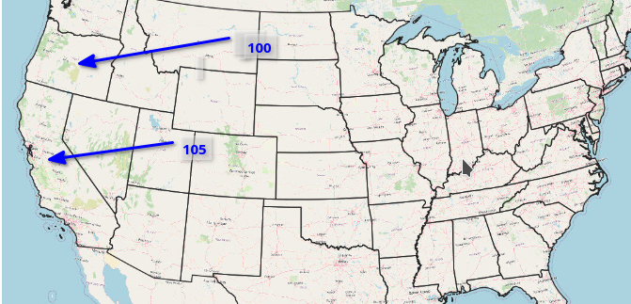

**5. Dot Density Map:**

**Description**: Each dot represents a certain number of phenomena (e.g., population, livestock).

**Legend Sketch:**

Single dot labeled, e.g., "1 dot = 1,000 people."



**6. Dasymetric Map:**

**Description**: Divides areas based on data distribution, not administrative boundaries.

**Legend Sketch:**

Color swatches similar to choropleth.

Each color labeled with a range or data description.

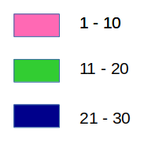

**7. Flow Map:**

**Description**: Shows movement between locations, like migration patterns.

**Legend Sketch:**

Lines of varying thickness or color.

Each line labeled with the flow magnitude it represents (e.g., "50,000 migrants").

**References**

Roth, R. H., Kelly, M., Underwood, N., Lally, N., Vincent, K., & Sack, C. M. (2019). Interactive &amp; multiscale thematic maps: a preliminary study. Abstracts of the ICA, 1, 1-2. <https://doi.org/10.5194/ica-abs-1-315-2019>

Słomska-Przech, K. and Gołębiowska, I. (2021). Do different map types support map reading equally? comparing choropleth, graduated symbols, and isoline maps for map use tasks. ISPRS International Journal of Geo-Information, 10(2), 69. <https://doi.org/10.3390/ijgi10020069>

Słomska-Przech, K. and Gołębiowska, I. (2021). Do different map types support map reading equally? comparing choropleth, graduated symbols, and isoline maps for map use tasks. ISPRS International Journal of Geo-Information, 10(2), 69. <https://doi.org/10.3390/ijgi10020069>

Tennekes, M. (2018). tmap: thematic maps in r. Journal of Statistical Software, 84(6). <https://doi.org/10.18637/jss.v084.i06>

Koo, H., Chun, Y., & Griffith, D. A. (2018). Geovisualizing attribute uncertainty of interval and ratio variables: a framework and an implementation for vector data. Journal of Visual Languages &Amp; Computing, 44, 89-96. <https://doi.org/10.1016/j.jvlc.2017.11.007>

Fauvel, M., Tarabalka, Y., Benediktsson, J. A., Chanussot, J., & Tilton, J. C. (2013). Advances in spectral-spatial classification of hyperspectral images. Proceedings of the IEEE, 101(3), 652-675. https://doi.org/10.1109/jproc.2012.2197589